Amy Soukup Rethinking Park Access In Baltimore
Econ 699 Capstone Final Paper, Summer, 2022

Capstone Question
This study analyzes the distribution of park accessibility in Baltimore City across neighborhoods with varying socioeconomic and sociodemographic variables. The spatial analysis will expand the definition of access to go beyond proximity and include measurements of park size, park amenities, park congestion, and perceived park benefits. This analysis will focus on the parks managed by the Baltimore City Department of Recreation and Parks, measuring the levels of accessibility and distributional equity offered by the park system. This study will, first of all, develop a standardized index which will provide a more sophisticated and innovative way of measuring park accessibility and secondly, will show why this more sophisticated measure will provide more accurate results of analysis.

Background
Parks
While many people can easily describe the components of a park, the exact definition and clasification is often vague and leaves room for interpretation. This is mainly due to the differencses in function, size, location, amenities, and design (open grass, forest, managed landscape, etc.) of parks. According to the Merriam-Webster Dictionary, parks are defined as “an area maintained - normally in its natural state - as public property, for ornament and recreation.” They are public amenities that provide a multitude of benefits for individuals and communities. Urban park systems in the United States represent a network of publicly owned green spaces for active and passive recreation managed by public park agencies (Rigolon et al., 2018).
Green spaces, in the urban context, are any area of grass, trees, or other vegetation set apart for recreational or aesthetic purposes in an otherwise urban environment (Green Streets and Community Open Space, EPA). Green spaces include parks, but also community gardens, cemeteries, schoolyards, and occasionally vacant lots. One important distinction between green spaces and parks is that parks are generally managed and maintained on a city or state level while many green spaces are frequently a community-level response to a lack of parks and green spaces in the community.
This study will be focusing on established parks managed by the Baltimore City Department of Recreation and Parks and will therefore exclude some green spaces located around the city. We will be able to examine the systemic equity of the park system by critically examining the distribution of parks that are managed by the Baltimore City Department of Recreation and Park. While green spaces provide an important aspect of access to space for physical activity, recreational activities, and connection with nature, they are excluded from this analysis. It is important to note that green spaces are many times more inviting and welcoming to marginalized communities and can allow for greater feelings of community ownership and that further research into their role in community development is important.

Benefits of parks
Parks are environmental amenities because of the multiple social, economic, health, and environmental benefits they provide. The benefits of urban parks are generally divided into two different categories; benefits to humans and benefits to the environment. Urban parks provide a wide range of benefits for both individuals and communities including reductions in chronic diseases and cardiovascular mortality and increases in mental well-being and cognitive development. Many of these benefits come from the physical activity associated with park usage. While living near a park does not guarantee an increase in physical activity there is strong evidence connecting the two (Van Cauwenberg et al., 2015). Physical activity can help maintain a healthy weight, reduce risks of cardiovascular diseases, reduce risks of type 2 diabetes, reduce risks of some cancers, strengthen bones and muscles, improve mental health and mood, etc (Parks, Trails and Health, CDC). As public places in highly privatized urban areas, parks also provide opportunities for social interactions, community engagement, and an increase in community identity.
Ecological and environmental benefits include improving air quality, moderating temperature, and reducing noise (Zhang et al., 2021). Parks can, depending on the landscape, infiltrate stormwater and replenish groundwater (Wolch et al., 2014). As shown above, the benefits include a wide range of improved quality of life and sustainable development in increasingly urbanized societies (Chiesura, 2004).

Baltimore City
Baltimore City is the largest city in Maryland with a population of approximately 585,708. While Baltimore City was once the 6th largest city in the United States, the population peaked in the 1960’s and has been declining ever since. According to the 2020 Census data, Baltimore City experienced a population decline of 5.7% in the last decade (U.S. Census Bureau, 2020). The census data also reported that Baltimore City has a median income of $52,164 with a per capita income of $32,699 and a poverty rate of 20%.
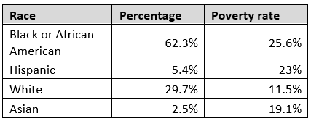
*Table 1: Baltimore City Demographics

Beyond those who reside in Baltimore City, the city also receives approximately 140,000 commuters a day who live outside of Baltimore City but work in the city. Fifty five percent of commuters live in Baltimore County and the remaining forty five percent live in nearby counties. The city also receives around 25 million visitors a year for work and pleasure. Both the commuters and the visitors add to the numbers of those who utilize Baltimore City’s amenities, including parks.
Baltimore City covers a total area of 92.1 square miles, with roughly 7 square miles being park acerage. Baltimore City Department of Recreation and Parks boasts of being the city's “leading provider of affordable, year-round leisure and recreational activities for citizens of all ages and abilities (Baltimore City, 2022).” The department manages 4,600+ acres of parkland and 262 parks, hosting approximately 120,000 trees, 120+ playgrounds, and 25+ miles of trails. The Department of Recreation and Parks is dedicated to improving the health and wellness of Baltimore through quality recreational programs, preserving parks and natural resources, and promoting fun, active lifestyles for all ages. Figure 1 is a map of all the parks managed by Baltimore City’s Department of Recreation and Parks.The establishment of parks has required a long and often difficult process of cobbling together parcels of private land as well as the action of civic groups seeking out large donors (Boone et al., 2009), due largely to the compact design of the city.
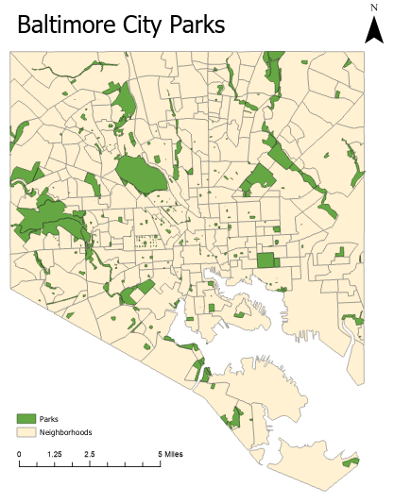
*Figure 1: Baltimore City parks

Literature Review
Some prior studies have reported disparities in access to parks across neighborhoods of varying socioeconomic status (SES) and racial/ethnicity compositions. Many of these studies found that racial/ethnic minority residents have to travel longer distances than white residents to access green spaces (Gobster and Wolch). Rigolon shows that many studies have found that low SES and racial minority neighborhoods have fewer acres of parks, fewer acres of parks per person, and parks with lower quality, maintenance, and safety than those of the racial majority and higher SES (Rigolon, 2016).
At the same time, other studies did not find any evidence to suggest that there are significant differences in terms of access to parks across neighborhoods of varying SES or racial and ethnic composition (Timperio, 2007). One study did conclude that while there was equity in the distribution of parks, the resources and programs offered at the park were not equally distributed (Moore et al., 2008). Odds ratio methods of analyzing park distributions also support the notion of equitable distribution (Miyake et al., 2010).
One reason for differences in findings is that the spatial inequality in the built environment is not well understood. The relationship between quality indicators and park availability across neighborhood SES and racial and ethnic minority composition has not been explored fully (Hughey, 2016). Because there is no uniform or standardized method of analysis, results will be different depending on the definitions, measurements, and variables included. The largest difference in findings comes from limiting the analysis to only include proximity as an indicator for access versus including expanding the analysis to include more variables.
I would like to draw attention to Christopher Boone’s analysis of the distribution of parks in Baltimore City in his paper, Parks and People: An Environmental Justice Inquiry in Baltimore, Maryland (Boone et al., 2009). His conclusion, using potential park congestion as the method of analysis, is that “the highest need populations have the best access to parks” in Baltimore City. Potential park congestion (PPC) is defined as the number of people per park acre (PPA) in a given park service area (PSA) if every resident were to use the closest park. Like many academics, Boone uses a 400 meter (a quarter mile) buffer from the perimeter of a park as the “service area”. This buffer distance is recommended by the National Recreation and Parks Association, the Trust for Public Land, and the Congress for New Urbanism and is the standard used by academics. Boone finds that park service areas that are predominantly black have higher park congestion than areas that are predominately white, indicating that there are more people potentially using each park in black neighborhoods than in white neighborhoods.
There are two main issues with his analysis that I would like to address. First of all, he assumes, as many others do, that proximity equates to accessibility; that access to a park is simply a measure of physical proximity to a park. Secondly, the use of PPC as a measure of distribution relies on the core assumption that people use the park closest to where they like. This ignores the role of other variables such as the size of the park, the quality of the park, or the programs or amenities offered at the park.
Boone mentions park quality briefly when he discusses park neglect. Neglect of existing parks, or nonaction, is “an injustice and can result from systemic inequalities”. While the neglect of an existing park is not likely to remove the park, it can make those spaces dangerous, unpleasant, and unwelcoming, sometimes to such a degree that park is no longer used. While Boone appears to understand the importance of the quality of a park, he does not include it in his analysis.
The paper does at one point mention the term “walking access” as a measure of proximity; “African American … have better walking access to parks but access to less park acreage per capita than white populations.” Beyond the mention of walking access, Boone does not provide any further elaboration or discussion. Walkability, a concept that includes walking access, is generally considered to be a more refined measure of physical access than proximity. Walkability, a concept which includes walking access, is a planning concept where cities are designed with the mixed-use of amenities in high-density neighborhoods where people can access said amenities by foot. The calculation of a walking score can provide a tool for analyzing how physically accessible a park is in relation to any amenities in the neighborhood. A walking score maps distances to amenities in different categories (grocery stores, restaurants, shopping, coffee shops, banks, parks, schools, book stores/libraries, and entertainment) that are weighted according to importance. The distance to a location, counts, and weights determine a base score of a neighborhood, which is then normalized to a score from 0 to 100. This will help us control for the fact that neighborhoods with higher population density tend to have amenities within a closer distance (urban) that neighborhoods with lower population density (suburban).
“Equity mapping”, coined by Emily Talen, is the literature on the spatial distribution of public amenities. Talen explores methods which use visualization techniques embedded in GIS as a way to analyze the spatial equity of public resources distribution (Talen, 1997). Mapping socio-economic characteristics alongside access to facilities allows us to include the social geography of the urban areas in the analysis. Defining equity without regard to socio-economic status may offer equality of opportunity, but will leave in place the inequalities of the existing social structure. Equity mapping is a useful visualization tool that allows researchers to gauge the degree of equity associated with any particular geographic arrangement of public facilities.
Socio-economic and racial composition differences of neighborhoods can lead to different exposures to built environments (Gordon-Larsen, 2006, Wen et al., 2011). In many cities, and especially in Baltimore City, the history of segregation, redlining, and blockbusting have all played a large role in current socio-economic and racial composition neighborhood differences. Because of this history, many neighborhoods in Baltimore City have clear socioeconomic and racial/ethnic demographics.

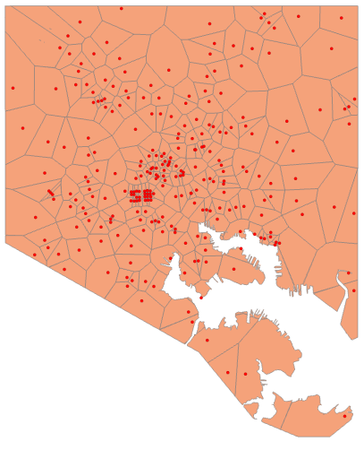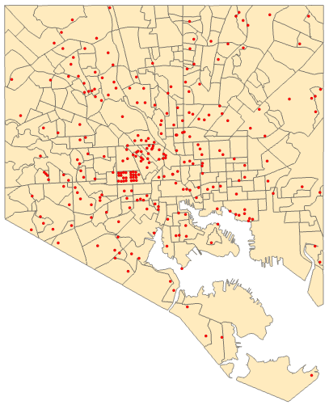
*Figure 2: Voronoi diagram Baltimore City parks *Figure 3: Baltimore City parks and neighborhoods

Voronoi diagrams are methods for the analysis of proximity and neighborhoods. By turning each park into convex polygons such that each polygon contains exactly one generating point, every area in a given polygon is closer to its generating point than to any other. This provides us with the spatial regions “serviced” by each park in the city. The typical definition of “access” is loosely defined on the basis of services in some geographic area. This definition does not take into account spatial externalities, the structure of the transportation network, the frictional effect of distance, properties of supply and demand, and measurement issues related to the geographic scale of analysis (Talen, 1996). Using proximity, or spatial nearness, as an indicator for accessibility speak only to spatial access and not to “social access”, referring to the socio-demographic features such as safety, traffic, and walkability that may directly affect park utilization (Weiss et al., 2011).

Environmental and Distributive Justice Framework
Environmental justice was defined by Dr. Robert Bullard in 1990 as, “the principle that all people and communities are entitled to equal protection of environmental and public health laws and regulations (Bullard, 1990).” Environmental justice is, essentially, the fair and equitable distribution of both environmental “negatives” (like hazardous waste sites, pollution, etc.), and environmental “benefits” (parks, open spaces, etc.). A large focus in environmental justice research and action thus far has been examining the spatial relationships between environmental burdens and the communities affected. This focus has shown the disproportionate distribution of negative exposures on communities of low SES and high racial and ethnic minority populations. But this has led to a lack of analysis of the relationship between neighborhoods of low SES and high racial and ethnic minority composition and environmental “benefits”.
The environmental justice framework is a useful conceptual model for studying the spatial distributions of parks. The core principle of environmental justice is that everyone, regardless of their socio-economic and socio-demographic background, is entitled to equal distributions of environmental amenities.
The second framework utilized in this study is the framework of distributive justice, as it can also provide a working model to help understand the inequality in the distribution of parks in Baltimore City. Equitable distribution means facilities, resources, etc. are located such that as many different spatially defined social groups as possible benefit from them (Talen, 1998). The ultimate desire is for the equitable geographic distributions of environmental threats and resources as a result of a fair decision-making process (Schlosberg, 2004).

Data and Methodology
Data on park locations, resources diverted to each park, park congestion and accessibility, neighborhood demographics, and property and vacancy rates will be collected.

Data Type | Data Source | Data Description
Baltimore City Parks | Baltimore City Department of Recreations and Parks | - Park ID  - Park name  - Park location  - Size of park  - Amenities
Baltimore City Neighborhoods | Open Baltimore | - Population  - Age  - Race  - Gender  - Socio-economic level
Real Property Information | Open Baltimore | - Property types  - Housing prices

Hypothesis
This study will analyze the spatial equity of the Baltimore City park system; specifically, the equity of park accessibility across the city. The analysis of the equity in the distribution of accessibility to parks will take place on a “service-area-neighborhood level”; comparing neighborhoods of different SES and racial/ethnic composition. The spatial analysis will expand the definition of access to go beyond proximity and include measurements of perceived park quality, park size, park congestion, and park investment. This study will, first of all, develop a standardized index which will provide a more sophisticated and innovative way of measuring access (to parks) and secondly, will show why this more sophisticated measure will provide more accurate results of analysis.
Park quality has been defined by others as, “the capacity to serve the recreation needs of a diverse range of residents, including providing appropriate acreage, walking access, facilities, and programing (Rigolon et al., 2018).” There is little standardization in how to actually measure park quality. Examining the quality of parks is important as studies have found that the quality, including facilities and amenities, contribute to park usage (Rigolon et al., 2018).
The Trust for Public Land has created a ParkScore to analyze the accessibility of parks in the top 100 cities in the United States. Their results are on a city level so they do not have any data on individual parks. But their ParkScore provides a model for this analysis. They model their score as follows:

ParkScore = Park Acreage score (median park size score + park coverage score) + Park Access score + Facilities and Investment score (park spending per resident score + facilities score)
*Equation 1:The Trust for Public Land Park Score

Adjusting the ParkScore above allows the creation of a park accessibility score. The first step is the development of a standardized index of variables to be included in the measurement. The index will include the following variables:
- Size of the park as percentage of land coverage
- Potential park congestion
- Park amenities
- Perceived benefit of the park

Park Accessibility Score = Park acreage score (as a percentage of city size) + Park congestion (population within service area/park acres) + Park amenities + Perceived benefit of living on/near the park
*Equation 2: Park Accessibility Score

One key variable in the Trust for Public Land’s ParkScore that is missing from this analysis is the “Facilities and Investment score (park spending per resident score + facilities score)”. This variable is captured to some extent with “park amenities” but does not perfectly capture the investment variable as it does not address park spending. This is due to a lack of reliable data regarding the resource and financial investment in parks. This lack of data will be discussed further in the section on limitations.

Creating a Standardized Index
For this index, Park size is reported as a percentage of the size of the city. Equation 3 shows the equation that is used for the calculation.

Park size =
[Size of individual park / total acreage of Baltimore City**] * 100
*Equation 3: Park size
**Baltimore City is a total of 58,944 acres

Potential park congestion (PPC) was briefly discussed above as the number of people per park acre (PPA) in a given park service area (PSA) if every resident were to use the closest park to them, within a “service area” of 400 meters. Figure 4 shows the park service area for every park in Baltimore City. These service areas were found by constructing a 400 meter buffer zone around each park and then the ‘remove overlay’ tool was used to get the service area polygons.
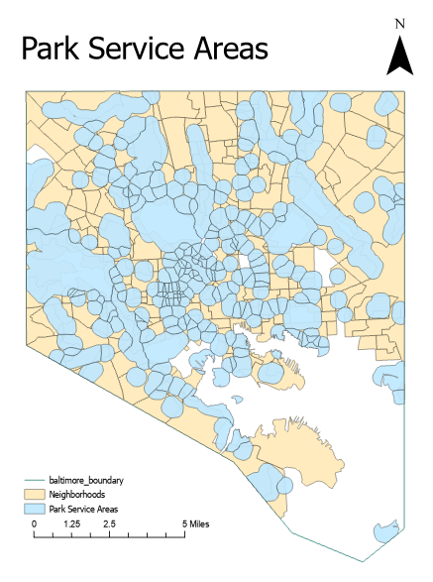
*Figure 4: Park Service Areas

Finding the park service areas is the first step to finding the congestion. The ‘Tabulate Intersection’ tool will pull the population data from the Neighborhood dataset for each park service area. This process relies on the assumption that the population has an even distribution throughout each neighborhood. There is no way to address this assumption and the process is still considered the standard. Once the population per park service area has been determined, it can be used to find the potential park congestion by finding the number of people per park acre. Figure 5 shows the potential park congestion; again, this relies on the assumption that people visit the park nearest to them.
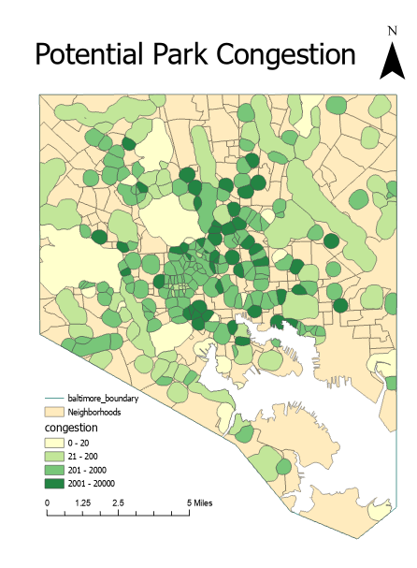
*Figure 5: Potential Park Congestion

Variable | Obs | Mean | Std. dev. | Min | Max
Potential Park Congestion | 262 | 1,824 | 3,714 | 0 | 27,872

The original data set for parks in Baltimore City included a total of 292 parks. Thirty of those parks were dropped because they were not managed by the Department of Recreation and Parks. Since we are specifically interested in analyzing the Department of Recreation and Parks we will not include any parks that are not under their management. Five of the parks are recorded to have 0 acreage and another 122 parks have less than one acre in size. The parks with 0 acreage are either just a fountain or a statue, but still considered a park by Rec and Parks. While the mean acreage is 18.3 acres, the median is only 1.1 acres, this wide spread of park acreage hints at the inequality in the park system.

Baltimore City Parks
Variable | Obs | Mean | Std. dev. | Min | Max
parks_id | 262 |  |  | 1 | 302
acres | 262 | 18.3 | 83.5 | 0 | 969.01
amenities | 523 | 3.5 | 4.7 | 0 | 34

Baltimore City parks host a variety of different amenities. The amenities included in this study are dog parks, playgrounds, pools, recreation centers, pavilions, special facilities, tennis courts, multiple fields, basketball courts, and ballfields. Each of these amenities are weighted equally in our analysis. Figure 5 shows the density distribution of amenities throughout the different parks. 114 parks do not have any of the above listed amenities and 108 parks have between 1 and 3 amenities. The parks with the highest number of amenities are Druid Hill Park (34 amenities), Gwynns Falls/Leakin Park (27 amenities), Patterson Park (26 amenities), Farring Baybrook Park (15 amenities), and Clifton Park (13 amenities).

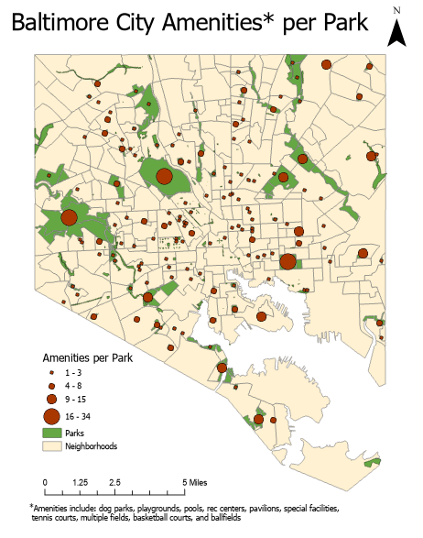
*Figure 5: Park Amenities

Real property data, residential units:
Variable | Obs | Mean | Std. dev. | Min | Max
salepric | 193,393 | 180,092 | 996,821 | 1 | 34,427,345

The Real Property data was used to measure the perceived benefit of living on/near the parks. The data set has been limited to only residential units in Baltimore City. To analyze property demographics immediately surrounding the parks we created a park buffer zone. After some analysis of Baltimore City, 50 meters was the decided upon buffer zone because the first row of residential houses immediately surrounding the park is included in that area while excluding any further rows. The buffer zone begins at the edge of the park and extends out for 50 meters beyond the park.
This perceived benefit is measured by the difference in the average sale price of residential units immediately surrounding the park (in the 50 meter buffer zone) and the average sale price of residential units in the surrounding neighborhood. The data has been limited to only include residential units, which includes both owner-occupied and rental properties. Figure 6 shows the average property value/sale price of residential housing within each park’s buffer zone. This alone does not control for the overall value/sale price of the neighborhood. We will compare the average property sale for residential units in the buffer zone of each park to the average property sale price of residential units in the neighborhood.

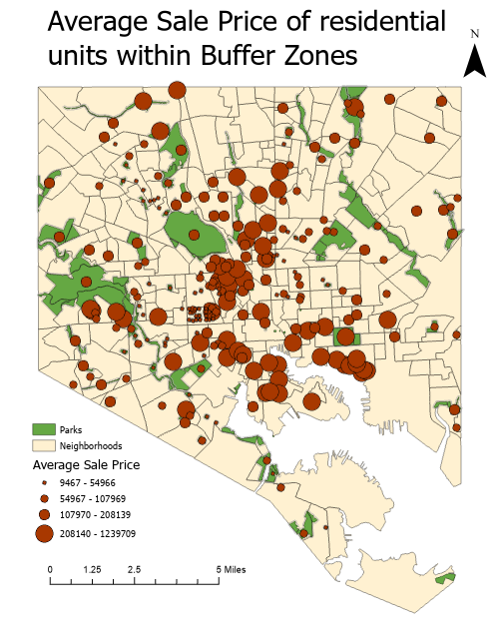
*Figure 6: Average Sale Price of Residential units within Buffer Zone

It is important to compare the average property value/sale price of houses within our buffer zone to the average property value/sale price in the surrounding neighborhood to control for the overall wealth of the neighborhood. To compare the averages, the average value/sale price of a residential unit in the park’s neighborhood is subtracted from the average value/sale price of a residential unit in the park’s buffer zone. This will both control for the wealth of the neighborhood as well as show the perceived benefit of living near/on the park.
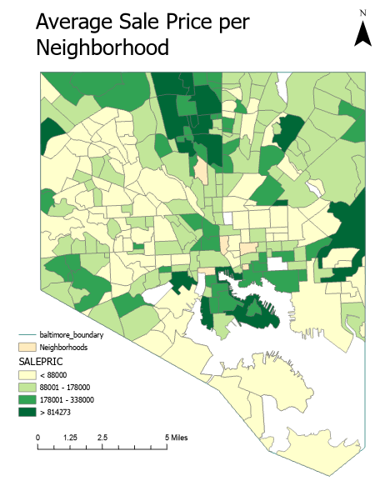

Average value/sale price in the buffer zone - Average value/sale price in the neighborhood
= Perceived benefit of living near/on the park
*Equation 4: Perceived benefit of living on the park

The larger the positive difference, the more desirable it is to live near the park and the larger the negative difference the less desirable it is to live near the park. This will help us determine the perceived quality of the park, since more people will want to live near the park (driving up property sales) the higher the quality of the park.
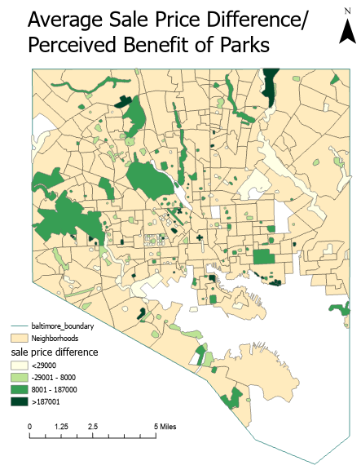
*Figure 7: Average sale price differences

The difference in residential sale prices inside the buffer zone with the residential sale prices in the neighborhood provides a value for the perceived benefit of living near the park.

All the previous calculations provide the following variables for the standardize index of park accessibility:

Variable | Obs | Mean | Std. dev. | Min | Max
Size of park | 262 | 0.031 | 0.14 | 0 | 1.64
Potential Park Congestion | 262 | 1,824 | 3,714 | 0 | 27,872
Amenities | 262 | 3.5 | 4.7 | 0 | 34
Park “Benefit” | 262 | 35,549 | 167,451 | -208,979 | 1,041,481

Below is the table of all the index variables normalized on a scale of 0 - 100. To conduct an analysis of the standardized index, the normalized values will be used.

Variable | Obs | Mean | Std. dev. | Min | Max
Size of park | 262 | 1.88 | 8.6 | 0 | 100
Potential Park Congestion | 262 | 6.5 | 13.0 | 0 | 100
Park amenities | 262 | 1.95 | 3.9 | 0 | 100
Park “Benefit” | 262 | 3.4 | 6.1 | -20 | 100

To get an accessibility score for each park, the variables above will be inputted into the ‘Park Accessibility Score’ (Equation 2) previously discussed. After calculating the park accessibility score, the normalization process will be repeated to provide a normalized score for each of the parks. The Park Accessibility Score assumes an equal weighting of each of the variables. In the future, a sensitivity analysis should be conducted to determine how weighting the variables differently impacts the analysis.

Variable | Obs | Mean | Std. Dev | Min | Max
Accessibility Score | 262 | 4.1 | 6.7 | -4 | 44
Accessibility Score Normalized | 262 | 16.8 | 14 | 0 | 100

The distribution of the accesibility score in Baltimore City is shown in Figure 9.
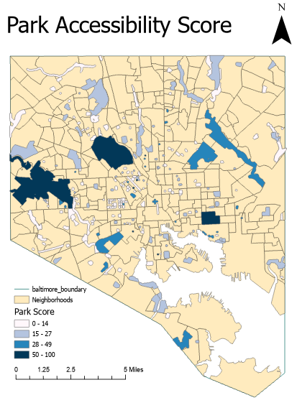
*Figure 9: Park Accessibility Score

Now that a park accessibility index has been developed and there is an accessibility score assigned to each park in Baltimore City, the regression analysis can take place.

Findings
Regression analysis
Now that the Accessibility Index is complete and a Park Accessibility Score has been calculated for each park it is time to perform the regression analysis. As a reminder, one of the goals of this study is to analyze how park accessibility is distributed across neighborhoods with varying socioeconomic and sociodemographic variables.

The formula for the multiple linear regression can be seen in Equation 4 and Equation 5 with the results of the regression analysis in Equation 6.
Y = β0 + β1X1 + β2X2 + β3X3 + … + βiXi + ε
*Equation 4: Multiple Linear Regression Equation

Accessibility Score** = β0 + β1(median household income)*** + β2(population density)*** + β3(non-white)*** - β4(male)*** + ε
*Equation 5: Park Accessibility Multiple Linear Regression Equation
**This score is the normalized score
*** Reported in 2019

The multiple linear regression model will guide the analysis. The model will be run multiple times to test the sensitivity of the variables in the equation. Table 2 shows the various models that were run and the magnitude and significance of the variables in each model. When run individually, three of the four variables are significant. When additional variables are added there are changes to the level of significance.

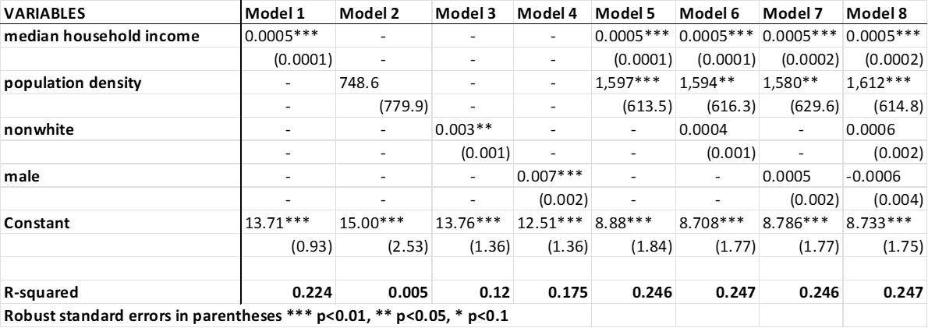

*Table 2: Regression output

Model 1 through Model 4 are all single linear regression models used to analyze the relation between each independent variable alone and the dependent variable. Model 5 through Model 8 show the multiple linear regression results for different combinations of variables. Median household income is the only variable that remains statistically significant across every model that it is used in. All of the models show very low R-squared values. R-squared, also called the coefficient of determination, is the statistical measure of what proportion of variance is explained in the model. All of the models shown above have low R-squared values which means that the independent variables are not explaining much of the variation in the dependent variable.
The coefficient estimate for median household income is consistent across all models at 0.0005. For an increase of $1 in median household income for a park’s neighborhood there is a corresponding increase of in the park accessibility score of 0.0005. A better example is an increase of $1,000 in median household income in a park’s neighborhood is associated with an increase in the park accessibility score of 0.5. The coefficient estimate for population density has some variation but stays close to 1,600. The values for population density range from .001 to 0.008 and a population increase of 1 person per 1000 acres would increase population density by 0.001. As an example, an increase in the population density by 0.001 is associated with an increase in the park score of 1.6.
Wald tests were conducted Model 5 and Model 8 to see if including the variables in the model created a statistically significant improvement to the fit of the model. The results of the wald tests should not be a surprise after seeing the regression output in Table 2.

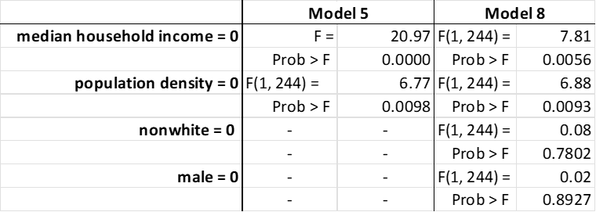
*Table 3: Wald test

In both Models, including median household income and the population density improves the fit of the model. Nonwhite and male on the other hand do not provide any statistically significant improvement to the model. Table 4 shows the correlation coefficients and significant levels that came from the Pearson product-moment correlation coefficient which measures the strength and direction of association that exists between any two continuous variables. Anything with a coefficient value between 0.1 and .3 has weak correlation, anything with a coefficient between .31 and .5 has a moderate correlation, and anything with a coefficient greater than .51 has strong correlation. Many of these variables are moderately or strongly correlated.

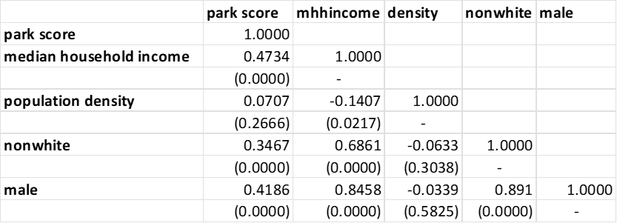
*Table 4: Pearson’s correlation output

Accessibility Score = 8.73 + 0.0005(median household income) + 1,612((population density) + 0.0006(nonwhite) - 0.0006(male)
*Equation 6: Model 8 results

It is possible to remove some of the correlated variables from the regression. Model 5 shows the regression with just the two statistically significant variables, median household income and population density. The results do not change too much when nonwhite and male are dropped, but the equation does look like it is lacking.

Accessibility Score = 8.88 + 0.0005(median household income) + 1,597((population density)
*Equation 7: Model 5 results

This equation may not be as informative as originally hoped for, but it is the first step in analyzing the distribution of park accessibility within Baltimore City and provides a good foundation for future research. Regardless of what model is used (Model 5 or Model 8) both show the role that median household income has when it comes to measuring the accessibility of parks. The impact that median household income has is statistically significant and does lead to the conclusion that the distribution of park accessibility in Baltimore City is not equitable. An equitable distribution of park accessibility would have produced a regression model where the level of median household income was not statistically significant in determining the level of accessbility.

Comparing Index with other studies
To analyze how this study compares to other studies we return to Christopher Boone’s Parks and People: An Environmental Justice Inquiry in Baltimore, Maryland (Boone et al., 2009). As a reminder, Boone conducts his analysis on the assumption that proximity equates to access and uses the potential park congestion (PPC) method to measure access to parks in Baltimore City. While Boone is not the first to use this approach, it is his paper that the comparison is based on. The two means of measuring park accessibility are show below:

Park Proximity = potential park congestion (population within service area/park acres)
*Equation 8: Boone’s equation of park access

Park Accessibility Score = Park acreage score (as a percentage of city size) + Park congestion (population within service area/park acres) + Park amenities + Perceived benefit of living on/near the park
*Equation 9: Revised equation of park access

Graph 1 and Graph 2 shows the spread of the proximity and accessibility values for each approach and highlight that the accessibility approach provides more insights and nuanced differences.

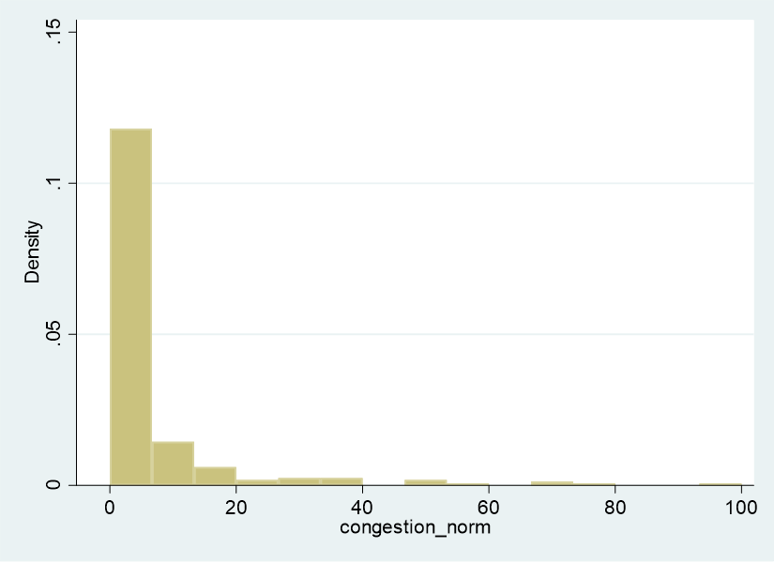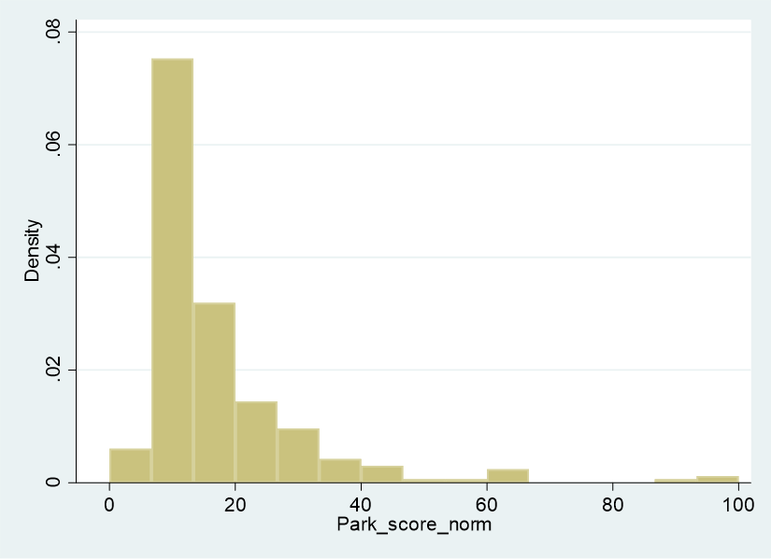
Graph 1: distribution of proximity Graph 2: distribution of accessibility

A visual comparison of these two approaches show the striking difference. Figure 10 and Figure 11 provide a visual comparison of the results when the Quantile classification method is used. The quantile classification method distributes observations into classes so that each class has the same frequency of observations.
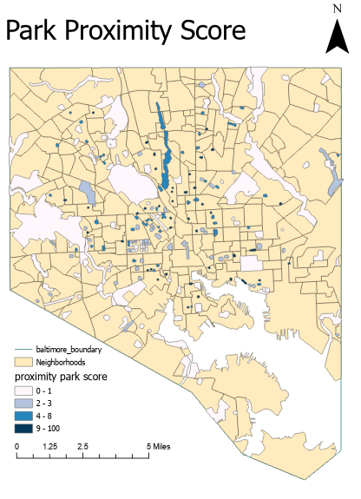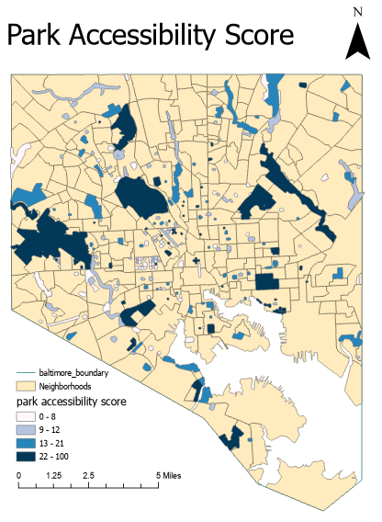
*Figure 10: quartile method (proximity) *Figure 11: quartile method (accessibility)

The second comparison is a visualization of the Equal Interval method, where the data range of each class is held constant and the frequency of observations in each class varies. Figure 12 and Figure 13 show the difference.
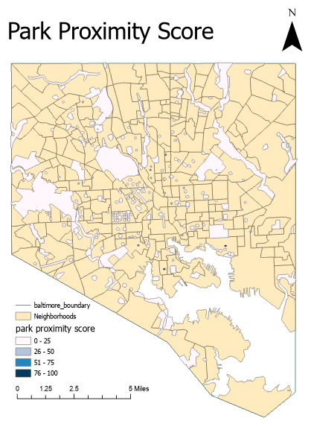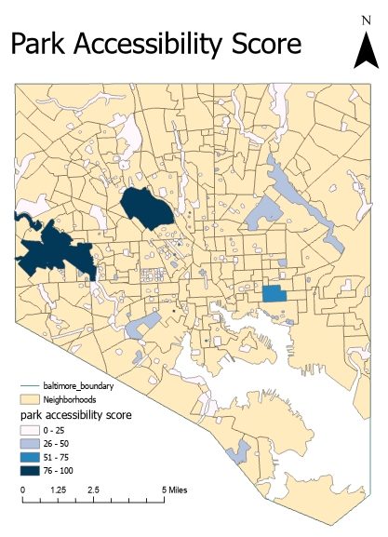
*Figure 12: equal interval method (proximity) *Figure 13: equal interval method (accessibility)

Below are the regression results for the proximity approach (used by Boone). As can be seen in Table 5, neither of the models (which reflect Model 5 and Model 8 from the accessibility approach) show strong results. Both R-squared values show how poorly the models work. Only population density is significant in both models, though it is highly correlated to the dependent variable. It is logical that the population per service area acre is significant in determining the population per park acre.

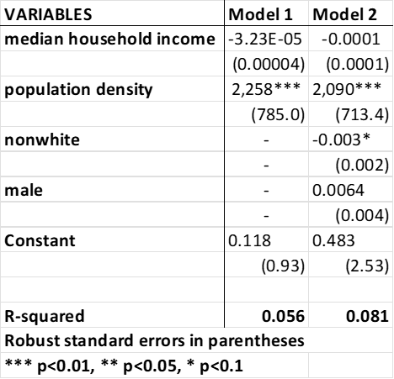
*Table 5: proximity regression output

As can be seen in Table 5, median household income has no statistically significant impact. The coefficient estimate is also much lower in this approach than the accessibility approach. Another interesting result is that coefficient estimate for nonwhite population is negatively associated and statistically significant. The interpretation for this is that, using the proximity appraoch, parks have a higher proximity score in nonwhite neighborhoods. This is the opposite case for the accessibility approach, where nonwhite is positively correlated. The reason for this may be that many nonwhite neighborhoods in Baltimore tend to be located in heavily urban areas where there are more small parks. Because the proximity appraoch does not take into account park quality or perceived benefit it will assign higher values to parks with higher population in the parks neighborhood ( the park service area).
Overall, Boone’s approach of proximity does not find inequitable access to parks in Baltimore. This is because his work and the proximity approach is not designed to take the Envrionmental and Distributive Justice Frameworks into consideration. The standardized index created for the accessibility approach provides a more sophisticated and innovative way to analyzethe distribution of park access. The results are more detailed and more accurate when park access moves beyond just proximity as a measurement. The new standardized index appraoch to park accessibility is more likely to capture elements of the Enviornmental and Distributive Justice Frameworks.

Limitations
Due to the scope and timeframe this study has a variety of limitations that are important to highlight. The first of these limitations is the exclusion of additional green spaces outside of the park system in the analysis. Because the goal of this study was to analyze the level of equitable distribution of parks managed by the city it focused on a small group of specific parks and excludes all other forms of parks and green spaces throughout the city. Green spaces have become more of a phenomenon in the last decade and frequently a direct result of a lack of accessible parks for local communities. Currently, there is no complete data on green spaces throughout the city. Once green spaces data has been collected and validated, it could be included in a similar analysis as the one conducted in this study.
This study did not include the impact that segregation has had on park access in Baltimore City. Baltimore City has a long history of racial segregation which has affected the built enviornment of the city. What started as residential segregation based on race led to redlining and blockbusting activities which continued to impact the socio-economic and socio-demographic makeup of the neighborhoods. In the future, it would be informative to see if there are any differences in park accessibility in between segregated neighborhoods. Adding the history of segregation to this analysis would provide a much deeper analysis of the distribution of parks but to do so will take more effort than is feasible in this study.
Another limitation is the inability to measure park usage. While being able to measure each park’s usage would have been very beneficial to this analysis it was not feasible. It is very difficult to infer park usage. Some studies have tried to do so through various models of inference but it is generally agreed upon that the best way to measure park usage is to sit at a park and count the number of people there throughout various times of the day. This method is very time consuming and not practical for this study.
As mentioned previously, this study does not include the resource and financial investments in the parks in the analysis. The original intent was to include Baltimore City Department of Rec and Park expenditures per park as well as the presence of “Friends of” organizations to capture park investment. After many email chains and lengthy discussions with people from Rec and Parks, Parks and Peoples, and various “Friends of” groups, it became apparent that there was not any available data. The Department of Rec and Parks create operation budgets on the park district level and not the individual park level. Each of the five park districts in Baltimore receives funding based on the acreage of parks in that district. Expenditures are reported on either a park district level or in broad categories, such as amenities, programs, maintenance, etc. Because of the way in which this data is collected and reported, there is no way to accurately include expenditure and investment data from Baltimore City for each park.
There is little to no consistent data on “Friends of” organizations for parks in Baltimore City. A “Friends of” group is a community based volunteer group affiliated with the Baltimore City Department of Recreation and Parks (BCRP). These organizations support the city in its efforts to maintain and program the park in its entirety. According to the Friends of Parks Manual created by the Department of Rec and Parks, the organizations are essential to the health, cleanliness, and vitality of the City’s Parks. “Friends of” groups invest time and resources to sustain healthy and welcoming park spaces that connect neighbors, build community identity, and enhance property values in their neighborhood (Friends of Parks Manual, Baltimore City Recreation and Parks).
According to the Department of Rec and Parks approximately 80 “Friend of” groups exist throughout Baltimore City. This information may not be the most accurate as not all of these groups “register” with Recs and Parks and there is no list of all active “Friends of” groups. There is also a range in what these groups look like and what purpose they serve. On one end, there are organizations like the Friends of Patterson Park or the Friends of Druid Hill Park who have staff, funding, offices, programming, etc. On the other end there are groups as small as two volunteers who may conduct the occasional park clean up but do not function on any larger level. Because there is only a partial list of existing groups with no indication of the level of investment they provide the park (in terms of funding, programming, volunteer hours, etc.) there was no adequate way to include it in the analysis.

Conclusion
This study expanded the definition of access to look beyond proximity and include measurements of park size, park amenities, park congestion, and perceived park benefits. A standardized index was created to measure the distribution of park accessibility in Baltimore City. The index assigned a park accessibility score to each park that was used in a regression analysis. Figure 9 and Equation 6 (shown again below) show the distribution of accessibility and the regression equation for park accessibility.
*Figure 9: Park Accessibility Score

Accessibility Score = 8.73 + 0.0005(median household income) + 1,612((population density) + 0.0006(nonwhite) - 0.0006(male)
*Equation 6: Model 8 results

When comparing the results from the two different approaches it is clear that the accessibility approach developed in this study is an innovative approach that provides more accurate results. The accessibility approach found inequality in the distribution of park access in Baltimore City but Boone’s proximity approach does not. The standardized index created for the accessibility approach is designed to capture elements of the Enviornmental and Distributive Justice Frameworks and highlights the inequality. Overall, the results are more detailed and more accurate when the analysis of park access moves beyond just proximity as as a measure and includes measures of park size, park amenities, park congestion, and perceived park benefits.

Bibliography
Boone, C. G., Buckley, G. L., Grove, J. M., &amp; Sister, C. (2009). Parks and people: An environmental justice inquiry in Baltimore, Maryland. Annals of the Association of American Geographers, 99(4), 767–787. https://doi.org/10.1080/00045600903102949

Bullard, Robert . (1990). Retrieved March 20, 2022, from https://drrobertbullard.com/

Chiesura, A. (2004). The role of urban parks for the sustainable city. Landscape And Urban Planning, 68(1), 129-138. doi: 10.1016/j.landurbplan.2003.08.003

Cohen, D. A., Marsh, T., Williamson, S., Derose, K. P., Martinez, H., Setodji, C., & McKenzie, T. L. (2010). Parks and physical activity: why are some parks used more than others?. Preventive medicine, 50 Suppl 1(Suppl 1), S9–S12. https://doi.org/10.1016/j.ypmed.2009.08.020

“Friends of Parks Manual”, Baltimore City Recreation and Parks. Retrieved from: https://bcrp.baltimorecity.gov/sites/default/files/Friends%20Manual.pdf

“Green Streets and Community Open Space”, EPA. Retrieved from: https://www.epa.gov/G3/green-streets-and-community-open-space

Gordon-Larsen, P., Nelson, M. C., Page, P., & Popkin, B. M. (2006). Inequality in the built environment underlies key health disparities in physical activity and obesity. Pediatrics, 117(2), 417–424. https://doi.org/10.1542/peds.2005-0058

Hughey, S. M., Walsemann, K. M., Child, S., Powers, A., Reed, J. A., & Kaczynski, A. T. (2016). Using an environmental justice approach to examine the relationships between park availability and quality indicators, neighborhood disadvantage, and racial/ethnic composition. Landscape and Urban Planning, 148, 159–169. https://doi.org/10.1016/j.landurbplan.2015.12.016

Maroko, A. R., Maantay, J. A., Sohler, N. L., Grady, K. L., & Arno, P. S. (2009). The complexities of measuring access to parks and physical activity sites in New York City: A quantitative and qualitative approach. International Journal of Health Geographics, 8(1), 34. https://doi.org/10.1186/1476-072x-8-34

Miyake, K. K., Maroko, A. R., Grady, K. L., Maantay, J. A., & Arno, P. S. (2010). Not Just a Walk in the Park: Methodological Improvements for Determining Environmental Justice Implications of Park Access in New York City for the Promotion of Physical Activity. Cities and the environment, 3(1), 1–17. https://doi.org/10.15365/cate.3182010

Moore, L. V., Diez Roux, A. V., Evenson, K. R., McGinn, A. P., & Brines, S. J. (2008). Availability of recreational resources in minority and low socioeconomic status areas. American journal of preventive medicine, 34(1), 16–22. https://doi.org/10.1016/j.amepre.2007.09.021

Neusel Ussery, E., Yngve, L., Merriam, D., Whitfield, G., Foster, S., Wendel, A., &amp; Boehmer, T. (2016). The National Environmental Public Health Tracking Network Access to parks indicator: A National County-level measure of Park proximity. Journal of Park and Recreation Administration, 34(3). https://doi.org/10.18666/jpra-2016-v34-i3-7119

Nicholls, S. (2001). Measuring the accessibility and equity of public parks: A case study using GIS. Managing Leisure, 6(4), 201–219. https://doi.org/10.1080/13606710110084651
Rigolon, A. (2016). A complex landscape of inequity in access to urban parks: A literature review. Landscape and Urban Planning, 153, 160–169. https://doi.org/10.1016/j.landurbplan.2016.05.017

Pallathadka, A., Pallathadka, L., Rao, S., Chang, H., & Van Dommelen, D. (2021). Using GIS-based spatial analysis to determine urban greenspace accessibility for different racial groups in the backdrop of COVID-19: a case study of four US cities. GeoJournal, 1–21. Advance online publication. https://doi.org/10.1007/s10708-021-10538-8

“Parks, Trails, and Health”, CDC. Retrieved from: https://www.cdc.gov/healthyplaces/healthtopics/parks.htm

Rigolon, A., Browning, M., & Jennings, V. (2018). Inequities in the quality of urban park systems: An environmental justice investigation of cities in the United States. Landscape and Urban Planning, 178, 156–169. https://doi.org/10.1016/j.landurbplan.2018.05.026

Schlosberg, David (2004), 'reconceiving environmental justice: Global Movements and political theories', environmental politics, 13, pp. 517-40. (2017). Environmental Justice, 195–218. https://doi.org/10.4324/9781315256306-18

Sheppard, E., Leitner, H., McMaster, R., & Tian, H. (1999). GIS-based measures of environmental equity: Exploring their sensitivity and significance. Journal Of Exposure Science &Amp; Environmental Epidemiology, 9(1), 18-28. doi: 10.1038/sj.jea.7500023

Talen, Emily (1997) The Social Equity of Urban Service Distribution: An Exploration of Park Access in Pueblo, Colorado, and Macon, Georgia, Urban Geography, 18:6, 521-541, DOI: 10.2747/0272-3638.18.6.521

Timperio, A., Ball, K., Salmon, J., Roberts, R., Crawford, D., 2007. Is availability of
public open space equitable across areas? Health and Place 13 (2), 335– 340

Van Cauwenberg, J., Cerin, E., Timperio, A., Salmon, J., Deforche, B., & Veitch, J. (2015). Park proximity, quality and recreational physical activity among mid-older aged adults: moderating effects of individual factors and area of residence. International Journal Of Behavioral Nutrition And Physical Activity, 12(1). doi: 10.1186/s12966-015-0205-5

Weiss, C. C., Purciel, M., Bader, M., Quinn, J. W., Lovasi, G., Neckerman, K. M., & Rundle, A. G. (2011). Reconsidering access: park facilities and neighborhood disamenities in New York City. Journal of urban health : bulletin of the New York Academy of Medicine, 88(2), 297–310. https://doi.org/10.1007/s11524-011-9551-z

Wen, M., & Maloney, T. N. (2011). Latino residential isolation and the risk of obesity in Utah: The role of neighborhood socioeconomic, built-environmental, and subcultural context. Journal of Immigrant and Minority Health, 13(6), 1134–1141. https://doi.org/10.1007/s10903-011-9439-8

Wen, M., Zhang, X., Harris, C. D., Holt, J. B., & Croft, J. B. (2013). Spatial disparities in the distribution of parks and green spaces in the USA. Annals of behavioral medicine : a publication of the Society of Behavioral Medicine, 45 Suppl 1(Suppl 1), S18–S27. https://doi.org/10.1007/s12160-012-9426-x

Wolch, J. R., Byrne, J., & Newell, J. P. (2014). Urban green space, public health, and environmental justice: The challenge of making cities ‘just green enough.’ Landscape and Urban Planning, 125, 234–244. https://doi.org/10.1016/j.landurbplan.2014.01.017

Zhang, R., Zhang, C.-Q., Cheng, W., Lai, P. C., & Schüz, B. (2021). The neighborhood socioeconomic inequalities in urban parks in a High-density City: An environmental justice perspective. Landscape and Urban Planning, 211, 104099. https://doi.org/10.1016/j.landurbplan.2021.104099

