“The Domestic Price and Output Effects of A Restriction On Foreign Exchange Requests For Imports Of Rice: Evidence From Nigeria”

Seun Odibo
University of Maryland, Baltimore County
Economic Policy Analysis Capstone Proposal Draft
Advisor: Dr. Oleg Firsin
Instructor: Dr. David Mitch
Abstract
The Central Bank of Nigeria currently manages the Nigerian currency through a pegged multiple exchange rate system. The exchange rates are held at predetermined levels by using foreign exchange reserves to maintain the pegged rates. With 90% of foreign reserves coming from crude oil revenue, fluctuations in the global price of oil are a significant source of pressure on the Naira. Oil prices began to fall dramatically in 2014, peaking at $107.95 a barrel on June 20, 2014 before plunging to $44.08 a barrel by January 28, 2015. Among other measures aimed at relieving the pressure or foreign reserves, the Central Bank enacted a ban on the authorization of foreign currency exchanges for the importation of rice and 40 other items on June 25, 2015. This study uses the Difference-In-Difference technique to estimate the causal effects of this policy on rice production and prices, with sorghum as the control group. The study finds that the policy had significant positive effects on price and no significant effects on quantity in the short term while both prices and quantity increased significantly in the long term. Specifically, rice prices increased by 23-24% in the short term because of the policy. In the long term, the policy effect on price is stable, with a 24-25% increase in price and rice production increasing by 38-41%.

Background on Rice Foreign Exchange Restriction Policy
For majority of the first decade of the 21st century, oil prices were on a continuous rise. Rapid growth in China had dramatically increased oil demand, with supply struggling to keep up. Unrest in large oil producers like Libya and Iran also restricted oil supply, driving oil prices even higher. By June 2008, oil prices had peaked at $169.54 per barrel. However, the development of innovative oil extraction methods in US and Canada, coupled with a slow-down in Chinese growth, led to large increases in supply and lower demand. This pushed oil prices down and necessitated a meeting of the Organization of Petroleum Exporting Countries (OPEC) members in November 2014 as oil-exporting countries became concerned about budget deficits. Surprisingly, OPEC decided against cutting supply to drive prices up, with Saudi Arabia particularly concerned about losing market share to non-OPEC oil-exporters. As a result, oil prices began to freefall, with prices reaching $44.08 a barrel by January 2015. Oil-exporting countries, which typically rely heavily on oil revenues for budgets, were facing a fiscal nightmare.
Nigeria, Africa’s largest economy and 11th largest crude oil producer in the world, was not spared from this fall in oil prices. With 86% of government revenue from crude oil sales and a budget that was based on a crude oil price of $77.5 per barrel, the country was facing a serious threat to its economic stability. Economic growth had fallen from 6.31% in 2014 to 2.65% in 2015, with the country officially entering a recession in 2016. Employment and inflation had also risen to 7.06% and 15.7% respectively by 2016 from 4.31% and 9.01% in 2015.

Figure 1
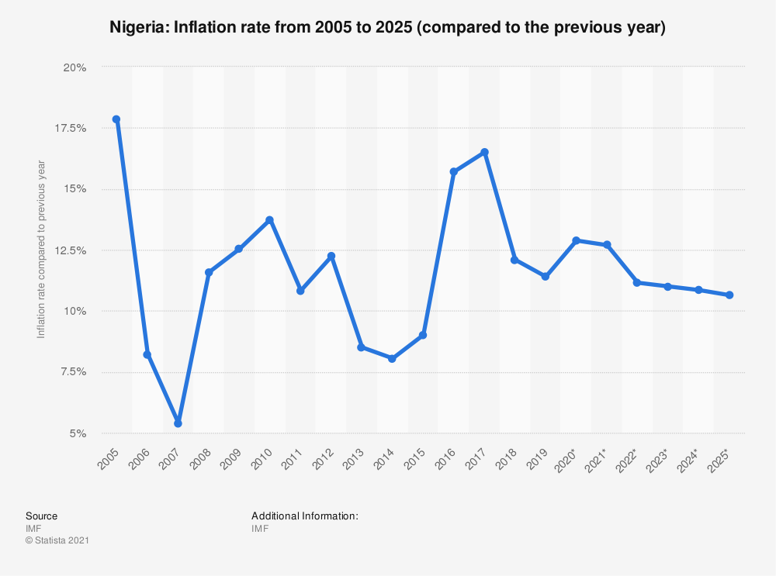
The Naira was another casualty from the drastic fall in oil prices. As oil prices began to fall and the economic downturn ensued, foreign investment began to leave the country, leading to a dump of the Naira and a demand for dollar reserves that were already limited by the reduced oil revenue. Pressure on the Naira forced the Central Bank of Nigeria to devalue the Naira from the target band of 150-160 Naira to Dollar to 160-176 Naira to Dollar by November 2014. By November 2015, further devaluation had driven the currency to 197 Naira to Dollar before the 2016 recession forced an unpegging of the exchange rate, leading to a further 30% devaluation .

Figure 2
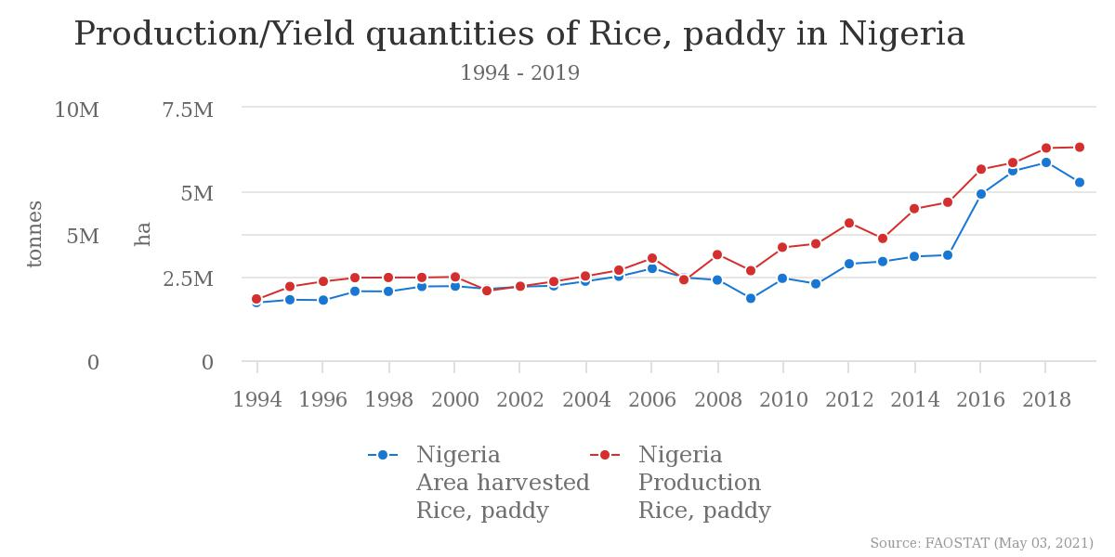
The Central Bank of Nigeria, which controls a significant portion of the exchange of currency in the country, attempted to relieve the deflationary pressure on the Naira by imposing strict requirements on requests for foreign currency exchanges. On June 23, 2015, the Central Bank released a list of 41 items for which importers would not be granted foreign currency to purchase. One of these items was rice and this study focuses on the effect of this restriction on rice prices and production. From Figure 2, we see that national rice production has increased since the implementation of the policy. Rice prices have also increased in the same period. However, it is not clear to what extent the policy is responsible for these changes since rice production was trending positively before the policy implementation and inflation has driven the general price level higher. The study uses a Difference-In-Difference method to remove the national trends from the rice production and price changes and obtain a plausibly causal estimate of the effect of the rice policy. The results find that the policy had no short-term effects on rice production but increased rice prices in the same period. In the long term, both prices and production were increased by the policy.

History of agricultural trade policy in Nigeria
Although oil production has been the largest source of revenue and exports, until recently, agriculture has consistently been the largest employer of Nigerians since its independence. As oil production became the dominant industry in the Nigerian economy, agriculture’s contribution to GDP fell from 69% in 1950 to 49% in 1970 and 22% by 1982 (Oyejide, 1986). Still, agriculture employment remained relatively high, accounting for 64% of the labor force in 1975 and 59% in 1982. Employment in the sector has seen a significant drop in recent times however, employing 50.6% of the labor force in 1990, 45% in 2005 and 35% in 2019.
The trade policy during the early years of Nigerian independence were influenced by the popular import-substitution industrialization theories of the time. Before the oil boom, revenue for industrial expansion was primarily gained from agricultural exports through commodity boards, with export duty levels ranging from 5-60% on key agricultural products (Oyejide, 1986). As oil revenue became available and agriculture began to suffer, export duties were removed from agricultural products. On the import side of things, manufacturing firms were encouraged through heavy import tariffs and restrictions on final goods and very low restrictions, and sometimes subsidies, on raw materials and intermediate goods. For agriculture, this meant heavy import duties on agricultural products but subsidized fertilizer, seeds and machinery (Oyejide, 1986).
As oil prices began to fall in the early 1980s, and spurred the ensuing economic recession, the Nigerian government attempted to relieve the pressure on foreign reserves by requiring import licenses for over 200 commodities (Oyejide, 1986). However, the introduction of the Structural Adjustment Program (SAP) ushered in a new approach to economic development and consequently trade policy. SAP sought to bring about economic progress through free market principles and called for a relaxation of trade controls. The import licensing policies were immediately abolished at the start of the SAP and export prohibitions were abolished for most items (Kwanashie et. Al, 1998). Commodity boards were also dissolved and producers were free to sell directly to the international market. Industrialization and agricultural policy shifted towards an export-oriented focus, though protections for industries were not fully removed. In an attempt to stimulate agricultural production, competing agricultural imports were assigned import tariff rates of 100% or more when most tariffs were set between 10-30% (Moser, et. al., 1997).
The SAP introduced a seven-year tariff structure that helped to harmonize tariff rates across goods and this was further extended in 1995 by another 7 years. However, tariff rates were routinely increased due to balance of payments concerns, which acted against the guiding free market principles of the Structural Adjustment Program. Between 1989 and 1981, import duties on some goods had been raised to between 100 and 300 percent. In 2005, Nigeria joined the Economic Community of West African States (ECOWAS) Common External Tariff (CET) regime. This recommended a four-band tariff structure with 0 percent (for products with social significance, such as medicines), 5 percent (for necessities, raw materials, and some inputs), 10 percent (for intermediate goods) and 20 percent (for finished consumer goods) (Ajayi & Osafo-Kwaako, 2006). An extra tariff band of 35% for imports into strategic sectors was added to the CET in its final version and additional charges like levies, excise and value added tax (VAT) may be assigned to imports, though these may not exceed 70% (International Trade Administration, n.d.).
By 2010-2011, federal policy began to prioritize agricultural production as a source of government revenue and a solution to the overdependence on oil revenues. This led to the Agricultural Transformation Agenda, which aimed to boost production of five key crops in Nigeria: rice, cotton, cassava, sorghum, and cocoa. In collaboration with the African Development Bank, subsidies on agricultural inputs were provided to farmers and private sector lenders were encouraged to provide financing to agriculture investments. The following administration built on this policy with the Green Alternative Plan in October 2016, which implemented pro-agriculture policies like increasing rice tariffs from 10% to 60%.
Theoretical Framework
The economic mechanism that underlies our assumptions about the impact of the rice policy are found in welfare economics. Because of the heavy reliance of exports on oil, a significant amount of the foreign exchange available in Nigeria comes from oil revenue and is in the direct control of the Central Bank of Nigeria. To gain access to needed foreign exchange, banks would need to buy foreign currencies from the Central Bank. The rice policy restricts banks from providing these foreign currencies to individuals and organizations for rice importation.
However, the policy release explicitly states that the policy should not be interpreted as a ban on rice importation, since individuals were free to use foreign exchange gained from other means to import rice. This leads to a significant reduction in the importation of rice, though one can assume that there will still be imported rice in the rice market. As such, viewing the policy as a tariff on rice imports can be helpful in gaining a simple understanding of the effects of the tariff. Much like a tariff, this policy imposes restrictions on rice imports that make them more difficult to purchase. While a tariff does this by raising the price of imported rice, the foreign exchange restriction policy does this by restricting access to the necessary funds for importation. Unlike a quota, which would also have the same effect on the rice market, comparing the policy to a tariff allows for changes in the domestic market to increase the supply of imported rice.

Figure 3
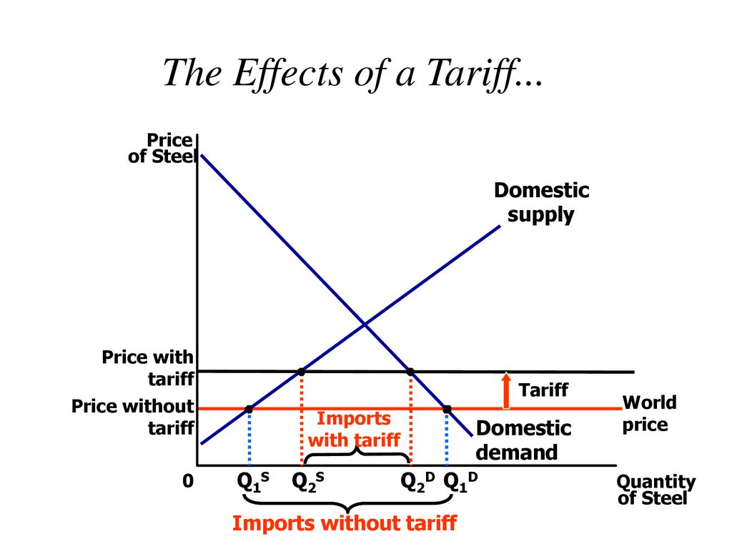
Source: https://slideplayer.com/slide/16128005/
The restriction on the use of foreign exchange for rice imports significantly restricts the importation of rice into Nigeria. This reduction in supply forces the domestic price of rice to move closer to the domestic equilibrium, thus raising consumer prices. Domestic supply also increases because of the new price of rice to take advantage of the higher prices. From this analysis, we expect an increase in the price of rice and an increase in local production. However, this is a simplification of the rice market as rice imports are already heavily tariffed at 60%. Depending on how much the tariff moves the world price closer to equilibrium, there will be a smaller or negligible impact on the domestic price and quantity produced. Illegal importation of rice may also cause rice supply to be higher than expected, leading to short term increases in quantity but less significant increases in the long term. This study aims to estimate the change from the World Price to Price with tariff and Q1s to Q2s shown in the graph above.
Literature Review
To my knowledge, there has been no research to estimate the effect of the 2015 foreign exchange restriction on rice in Nigeria. However, the policy is based on the import substitution policies enacted by developing economies in the mid to late 20th century, and there has been extensive research on the efficacy of these policies and how they distort domestic markets. Anne Kreuger (1974) critically evaluates the rent seeking that foreign exchange manipulations creates and the market inefficiencies that it leads to. Bhagwati (1982) develops on this by introducing an examination of directly unprofitable profit-seeking (DUP) activities and categorizing the possible distortions.
Other researchers have analyzed the effect of foreign exchange controls at a country level. Wilson & Johnson (1972) use the elasticity technique to estimate the welfare effects of the exchange rate regime in Rhodesia (modern day Zimbabwe). Dorsainvil (2000) investigates the effect of distortions caused by the parallel market in Haiti and estimates the monthly welfare loss. Finally, Rosenberg & De Zeeuw (2001) estimate the new welfare loss in Uzbekistan’s multiple exchange rate policy.
This paper will differ from previous research as it is the first to evaluate the foreign exchange restriction on rice imports in Nigeria. The paper will also employ a different model approach, the difference-in-difference OLS model, as opposed to the elasticity technique that is typically employed to determine market distortions from foreign exchange policies.

Data
This analysis uses the Nigerian General Household Survey carried out by the World Bank in conjunction with the Nigeria Bureau of Statistics, Federal Ministry of Agriculture and Rural Development, the National Food Reserve Agency, and the Bill and Melinda Gates Foundation. The survey is a panel dataset that consists of a nationally representative selection of 5,000 households in Nigeria. Households are visited twice during each wave of data collection: once after the planting season between August and October and again after the harvest season between February and April. Data for this analysis comes from the harvest season datasets. Household weights are also included in estimations to accurately represent the national distribution. Data for households that farm either rice or the control group, and not both, will be used for this analysis, since the rice policy would have direct effects on both the control group and rice in those households. The analysis will not use the longitudinal power of the datasets as it is not necessary for a Difference-In-Difference estimation and would only reduce the statistical power of results. To date, there have been 4 waves of data collection: 2010/2011 and 2012/2013, which occurred prior to the implementation of the policy in question, and 2015/2016 and 2018/2019, which were after the policy had been implemented. The policy was implemented in June 2015, a few months before the first visit in the 2015/2016 survey.
The survey provides information on agricultural activities at the household level, including information about quantity harvested and the total value of the harvest. To get the total quantity harvested, respondents were asked how much of each crop they had harvested after the harvesting period. With this data, we can estimate the effect of the rice policy on quantity and on price, using the total value divided by the quantity harvested as a proxy for price per unit. Consumer Price Indexes (CPI) from the Nigerian Bureau of Statistics was also used to calculate real prices for this analysis, with 2011 as the base year.
Control Group
To narrow down on a control group from the number of agricultural products produced in Nigeria, the analysis focuses on five crops that have been explicitly targeted for government support: rice, cassava, sorghum, cotton, and cocoa. The Agricultural Transformation Agenda (ATA), set up in 2011, targeted these five crops to drive the economic diversification away from oil. Ideally, choosing one of the other crops as the control variable would allow us to eliminate the option that other government interventions were responsible for any observed changes in the rice market. However, we cannot completely eliminate the influence of other government policies on rice production. As earlier mentioned, in 2016, with a change in federal administration, the Green Alternative Plan was implemented. Much like the ATA, the plan focused on developing agricultural production, with some crops slated for domestic consumption and others viewed as export crops. Rice falls under the domestic consumption category, cocoa, cassava, and cotton fall under the export category, while sorghum is not a targeted crop under this plan. Since the plan was implemented in June 2016, after the harvest period of the 2015/2016, we can have more confidence in our short-term results. However, long term effects are likely to be less accurate estimates of the true effect of the foreign exchange restriction policy on rice.
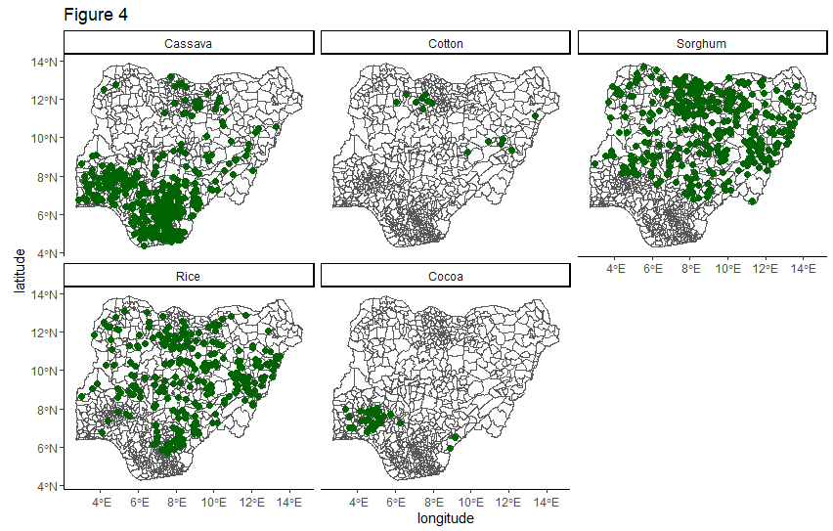
We also take a geographical look at the four possible options for control groups. Ideally, we would want the control group to cover similar areas of the country as rice, so that regional and environmental effects can be eliminated as explanations for the observed effect of the policy. From Figure 4, we see that only sorghum has similar geographical distribution as rice. Cotton and cocoa suffer from a lack of data. Cassava is mainly produced in the south and south-west regions, as opposed to rice and sorghum, which are well dispersed across the north and north-central region of the country. From the geographical distribution, it seems that sorghum would be the best counterfactual crop for this analysis.
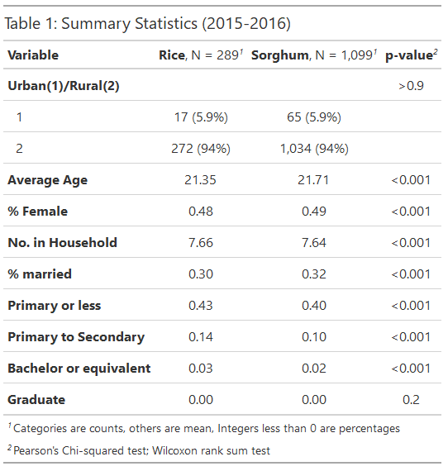
Finally, we look at household demographics to determine the control group for the model. The survey collects demographic data such as age, sex, number of people in each household, education and sector. This information is used to compare the household demographics of rice and the control group. From Table 1, we can see that the households producing rice and sorghum do not differ in economically significant ways. Households are similarly distributed between rural and urban sectors, while the average age and number of people in each household differs by less than 1 point. Education variables suggest that rice households are slightly more educated than sorghum households, though differences are not more than 5 percentage points in any category. Similarly, the percentage of married individuals in each household only differs by 0.02 percentage points. Due to an inconsistency in measurements and the lack of simplified streams of income for most households, data on land area of household plots and income per household are not included in this analysis.
In the Appendix, we also have summary statistic tables for rice versus cocoa, cotton and cassava. For the 2015-2016 wave, there is only one household that produces cotton, which effectively rules out this crop as a control group. In the same wave, there are 153 cocoa-producing households. However, we see significant differences between rice producing households and cocoa producing households. Cocoa households are older by about 9 years with households that are 3 persons smaller on average. Cocoa households also seem to be better educated, with a 15-percentage point difference in percentage of individuals with some secondary school education. There are also 13 percentage points more married couples and 22 percentage points less rural households in cocoa-producing households than in rice-producing households.
For cassava, we see less drastic differences than in cocoa, but much larger differences than in sorghum. Rural populations of cassava-producing households are 7 percentage points smaller than rice, average age is 5 years higher, and the average number of people in households is over 2 persons lower. From this review, it becomes clear that sorghum would be the appropriate choice for the control group, though we must keep in mind the change in agricultural policy after the third wave of surveys for interpretation of our results.
Model
A difference-in-difference regression is used to estimate the effect of implementing the rice foreign exchange restriction policy. The difference-in-difference model allows us to compare not only the change in production and price in rice, but also to compare this change to the change in production and price in a control crop. This allows us to account for the possibility that production and price nationwide was trending in a certain direction, which would have impacted rice whether the policy was implemented or not. The change in production and price among the control group gives us the national trend in production and price movements across agricultural products. When we subtract this from the change in rice production and price, we can observe the true effect of implementing the rice policy.
Based on the distribution of the data from Figure 5, we can see that quantity produced is heavily skewed leftward. Distribution plots for Price can be found in the Appendix. To correct this, a log-level model will be estimated. This will allow the data to fulfill the OLS assumption requiring a normal distribution and will also allow for a percentage change interpretation of results. Below is the difference-in-difference model used to estimate this effect:
$$Log({Quantity)}_{ct}= β_{0}+ β_{1}{Rice}_{c}+ β_{2}{FX Restricted}_{t}+ β_{3}{Rice}_{c}*{FX Restricted}_{t}+ e_{ct}$$
$${Log(Price)}_{ct}= β_{0}+ β_{1}{Rice}_{c}+ β_{2}{FX Restricted}_{t}+ β_{3}{Rice}_{c}*{FX Restricted}_{t}+e_{ct}$$
where ${Rice}_{c}$ is 1 if the household produces rice and 0 if the household produces sorghum, ${FX Restricted}_{t}$ is 1 if the household is from the 2015/2016 wave and 0 if the household is from the 2012/2013 wave, and ${Rice}_{c}*{FX Restricted}_{t}$ as the interaction term which represents the difference-in-difference estimate. Hence, the hypothesis for the model is stated as:
$$H_{0}: β_{3}=0$$
$$H_{A}: β_{3} ≠0$$

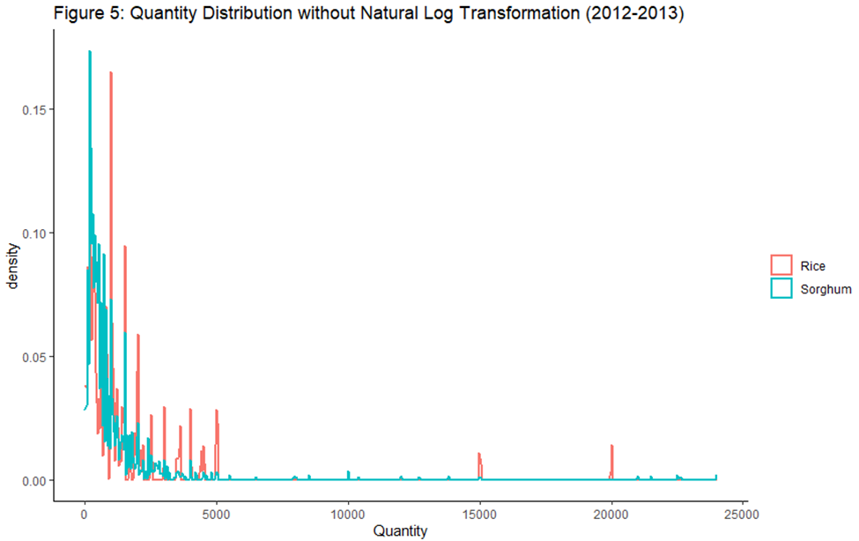
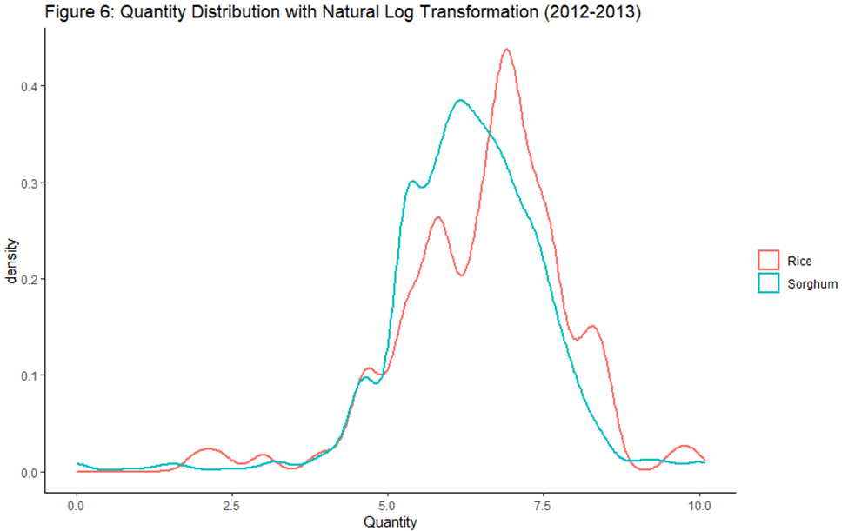

One of the conditions for a difference-in-difference model is that the treatment and control group must have moved in parallel prior to the implementation of the treatment. From Table 2 and Figures 2 and 3, we can observe the movement of rice and sorghum prices over time. For this analysis, we will be primarily considering the inflation-adjusted price of rice. This simplifies the comparisons across time and allows estimates to represent the true change in the value of rice. The consumer price index for the harvest year of each survey wave was used to calculate the real prices, with a base year of 2011.
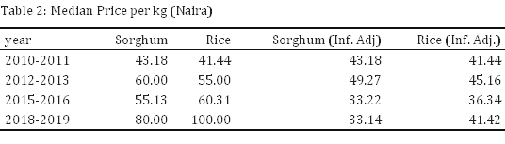
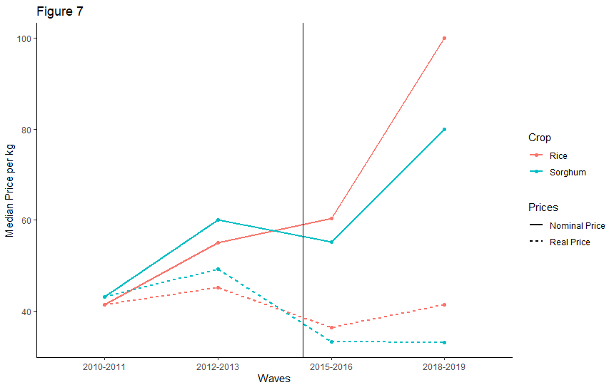

In real terms, prices have fallen since the implementation of the policy. However, we see that nominal prices have risen, which is consistent with theoretical predictions. The fall in real terms suggests that inflation in the general economy significantly outpaced the price increases in the rice and sorghum industry. However, in both nominal and real terms, we see that in the two periods before the rice policy was implemented, sorghum prices were higher than rice prices and both prices were increasing. From then on, real and nominal prices begin to diverge. Real rice prices fall during the first period after the policy was implemented and sorghum prices fall by more, which raises rice prices to a higher level than sorghum. In the second period after the policy, rice prices increased significantly while sorghum prices remained relatively stable.
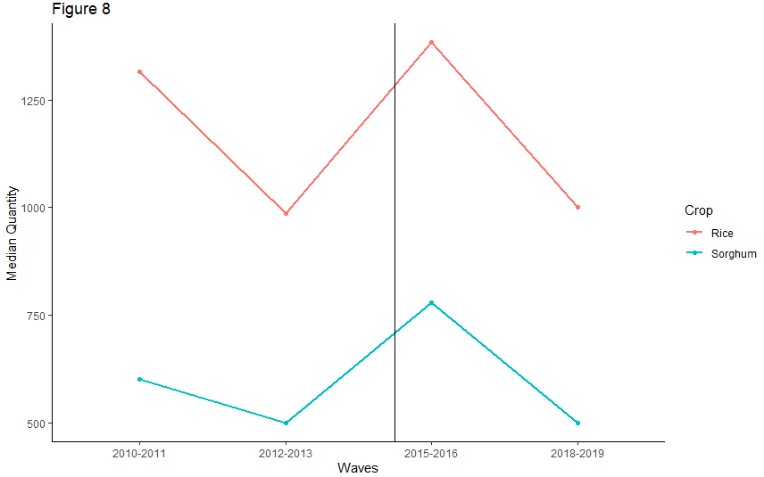
Table 3 and Figure 8 provide data on the movement of the rice and sorghum quantities produced by households. At first glance, it seems that rice and sorghum quantities typically trend in similar directions. However, in the first available period before the policy is implemented, rice quantities are more than double the sorghum quantities and the following period shows a steeper drop in production among rice producers than sorghum producers. The first post period sees production increase for both crops, though there is slightly steeper incline for rice production. Conversely, the following post period shows a slightly steeper decline in rice production and a general decline in production among both groups. As with prices, lack of more pre period makes it difficult to determine parallel trends. Production changes after the policy are less clear from this preliminary analysis.
Regression Results
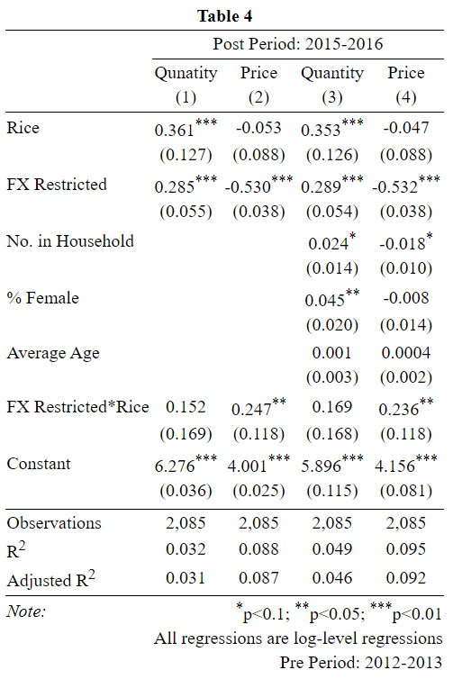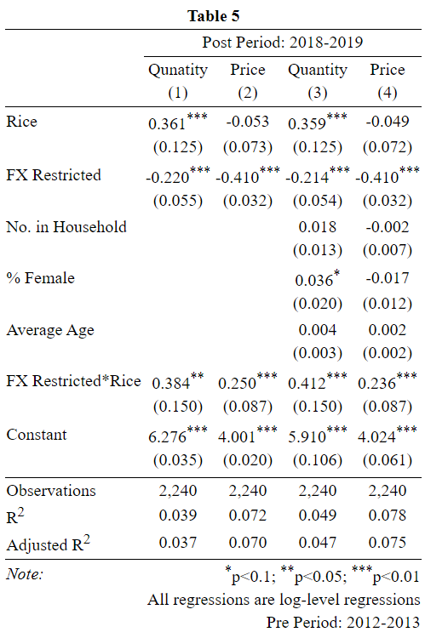
Table 4 shows the results of the difference in difference regression, using 2015-2016 data points as the post period and 2012-2013 data points as the pre period. From this regression, we see that there is a 15.2% increase in rice production as a result of the policy, though these results are not statistically significant. However, we do find significant results in our estimate on the effect on price, with an estimated 24.7% increase in the price of rice due to the rice policy. A model is also estimated that includes the number of people in each household, the percentage of women in each household, and the average age of each household, accounting for the fact that younger and larger households may have productivity advantages, while gender roles in households may either positively or negatively affect productivity. In the models with controls, we do not find significant differences in our estimates. Production increases by 16.9% and is not statistically significant, while price increases by 23.6% and is still statistically significant from zero.
Table 5 estimates the policy effect using the 2018-2019 data points as the post period and 2012-2013 as the pre-period, which provides a longer-term view of the impact of the policy. From this regression, we see that there is a 38.4% increase in rice production because of the policy, and these results are statistically significant. We also find significant results in our estimate on the effect on price, with an estimated 25% increase in the price of rice because of the policy. Estimates with controls slightly differ, with a 41.2% increase in rice production and 23.6% increase in price, with the same levels of significance as the results without controls.
Short Term Effects of Rice Policy
The lack of observed short-term effects on rice production are contrary to the theoretical predictions. Prices have risen, but production has not responded to this price rise. The short-term effect of the policy on production would be highly dependent on how farmers form expectations about prices. If farmers anticipate that prices will rise as a result of the supply constraint caused by the policy, we would expect to see almost immediate short term effects of the policy. However, if farmers depend on observed prices to adjust production levels, then there would be a delayed effect of the policy, as we see in the regression results. Further investigation about the duration of the delay will not be possible in this analysis due to large time intervals between survey waves.
Figure 9: Crop calendars in Nigeria
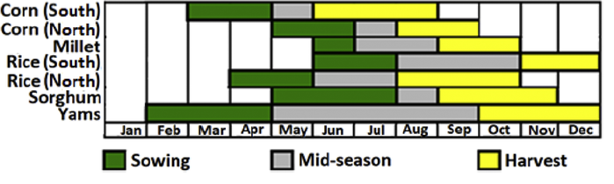Note: Figure from Changing characteristics of meteorological droughts in Nigeria during 1901–2010 - Scientific Figure on ResearchGate. Available from: https://www.researchgate.net/figure/Cropping-season-calendar-of-selected-crops-of-Nigeria_fig3_331550001 [accessed 6 May, 2021]

A potential opportunity to investigate the expectation setting practices of rice farmers is by looking at the different production responses between Northern and Southern farmers. From Figure 9, we see that the cropping or planting seasons are different for rice grown in northern and southern Nigeria: southern rice planting season is June-July, while northern rice planting season is from May-June. The policy was enacted on June 25, so only the southern farmers would have had the opportunity to increase production. If farmers update their expectations based on the knowledge of the rice policy, we would expect to see a significant difference in short term production between northern and southern rice production.
To estimate the difference in regional short-term production, we use the Difference-In-Difference technique. In this model, the control group is northern rice producers while the treatment group is southern producers. The estimated model is:
$$Log({Quantity)}_{ct}= β_{0}+ β_{1}{South}_{c}+ β_{2}{FX Restricted}_{t}+ β_{3}{South}_{c}*{FX Restricted}_{t}+ e_{ct}$$
where ${South}_{c}$ is 1 if the household produces rice in Southern Nigeria and 0 if the household produces rice in Northern Nigeria, ${FX Restricted}_{t}$ is 1 if the household is from the 2015/2016 wave and 0 if the household is from the 2012/2013 wave, and ${South}_{c}*{FX Restricted}_{t}$ as the interaction term which represents the difference-in-difference estimate.
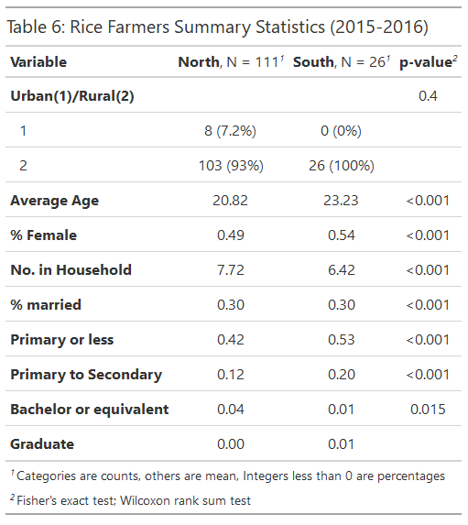
Because this model will only be using rice farmers as the sample, the estimates will likely lack statistical power. From Table 6, we can see that there are only 26 southern rice farmers in the post treatment, hardly a robust representation of the southern rice producing population. However, from this small sample size, we notice some key differences in demographics. Southern rice farming households have 5 percentage points more women and are almost 3 years older on average. There is also one less person in southern households. Southern households seem to be more educated than northern households, though there is a higher percentage of observations with no education data in the northern sample.
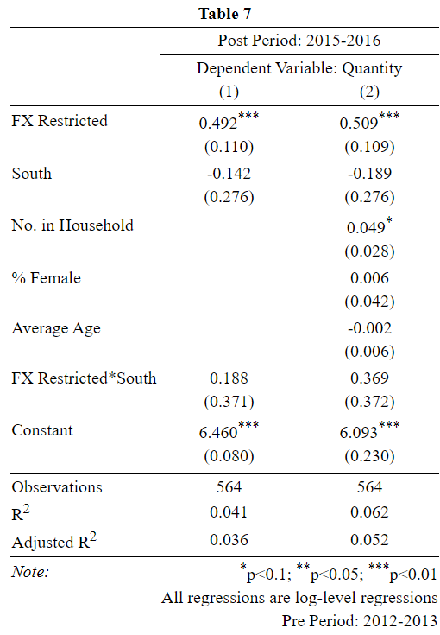
From the regression results, we can see that there are no significant differences between northern and southern rice production in the short term. However, this is likely due to the low number of observations available for this analysis. The positive coefficient of the interaction term suggests that the change in southern rice production was higher than the change in northern rice production, though we cannot conclude on this result due to the lack of significance. If the results truly are insignificant, further research on the expectation formation habits of farmers would provide more information about production responses to the policy. A lack of trust in government, for example, may lead to a hesitancy to adjust production solely based on the news of the policy. There may also have been communication barriers, where access to technology may have prevented news of the policy from reaching rural farmers quickly.
Another implication of the results in Table 4 is that short term price effects should be higher than long term price effects. Since rice producers evidently do not increase production in response to the policy in the short term, there would be a shortage of rice in the short term. Conversely, we observe that rice production increases in the long term. From these results, increased production in the long term should have caused rice prices to fall, leading to a smaller price effect in the long term than in the short term. However, from our analysis we find similar increases in prices over time. One possible explanation for this is gradually stricter implementation of the policy over time. This would have constricted import supply as domestic supply grew, cancelling each other out as a result.
Interpretation and Limitations
The results from the Difference-In-Difference estimation allow us to make causal inferences about the estimates, assuming that the DinD assumptions are sufficiently satisfied. Results are in line with theoretical predictions, suggesting that the policy was successful in restricting the importation of rice enough to generate price and production reactions. From the results, we find that there is no short-term effect of the rice policy on rice production. However, there is a short-term effect on rice prices, estimated at a 23-24% increase. In contrast, the longer-term analysis uses data 3-4 years after the policy was implemented. Farmers have had sufficient time to adjust planting levels and the results reflect the increased production as a result of the policy. This would suggest that there would be a higher price effect in the short-term period than in the longer-term period since rice supply would be lower, but we see that the price effect was similar for both post periods. Thus, a different or supplementary explanation may be necessary for the insignificant effect of the rice policy on quantity produced in the short-term.
Because data is only available for one period before the policy, there is not sufficient evidence to conclusively determine that parallel trends exist. For this period, we also see movements in the same direction for both crops but these movements do not seem to move in parallel to each other, suggesting that prices and quantity of rice and sorghum were moving at different rates. Furthermore, though the dataset used is representative of the nation, it is not representative of the rice market. Because commercial rice farmers are not included in the dataset, only the impact of the policy on smallholder farmers is measured through this analysis. Increases in commercial-level rice production in the first post period could be another explanation for the lower-than-expected price effect of the policy.
Finally, as mentioned earlier, local rice production has been particularly encouraged through subsidies and grants to farmers as part of the Green Alternative Plan. This would serve to increase production, suggesting that the estimates derived from the analysis are likely overestimations of the effect of the foreign exchange policy.
Conclusion and Policy Implications
The Central Bank of Nigeria restricted the use of foreign exchange for rice importation in June 2015, as oil prices began to fall and foreign reserves became scarce. The official edict from the Bank cites this policy as both an attempt to preserve foreign reserves and to boost local production. The study analyzes the local production effects of this policy, using a Difference in Difference model to estimate the effect of the policy on rice production and price. Sorghum was chosen as the control group due to geographical and demographical similarities with rice. The study found significant increases in price one year after the policy was implemented while increases in quantity were not significantly different from zero. However, increases in quantity and price were found to be significant 3-4 years after the policy was implemented.
This provides some evidence that the policy successfully affected rice production outcomes in the intended ways, though there seems to be a delay in its effectiveness. Data limitations as well as confounding factors reduce the confidence in the accuracy in these results. Future studies can improve on this analysis from using data with smaller time delays between observations. An analysis on rice farmers which controls for the government benefits that were received would also allow for more confidence in the accuracy of our results. Finally, for future implementations of similar policies, timing policy implantation with the farming seasons of targeted crops will allow us to better determine the true effect of this policy. The policy may have more immediate impacts as a result, or at the very least, will be able to eliminate one explanation for the lag in the effect on rice production

References
Oyejide, T. A. (1986). The Effects of Trade and Exchange Rate Policies on Agriculture in Nigeria. International Food Policy Research Institute. https://play.google.com/books/reader?id=Lx1WW1VLC1sC&hl=en&pg=GBS.PA7
Mosley, P. (1992). Policy-Making without Facts: A Note on the Assessment of Structural Adjustment Policies in Nigeria, 1985-1990. African Affairs, 91(363), 227-240. Retrieved April 8, 2021, from http://www.jstor.org/stable/723124
Ogbonna, B. C. (2012). Structural Adjustment Program (SAP) in Nigeria: An Empirical Assessment. Journal of Banking, 6(1), 19-40.
Ekwe-Ekwe, H. (1985). The Nigerian Plight: Shagari to Buhari. Third World Quarterly, 7(3), 610-625. Retrieved April 8, 2021, from http://www.jstor.org/stable/3991967
https://www.thisdaylive.com/index.php/2016/10/10/soludo-i-warned-nigeria-about-this-economic-crisis/
Kwanashie, M., Ajilima, I., & Garba, A. G. (1998). The Nigerian economy: Response of agriculture to adjustment policies.
Moser, Gary, Scott Rogers, and Reinold van Til,. Nigeria: Experience with Structural Adjustment, IMF Occasional Paper, No: 148, March 1997
Washington, D.C. : World Bank Group (1994). Nigeria - Structural adjustment program : policies, implementation, and impact (English). http://documents.worldbank.org/curated/en/959091468775569769/Nigeria-Structural-adjustment-program-policies-implementation-and-impact
Ajayi, K., & Osafo-Kwaako, P. (2006). The role of research in trade policy formulation: The case of Nigeria’s adoption of the ECOWAS common external tariff. Unpublished draft. UNCTAD Virtual Institute on Trade and Development.
(n.d.). International Trade Administration. Nigeria - trade barriers. Retrieved April 17, 2021, from https://www.trade.gov/knowledge-product/nigeria-trade-barriers#:~:text=The%20country's%20tariffs%20are%20determined,on%20imports%20into%20strategic%20sectors.
Rosenberg, C. B., & De Zeeuw, M. (2001). Welfare effects of Uzbekistan's foreign exchange regime. IMF Staff Papers, 48(1), 160-178.
Dorsainvil, K. (2000). Welfare effects of exchange controls: An application to the Haitian economy. International Advances in Economic Research, 6(3), 427-437.
Krueger, Anne O. "The Political Economy of the Rent-Seeking Society," American Economic Review, 64, June 1974, pp. 291-303.
Bhagwati, Jagdish. "Directly Unproductive Profit-Seeking (DUP) Activities," Journal of Political Economy, 90, 5, October 1982, pp. 988-1001.
Wilson, E., & Johnson, P. (1976). Welfare and Exchange Rate Effects of the Rhodesian Trade Embargo: An Elasticity Approach. American Journal of Agricultural Economics, 58(4), 721-724. doi:10.2307/1238815
Moon, B. E. (1998). Exports, Outward-Oriented Development, and Economic Growth. Political Research Quarterly, 51(1), 7–36. https://doi.org/10.1177/106591299805100101
Bruton, H. (1998). A Reconsideration of Import Substitution. Journal of Economic Literature, 36(2), 903-936. Retrieved May 4, 2021, from http://www.jstor.org/stable/2565125
Shiru, Mohammed & Shahid, Shamsuddin & Chung, Eun-Sung & Alias, Noraliani. (2019). Changing characteristics of meteorological droughts in Nigeria during 1901–2010. Atmospheric Research. 223. 10.1016/j.atmosres.2019.03.010.

Appendix
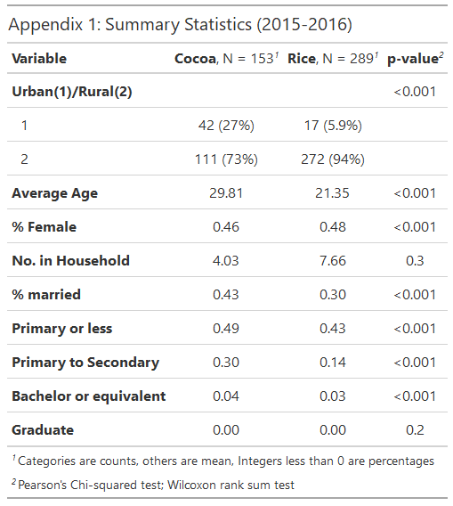

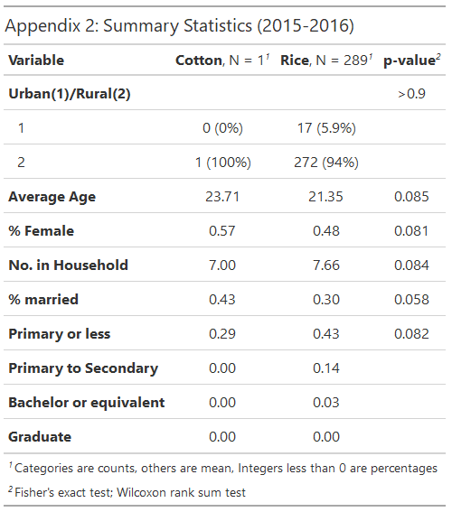

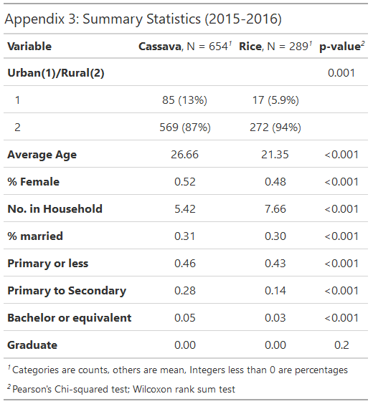

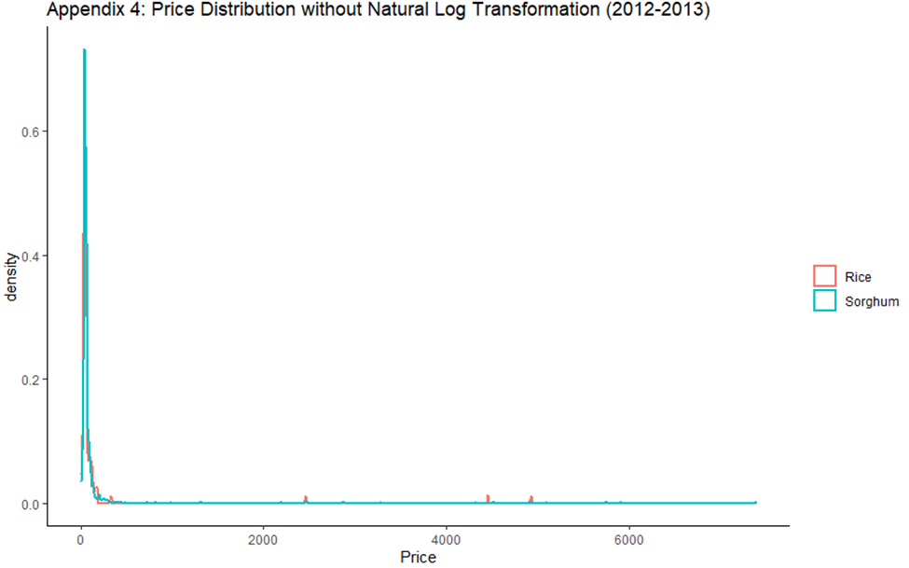
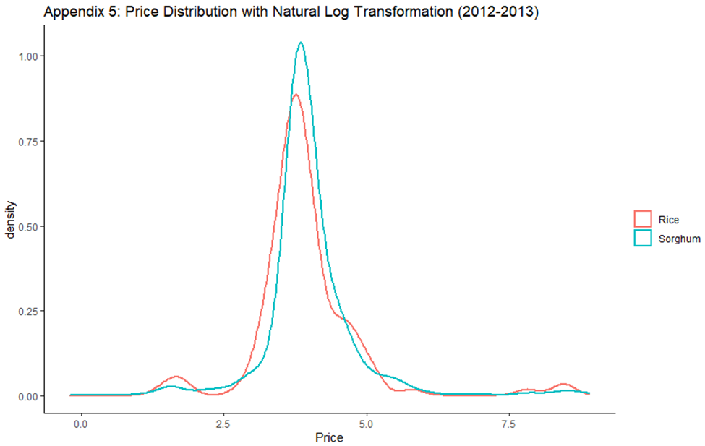

https://www.reuters.com/article/nigeria-currency-idINL8N2K937X
https://www.bls.gov/opub/btn/volume-4/pdf/the-2014-plunge-in-import-petroleum-prices-what-happened.pdf
https://www.macrotrends.net/1369/crude-oil-price-history-chart
https://blogs.worldbank.org/developmenttalk/what-triggered-oil-price-plunge-2014-2016-and-why-it-failed-deliver-economic-impetus-eight-charts#:~:text=The%20initial%20drop%20in%20oil,mid%2D2015%20to%20early%202016
https://www.vox.com/2014/12/16/7401705/oil-prices-falling
https://www.opec.org/opec_web/en/about_us/167.htm
https://www.statista.com/statistics/382366/unemployment-rate-in-nigeria/
https://www.statista.com/statistics/383132/inflation-rate-in-nigeria/
https://www.bbc.com/news/business-30196496
https://www.reuters.com/article/us-nigeria-currency/nigerian-naira-tumbles-30-percent-after-peg-removed-idUSKCN0Z61F7
https://www.bbc.com/news/world-africa-38795673
https://data.worldbank.org/indicator/SL.AGR.EMPL.ZS?locations=NG
https://www.economist.com/middle-east-and-africa/2018/03/15/nigeria-hopes-high-tariffs-will-make-it-grow-more-rice
http://unaab.edu.ng/wp-content/uploads/2012/10/Agricultural%20Transformation%20Blue%20Print.pdf
http://nssp.ifpri.info/files/2017/12/2016-Nigeria-Agric-Sector-Policy-Roadmap_June-15-2016_Final.pdf

