Measuring the Relationship Between Single-Family Zoning Restrictions and Residential Segregation in the Baltimore Region

Abstract
This study uses a fixed effects OLS estimation model to measure the relationship between single-family zoning and neighborhood demographics in the Baltimore region. Studying the effects of Single-family zoning restrictions are not only important because they provide insight around how zoning policy can influence community outcomes, but also can uncover potential policies and practices that can be implemented to improve diversity and affordability of various neighborhoods in Maryland. Specifically, this study will use OLS regression with county fixed effects to measure the effect that an increase in the proportion of single-family zoned properties has on the proportion of a census tract that is occupied by those at the top and bottom of the income distribution.

- Introduction & Significance

Countless political battles within the United States have centered around how land can best be distributed to ensure that all individuals have access to safe, affordable, and well-resourced communities. One of the key tools wielded by those in power to regulate land and establish the infrastructure of our communities is public policy defining land-use and zoning standards. Unfortunately, many groups throughout American history have used zoning policies to control land in a way that enforces race and class-based hierarchies, often having severe consequences in both short and long-term. Zoning policies define the physical conditions under which individuals must live as well as the legal authority they have to change it, and as a result these policies hold immense power and influence over the conditions and outcomes of any community. Even though overt racial segregation considered to have been outlawed, there are still many exclusionary land-use policies in effect that effectively segregate communities based on a variety of social characteristics (inevitably inflicting the most harm onto communities who were already historically marginalized). While many different policies could arguably fit this description, this paper will specifically focus on the way single-family zoning restrictions (commonly referred to as “Single-family zoning”) influence residential segregation in the Baltimore region. Single-Family zoning restrictions restrict residential development in land spaces to that of only single-family homes and associated structures (i.e. traditional suburban homes, playgrounds, churches, etc.), and many theorize that it inadvertently locks out many lower-income and non-white residents that are more likely to use mixed-use and multi-family housing. By examining the effects of Single-Family zoning restrictions on residential segregation, it not only becomes possible to better understand the way this often-overlooked policy affects community outcomes, but also can provide useful information regarding the way zoning policy can be used to decrease segregation in Maryland and improve various social outcomes in Maryland neighborhoods.

- Literature Review
Understanding Single-family zoning restrictions requires both an understanding of the history of segregation in American communities as well as a knowledge of the different methods researchers and organizations have used to measure the presence of segregation and its effects on different communities. While literature specifically examining single-zoning restrictions in Maryland is not widely abundant, a wide range of research exists that details both the history of exclusionary zoning practices within the United States as well as the different methods that researchers have used to estimate segregation. My literature review will first explore the background of single-family zoning restrictions (both historically and in the Baltimore Metropolitan Area), and then will explore some of the techniques that researchers have used over time to measure the prevalence of Single-family zoning and its effects on communities.
Understanding the history of single-family zoning restrictions first requires a review of the different ways zoning policy has been wielded throughout history to influence American communities. U.S. municipalities first began enforcing zoning ordinances in the early 20th century to help standardize growing national land-use and help protect communities from social, economic, and environmental exploitation such as industrial expansion, environmental waste and pollution, and unsafe community infrastructure. Unfortunately, many of the beneficial elements of early zoning policy were overshadowed by the social and political goals of the United States that practically ensured the institutions responsible for enforcing zoning policies would use them to help reinforce racial and economic hierarchies. The Color of Law by Richard Rothstein gives an in-depth look at the different tools and techniques local and state governments used to segregate communities and strip power away from Black and poor neighborhoods throughout the 20th century. According to Rothstein, many U.S. cities in the early 20th century (most notably southern cities) began to adopt explicit racial zoning laws that would divide communities by race, restricting the access these neighborhoods had to various resources and institutions that would give them the ability to compete with white neighborhoods on a social, economic, and political level. Rothstein repeatedly talks about the negative effects of racist zoning policies and the historical roots from which they arose. After the New Deal (about 30 years after states began adopting popular zoning ordinances), state and federal agencies such as the Federal Housing Administration utilized practices like red-lining to give governments the ability to deny black neighborhoods various financial services such as home-loans and even the right to purchase property. Zoning laws like these essentially helped make whiter, wealthier communities more exclusive and difficult to access by black and working-class people. What this suggests is that even though zoning is a useful policy tool that can improve the health and environmental quality of neighborhoods, the socioeconomic philosophies of our most powerful American institutions ensure that many modern U.S. zoning policies directly or indirectly contribute to racism, segregation, and capitalistic exploitation.
Research specifically exploring the history of single-family zoning in Maryland is not widely abundant, but many studies created across various U.S. municipalities can provide a thorough look into both the reason single-family zoning was created as well as the ways researchers have been able to analyze it over time. The single-family home remains an important asset in American culture, and is not only a place of comfort for millions of families, but also an investment vehicle and symbol of social success. In The Color of Law, Rothstein shows that exclusionary policies arose shortly after the U.S. Supreme Court handed down its 1917 decision, Buchanan v. Warley, which eliminated zoning laws that forbade Black people from buying in white neighborhoods. “Economic zoning was rare in the United States before World War I… but the Buchanan decision provoked urgent interest in [single-family] zoning as a way to circumvent the ruling.” (Rothstein, 63). It was not long after the Buchanan v. Warley decision that one of the first single-family zoning restriction policies in the country became adopted in. Marc Weiss’s research on the history of single-family zoning restrictions gives deep insights into the ideologies and incentives that were motivating lawmakers and regular citizens to support these restrictions. According to Weiss, the first single-family zoning restriction policies were adopted in 1916 by planners in Berkeley, California (led by planner Duncan McDuffie) in an attempt to consolidate wealth within certain communities, increase the economic activity of others, and shape California’s districts in a way that best appealed to the sensibilities of upper-middle class white homeowners.
“Berkeley's [single-family] zoning law was primarily designed to protect the developers and owners of large and expensive homes on the east side of the city, and the developers and owners of factories and railroad property on the west side. Requests for protective restrictions that would benefit residents of "old and dilapidated" houses in the west side industrial areas were rejected by the Berkeley City Council in hopes that "the residences within that zone would gradually be abandoned, and the district would become a purely manufacturing locality. The first zoned district created in Berkeley was the single-family residence restriction applied to Elmwood Park. Other zoning actions by the City Council in response to property owner petitions included one which required two Japanese laundries, one Chinese laundry, and a six-horse stable to vacate an older apartment area in the center of town, and another that created a restricted residence district in order to prevent a "negro dance hall" from locating "on a prominent corner." (Weiss, 13)

Ultimately, single-family zoning restrictions were designed to maintain the power and hegemony of wealthy white neighborhoods by segregating communities according to their class and societal access as opposed to their race alone. By limiting the degree of living options available to poor and minority workers, it became possible to push them into underserved communities with exploitative conditions.
Literature on segregation and zoning policy specifically pertaining to the Baltimore region also suggests that exclusionary forms of land-use regulation are influencing segregation and community outcomes. Even after the end of explicit racial zoning laws that barred black residents from white communities, other forms of exclusionary zoning and residential segregation remained longstanding problems within Maryland, and many of these differences can be seen in demographic differences between the more suburban counties and those in Baltimore City. Research performed by the Urban Institute in 2019 reports that the poverty rate in Baltimore City is not only double the national average (23.1% vs 12.7%), but also mainly concentrated within poor Black communities. In Baltimore’s surrounding county (Baltimore county) the poverty rate drops to only 9% (mirroring Maryland’s average which is 9.7%). Other economic features of Baltimore City follow similar patterns, such as the average amount of home loans to low-poverty areas being about $60,000 higher than those of high-poverty areas, or the fact that tracts with African-American populations greater than 85% received almost $30,000 less in commercial real-estate loans (and $10,000 dollars less in small business loans) than communities with African American populations less than 50% . While these issues are reflective of an issue that extends far beyond zoning policy, these statistics suggests that the way in which neighborhoods are constructed and organized is greatly affecting the economic opportunities available to residents. Problems like these have led many organizations in the DC, Maryland, and Virginia area to make demands for various public policies that prioritizes solving issues caused by historical inequality and injustice, many of which call for changes in land-use and zoning policy. By measuring the effect that Single-family zoning restrictions have on economic segregation in the Baltimore area, it becomes both possible to better understand the individual policies responsible for influencing segregation, as well providing useful data to researchers across the state of Maryland on what policies can be implemented to reduce poverty and promote residential development in the area.
As previously mentioned, even though research on single-family zoning restrictions is not widely available for the Baltimore region, the long-lasting effects of these restrictive policies across different cities have still pushed many scholars, researchers, community leaders, and policy makers to develop methods to better understand the effects of single-family zoning restrictions and the different policy solutions that can help solve the issue. The frameworks and models developed by these different groups heavily influenced the way I conducted my own analysis on single-family zoning restrictions in the Baltimore region. The first study that should be mentioned is research done by Donald Jud which sought to measure the effects that exclusionary zoning policy (including single-family zoning restrictions) has on residential property values. Jud utilized a hedonic pricing model to measure the effects that various land-use policies have on single-family properties in North Carolina. One of the variables included in his study specifically measured the effect that single-family zoned property has on pricing values, ultimately concluding that neighborhood land-use patterns significantly affect the value of single-family residential properties, with single-family zoned land having one of the highest positive effects on property values. While many aspects of Jud’s analysis differ from the techniques used in this study, the process used to obtain his estimates provided a useful blueprint for devising different ways to measure the effects of zoning and land-use policies.
The most critical studies referenced for this analysis was research performed by the Othering and Belonging Institute that measured the effects of single-family specifically on segregation. The OBI developed multiple empirical models measuring the propensity of Single-family zoning in the Bay Area as well as the effects that Single-family zoning restrictions had on the social outcomes of community members. Conducted in 2020, their research not only found that over 82% of residential land in the Bay Area operated under single-family zoning restrictions, but also that these areas had higher levels of racial segregation and poverty, suggesting that the predominance of single-family zoning restrictions plays a role in exacerbating segregation and inequality for Bay Area residents. The different statistical techniques used by OBI researchers to construct and estimate causal impact closely mirror the techniques used for the analysis in this study, with slight difference existing in both the unit of analysis and technique used for estimation.
Researchers at OBI began by compiling useful data for measuring the propensity of Single-family zoning and associated restrictions by gathering detailed maps indicating where single-family zoning was located (taken from department of planning). They then created various socio-economic indicators to measure the community demographics of residents in those areas (indicators like income, educational attainment, property values, school performance etc.). This was done by using a multi-index approach that measured segregation by looking at four separate indexes: the Entropy Index, Isolation Index, Dissimilarity Index, and Divergence Indexes (with varying degrees of validity for each measure). Each of these indexes take different statistical approaches towards measuring the degree to which segregation and diversity exist within communities. For example, the exposure index measures the degree to which people see others of different identities in their neighborhood, while the Divergence Index measures the degree to which certain demographics like income and education diverge between neighborhoods. By combining these different indexes and looking at them together, OBI researchers were able to effectively estimate the way segregation in the Bay area had changed over time on a racial, social, and economic level. While many of these steps will be repeated in the analysis for this study, this study will differ from past research specifically in regards to the unit of analysis (Baltimore Metropolitan Area as opposed to the Bay Area) and the indicator variables that will be selected to measure segregation and community outcomes.
Overall, the research and literature reviewed for this study suggests that single-family zoning restrictions and other exclusionary land-use restrictions significantly affect the social outcomes and conditions of communities. Despite these assumptions, no nation-wide data has yielded definitive results about the way Single-family zoning restrictions affect neighborhoods across the U.S. (The technical classifications for Single-family zoning restrictions vary by neighborhood and have been difficult to test across the thousands of counties and municipalities within the U.S.) or specifically within the Baltimore region. By adopting techniques of past researchers and extending my analysis to the Baltimore Metropolitan Area, more information can be uncovered about the wide-ranging impact of Single-family zoning restrictions and potentially provide insight on ways that residential segregation can be improved in both Baltimore as well as other working-class communities across the country. Performing research on the community outcomes associated with single-family zoning restrictions not only provides extremely useful information regarding the way systemic inequality affects communities, but also provides information aid city planners and policymakers in developing new legislation that can eliminate segregation in Baltimore Neighborhoods.

- Data Collection

The aim of this paper is to measure the effects that single-family zoning restrictions have on segregation, and as such the data for this study needed to consist of variables identifying where single-family zoning is present in the Baltimore region, along with variables indicating the demographics and spatial polarization of the community. The Baltimore–Columbia–Towson Metropolitan Statistical Area, or the Baltimore Metropolitan Statistical Area (BMSA) for short, contains the region of Baltimore city along with its surrounding counties. Geographically, the BMSA consists of Anne Arundel County, Baltimore City, Baltimore County, Carroll County, Harford County, Howard County and Queen Anne’s County. The unit of analysis for this research is performed on the census tracts of the BMSA, and data collection for this research was primarily obtained from 2 different sources. Data on Zoning regulations for individual property lots in the BMSA were obtained from the real property data set provided by the Maryland State Department of Assessments and Taxation (SDAT). The SDAT compiles data on most registered property within the state of Maryland as well as data on the zoning regulations attached to each property. The shapefiles contained within the real property dataset were used to calculate how many residential properties are coded with single-family restrictions along with the full BMSA zoning maps (located in appendix A).
Gathering data on community characteristics such as race and income were obtained from the American Community Survey (ACS), an annual survey that compiles annual data on millions of U.S. households on a wide variety of subjects (the specific variables taken for our analysis will be further described in the methodology section). Data for the ACS was obtained using R software with the tidycensus program, a statistical package that allows numerical data from the census to be converted into spatial data that can be fitted to coordinates on a map. After obtaining ACS data from R, the data was then transformed into shapefiles that were imported into QGIS mapping software that could pair the demographic data from the ACS with the zoning maps obtained from the Maryland Department of Planning. Data obtained from Real property data search includes information on the address, residential type, zoning code, and land use classification of all observed properties within the various counties. Data from the ACS survey contained information on race, education, housing costs, income, and racial demographics.
After all zoning and demographic data were outputted into QGIS, maps were created indicating where single family zoning is present in the individual census tracts composing the BMSA. The data from these resulting map files were transferred into comma separated value (CSV) files that were then imported from Microsoft Excel into STATA for regression analysis and interpretation. Data from the ACS survey was taken from the year 2019 and all zoning data has been updated since at least 2021 (zoning codes themselves were established in periods ranging from 2015-2019). Although most data in the dataset was present and accurate, a few problems existed within both the dataset and zoning ordinances themselves, specifically regarding the availability of data and the limitations of the computer technology used to conduct the research. An in-depth discussion of both the limitations in the data set and the strategies taken to overcome them will be discussed further in the limitations section of the paper.

- Descriptive Statistics
Before exploring the methodology of how the effects of single-family were estimated, it is important to provide a brief look at both the properties of the originally collected zoning data as well as the demographic variables that will be used in the analysis. Figure 1 below shows a map of the census tracts that make up the BMSA, while Figure 2 displays a map indicating where single-family zoning restrictions are and are not present. The map in figure 1 shows all 686 census tracts that exist in the BMSA, but only 660 census tracts were used in the final analysis of the study (some structures were removed due to inaccurate information, or not having a special purpose that eliminated the need for traditional zoning codes such as military bases and airfields). It must be noted that the map in Figure 2 is based on land-use codes, meaning that all spaces in the map coded as single-family do not necessarily have a single-family home present in that location. For example, the spaces shaded red in Figure 2 may be a space under construction, a space that recently had its zoning code changed, or some other type of community infrastructure allowed on single-family zoned land such as churches, farmland, or playgrounds. Given these issues, separate maps were created that specifically counted the number of residential properties that have single-family zoning restrictions and were then divided by the total number of residential properties to obtain variables indicating the proportion of single-family zoned property in a census tract. These maps are only included in Appendix B because the extremely large number of points make it difficult to visually distinguish where single-family and non-single-family zoned residential properties are located with the naked-eye (For example, Anne Arundel appears to be majority single-family zoned at first glance, but table 4 in Appendix A shows that only 40% of all residential properties in Arundel have single-family zoning restrictions). A full list of single-family zoning maps for each county in the BMSA are included in Appendix B.

Figure 1:

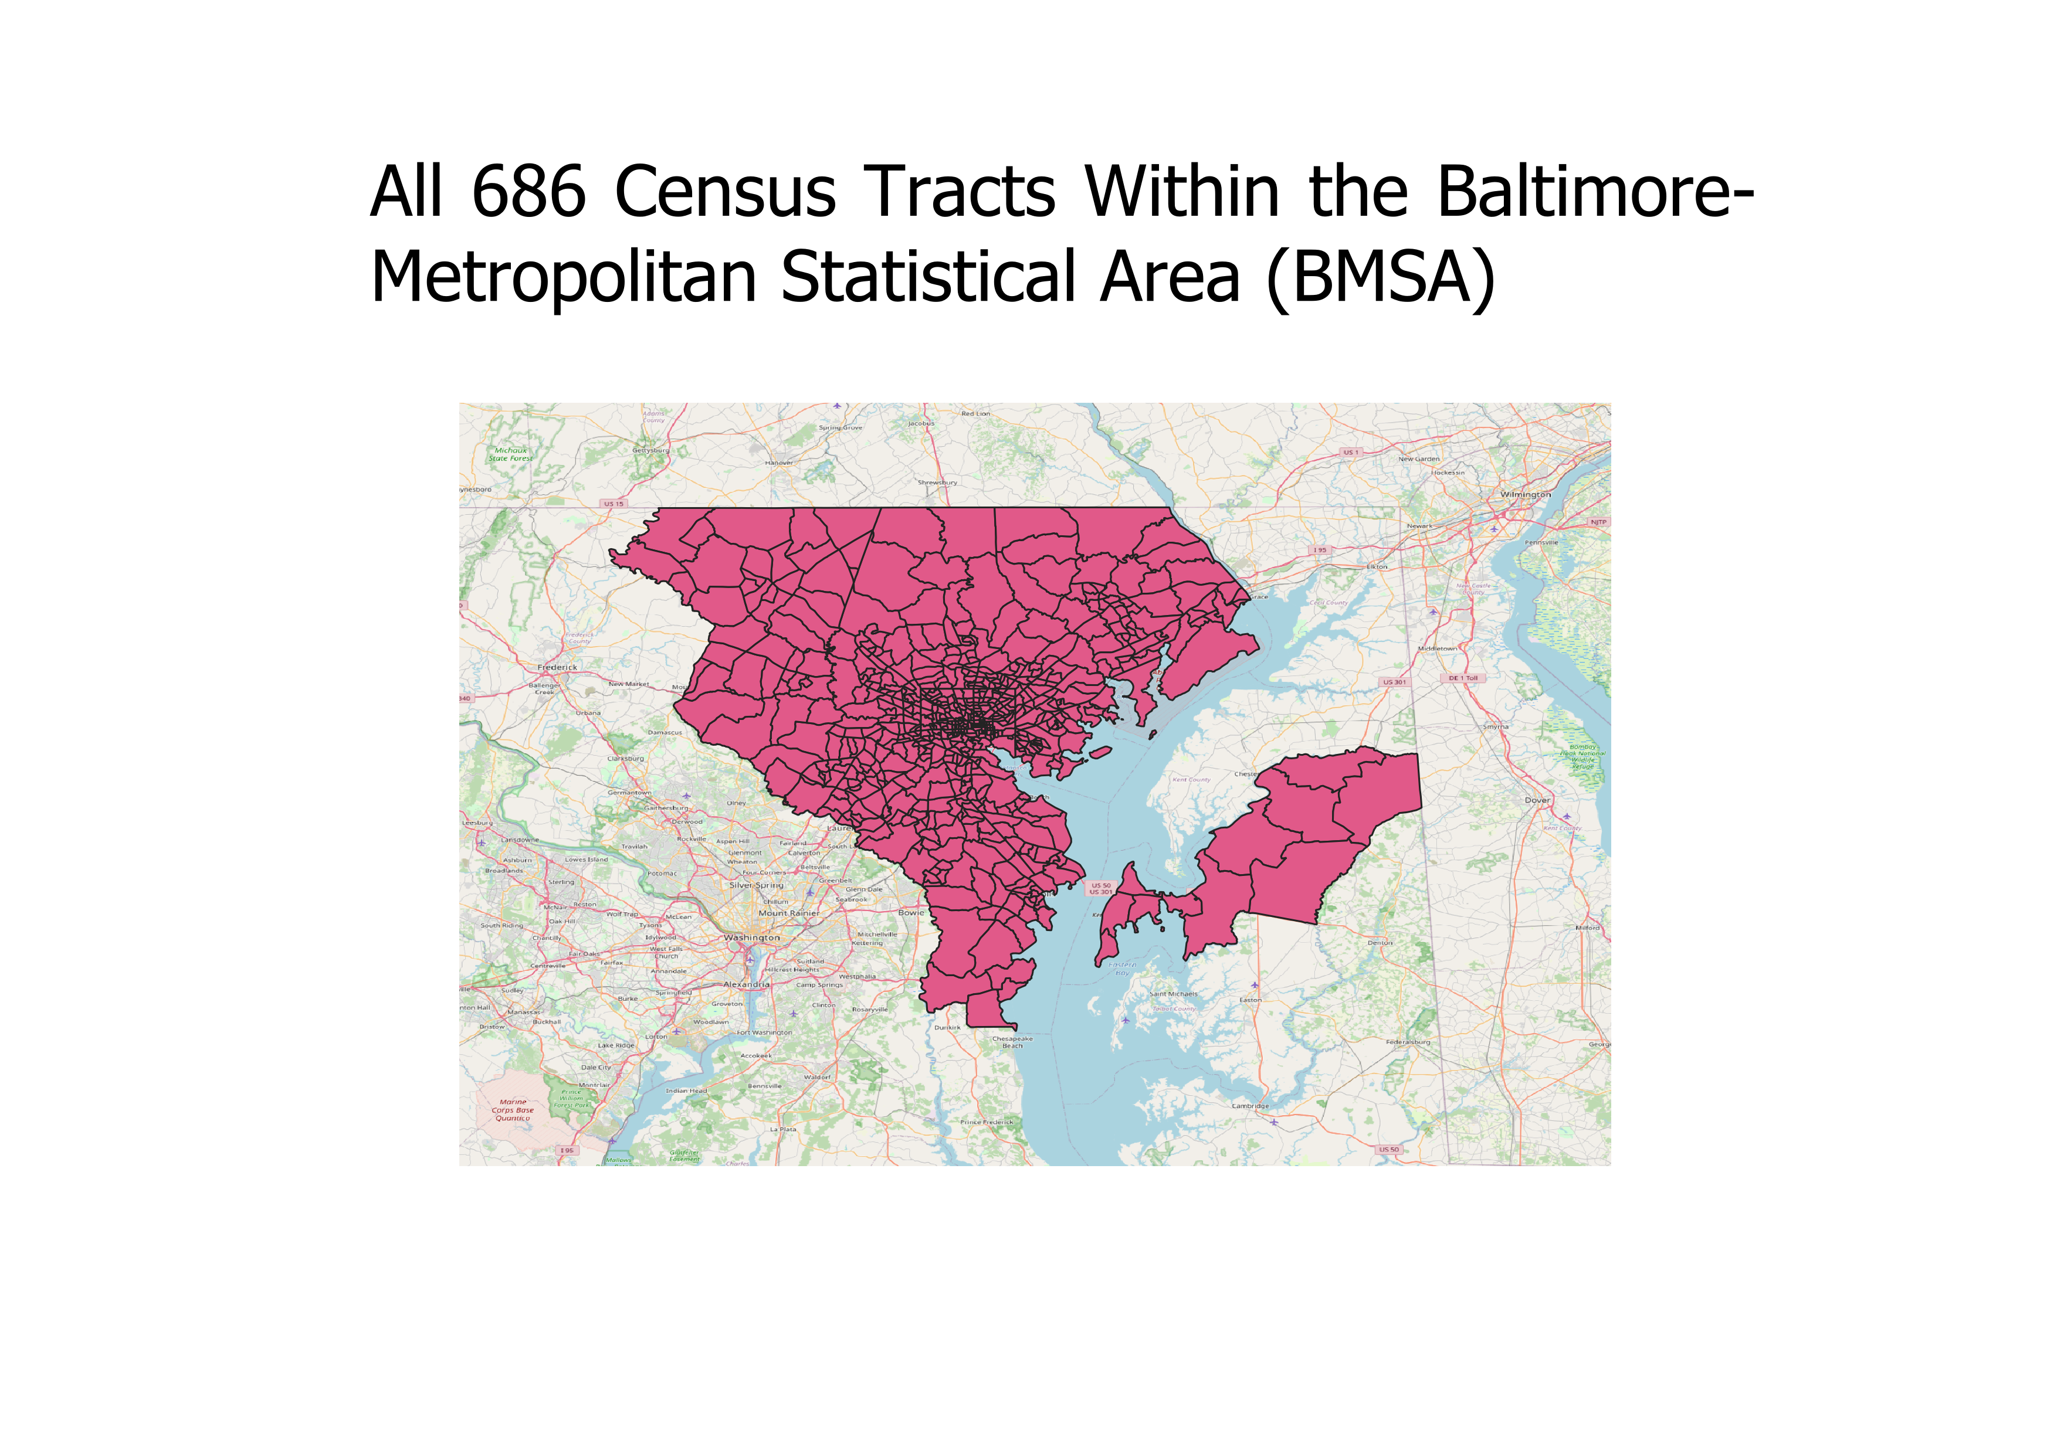
Figure 2: 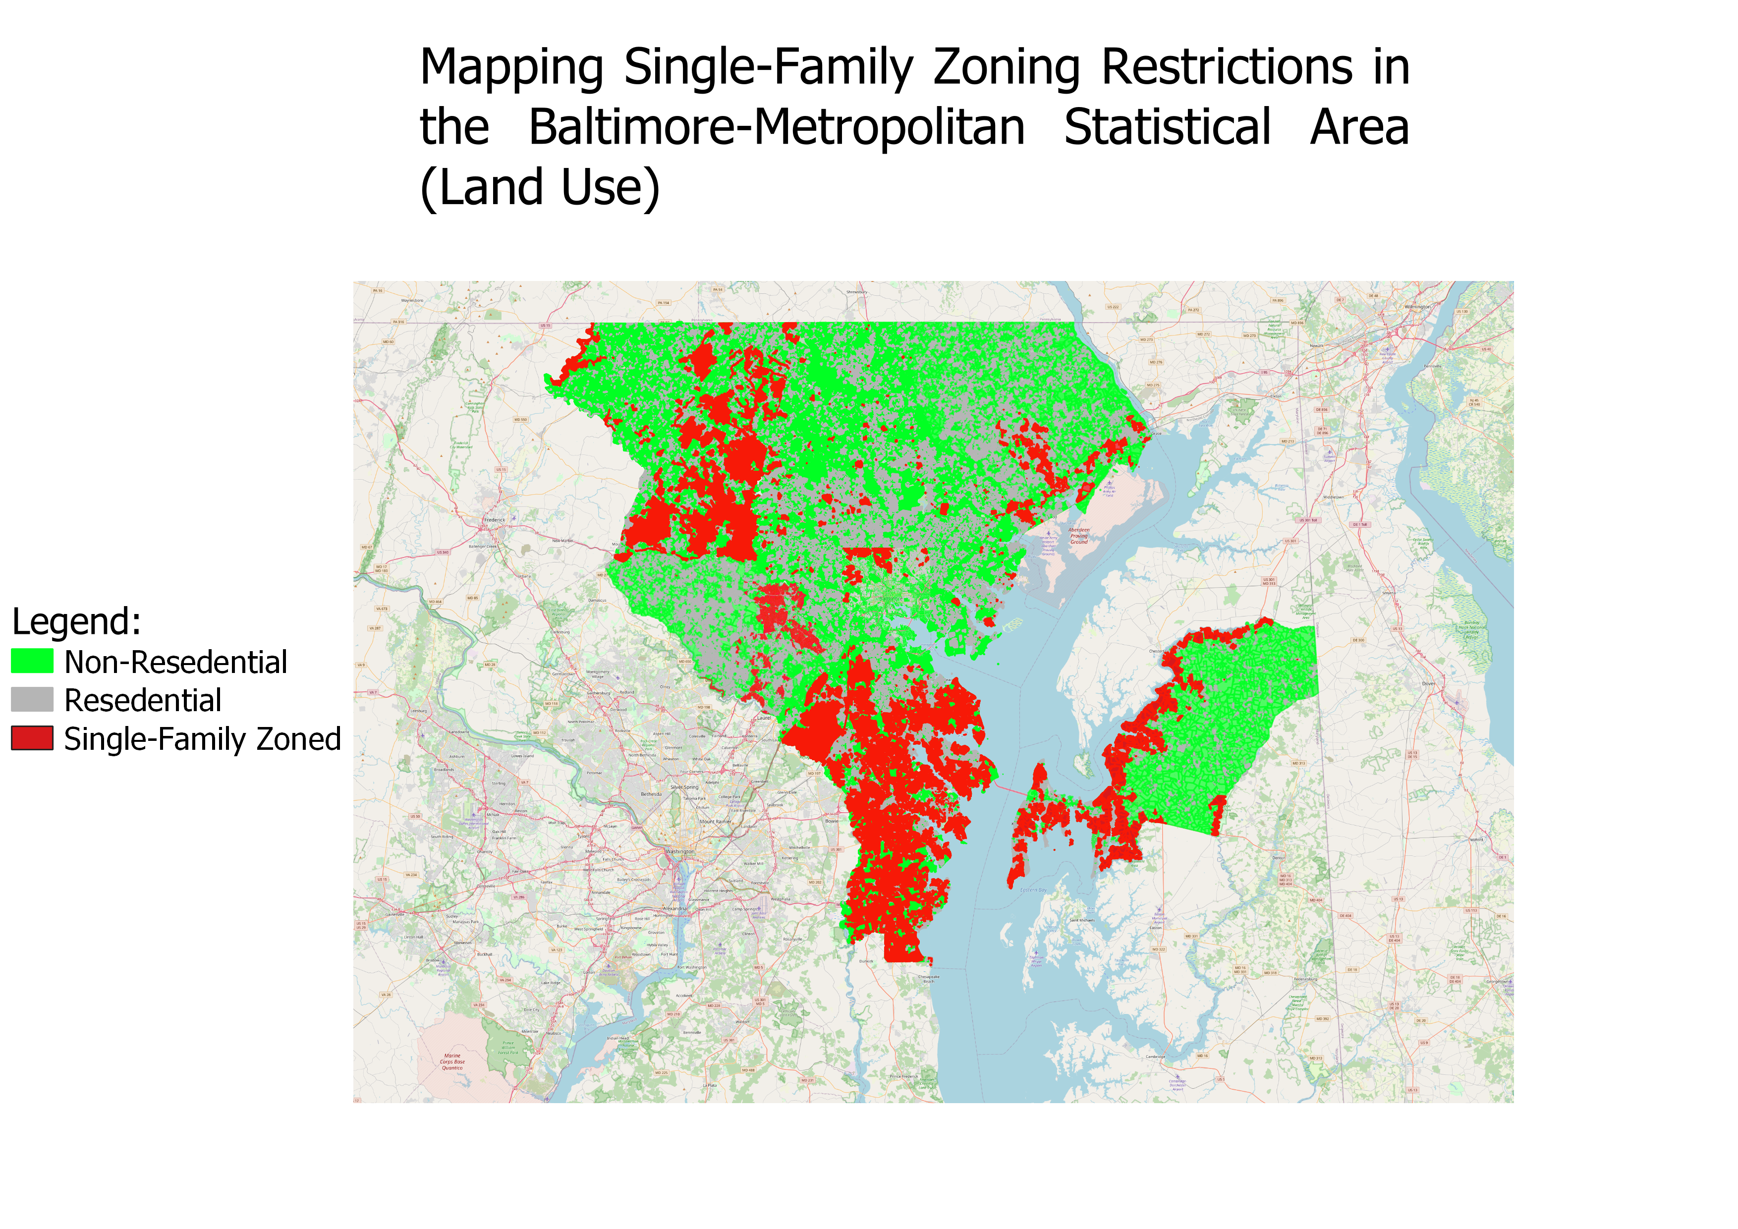
Table 1 displays the variable names and descriptions of all relevant data obtained from the ACS and real property dataset for the 660 census tracts that were used in the final analysis (a full list of all variables obtained for study are available in Appendix A). The goal behind data collection was to obtain variables that provided a comprehensive look into both the prevalence of single-family zoning restrictions and the social demographics that the community is comprised of. To construct variables defining residents who are rich and poor, I used a cutoff point of $30,000 to distinguish the poor from the non-poor, and a cutoff point of $150,000 to distinguish the rich from the non-rich, based on reports from the Pew Research Center that estimate a household of four people needs to make approximately $156,000 a year to be considered high income in the U.S. ($75,000 for a single individual). While there may be some discrepancies between an individual’s income and actual class status, these arbitrary cutoff points help to establish a clear distinction between who can be considered rich and poor within the census tracts (A more detailed discussion about the challenges imposed by these cutoff points is included in the limitations section of the analysis).

Table 1:
Description of Relevant Variables
Variable | Description
- SFZ_Ratio | Proportion of Single-Family Zoning in Census Tract
- ICE | Index of Concentration
- blackprop | % of Census Tract that is Black
- whiteprop | % of Census tract that is White
- Educatedprop | % of population in Census Tract with a bachelor’s degree or above
- Med_houseprice | Median House Price of Census Tract
- Noncitizenpr | % of census tract that are not U.S. Citizens
- Unemployedrate | Unemployment Rate for census tract
- Povertyrate | % of People in Census Tract Living Below Poverty Line
- Gini | Gini Index for Census Tract
- Monthlycost | Median Monthly Housing Cost
- Howard | = 1 if Census Tract in Howard County
- Queen Anne | = 1 if Census Tract in Queen Anne’s County
- Arundel | = 1 if Census Tract in Anne Arundel County
- Harford | = 1 if Census Tract in Harford County
- BaltCounty | = 1 if Census Tract in Baltimore County
- BaltCity | = 1 if Census
- Carroll | = 1 if Census Tract in Carroll County

- Methodology
The methodology for calculating the effect of single-family zoning restrictions on residential segregation will rely on using a standard linear model to estimate the relationship between the proportion of single-family zoned properties in a census tract and the concentration of low-income and high-income residents within a census tract. The specified model was estimated using a multi-step fixed effects OLS model with additional control variables. OLS estimation is a technique that calculates the values of beta coefficients in a way that minimizes the sum of the squares of the differences between the observed dependent variable and predicted dependent variable to measure the statistical effect caused by the independent variables. Ultimately, the goal of using this technique is to estimate how much the dependent variable will increase (or decrease) when our independent variable is increased by 1 unit.
For this study, the chosen independent variable is the proportion of properties in a census tract that are coded with single-family zoning restrictions, while the dependent variable is the Index of Concentration at the Extremes for that census tract. The Index of Concentration at the Extremes (ICE) quantifies the extent to which persons in a specified area are concentrated into the top or bottom extremes of a specified social distribution (in this case, the income distribution). The ICE has been used in various research studies to estimate both the effects of spatial polarization and the impacts of differing treatments on those at the highest or lowest end of a population’s distribution. The Formula for calculating the index of concentration is as follows:
ICE_{i} = (A_{i} – P_{i}) / T
A = total population at highest extreme (i.e. affluent population)
P = total population at lowest extreme (i.e. poorest population)
T = total population (i.e. all income-earners)
i= observation in question (i.e. census tract)

The ICE measure takes on a value ranging from -1 to 1, with a value of 1 indicating that 100% of the population belongs to the highest extreme (100% of population is high-income) and a value of -1 indicating the opposite. The ICE measure allows for a great amount of variation even within a small dataset as well as requiring relatively few variables to calculate. By combining the ICE measure with OLS regression, it becomes possible to estimate the effect that single-family zoning restrictions have on the distribution of the lowest and highest income groups in a population, signaling whether more single-family zoning restrictions increases disparities within the distribution between the richest and poorest residents in a census tract.
OLS estimation for this project will take place over 4 separate steps. The first step will be a simple regression between the main dependent and independent variable, the second step will add demographic controls to the estimation, and the final third step will add both controls and interaction terms. After performing statistical regression, hypothesis testing was performed to measure significance within the model. The theoretical model for the study relies on estimating the relationship between the proportion of single-family zoning restrictions in a census tract and the ICE corresponding to that in a census tract, which will then be repeated several times across the different models using added fixed effects and demographic controls. The theoretical model for estimating this relationship is shown below:

OLS Estimation:
$$Y=B_{0}+{X_{1}(B}_{1})+X_{2}\left(B_{2}\right)+…{ X}_{n}{(B}_{n})$$

Model 1: Basic Model
$$ICE=B_{0}+{SFZ_Ratio(B}_{1})$$

Model 2: County Fixed Effects
$ICE=B_{0}+{SFZ_Ratio (B}_{1})+Howard{(B}_{2})+AnneArundel{(B}_{3})+ Carroll{(B}_{4}) BaltCounty{(B}_{5})+ Harford{(B}_{6})+ QueenAnne{(B}_{7})$

Model 3: Fixed Effects w/ Controls
$ICE=B_{0}+{SFZ_Ratio (B}_{1})+ Whiteprop{(B}_{2})+Blackprop{(B}_{3})+Educatedprop{(B}_{4})+ Higheducated{(B}_{5})+Med_age{(B}_{6})+ noncitizenpr{(B}_{7})+Howard{(B}_{8})+ QueenAnne{(B}_{9})+ Harford{(B}_{10})+ Carroll{(B}_{11})+BaltCity{(B}_{12})+ BaltCounty{(B}_{13})$

Model 4: Fixed Effect, Controls, and Additional Variables of Interest
$ICE=B_{0}+{SFZ_Ratio (B}_{1})+ Whiteprop{(B}_{2})+Blackprop{(B}_{3})+Educatedprop{(B}_{4})+ Higheducated{(B}_{5})+Med_age{(B}_{6})+ noncitizenpr{(B}_{7})+ Unemployment{(B}_{8})+ Gini{(B}_{9})+ Monthlycost{(B}_{10})+ Med_Houseprice{(B}_{11})Howard{(B}_{12})+ QueenAnne{(B}_{13})+ Harford{(B}_{14})+ Carroll{(B}_{15})+BaltCity{(B}_{16})+ BaltCounty{(B}_{17})$

Performing OLS analysis in this way can provide an estimation of the relationship between single-family zoning and the distribution of the lowest and highest income earners across these neighborhoods. If a positive relationship exists between these variables it implies that a higher amount of single-family zoning restrictions in a census tract is associated with an increase in the number of high-income earners in the area while simultaneously associated in a decrease in the number of low-income earners (a proxy for estimating segregation). OLS estimation was chosen both due to the practicality and simplicity of using OLS to estimate linear relationships between two variables. By performing the analysis on the census tract level (increasing the number of observations to 660 as opposed to 7), using OLS estimation on interval-ratio data such as the proportion of single-family zoned properties and the ICE can provide sufficient estimators regarding the effect of single-family zoning on residential segregation. It should be noted that the variables for income are based on individual income (not household income) and are calculating the number of residents earning up to a certain income as opposed to holding a certain amount of wealth. This choice to only observe wage-earners may leave out a number of poor and wealthy households that do not earn income, but was still chosen in order to provide consistency among the individuals being observed (no data was available distinguishing retirees from those with inheritances, parental support etc.). The limitations section of this study will provide a more in-depth discussion about the obstacles faced in the statistical analysis process.
The hypothesis for this research is that single-family zoning restrictions influence residential segregation, and as such the hypothesis for the empirical model is that census tracts with higher proportions of single-family zoning restrictions will significantly increase the estimated ICE value for that area even when controlling for other demographic variables. If this hypothesis is correct, this would mean that single-family zoning restrictions significantly affect the economic makeup of a community, suggesting that it has some significant effect on the spatial distribution of neighborhoods. The structure of the performed hypothesis test is displayed below.
H₀: SFZ_Ratio = 0
H₁: SFZ_Ratio ≠ 0
If the null hypothesis for this model is rejected, it can be concluded that single-family zoning restrictions significantly increases (or decreases) the proportion of the highest-income residents in a census tract while simultaneously decreasing (or increasing) the number of the lowest-income residents.

- Results
The results for both the summary statistics and the OLS regression estimates are reported in Tables 2 and Table 3 respectively (a full list of summary statistics for all obtained variables are located in Appendix A). The summary statistics show that overall single-family zoning across the BMSA is not highly prevalent, with the mean value for the proportion of single-family zoned property being only 14% for all census tracts. Table 2 also suggests that income is distributed evenly across many census tracts, with the mean value of the ICE variable being only 3.8%, suggesting that on average, most census tracts are not heavily skewed towards the lowest or highest income distributions. For the regression results reported in Table 3, all 4 models estimate both a significant and positive relationship existing between the ICE and the proportion of single-family zoned properties in a census tract, but the significance and strength of that relationship becomes weaker when the various control variables were added into the regression. For models 1 and model 2, all variables were estimated to be both positive and significant (p-value < 0.01), but significance was weakened for several variables when control variables were added into the estimation. More specifically, significance did not exist for variables indicating the proportion of Black residents in a census tract, the median age of residents within a census tract, and the county dummies for Carroll County and Queen Anne’s County (2 of the smallest counties in the dataset by population).
In model 1, it is estimated that single-family zoning restrictions has a very strong effect on income distribution. Model 1 suggests that a 1 unit increase in the proportion of single-family zoning is associated with a 37% increase in the ICE, meaning that 37% more of the census tract will belong to the highest income distribution as opposed to the lowest-income distribution. In model 2, the added county fixed effects slightly reduce the value of the independent variable, but all variables are still estimated to have a significant and positive effect on the index of concentration. In the model 3 estimates, the effect of single-family zoning restrictions on the index of concentration becomes much smaller, although it is still significant at the 1% level, suggesting that controlling for race and education will decrease the estimated effect these zoning restrictions have on the income distribution of a community. When performing estimation for model 4 however, the estimated effect of single-family zoning on the index of concentration becomes much weaker, with the coefficient being below 0.05 and only significant at the 10% level. Given these estimates, the null hypothesis (SFZ_Ratio = 0) can be rejected, indicating that a greater number of single-family zoning restrictions do significantly alter the income distributions of a neighborhood in favor of those with higher income, but when factors such as housing price and poverty are held constant, the overall effect that single-family zoning restrictions will have on a community will be much smaller.
Ultimately, all of this information suggests that single-family zoning restrictions are correlated with the income distribution of a neighborhood, but the underlying causes driving that spatial separation may be stemming from other aspects of a community such as the price of housing and the educational attainment of that community. While these estimates do suggest that single-family zoning is correlated with segregation, the results of these estimates are not sufficient for establishing a causal relationship between the two variables.

Table 2: Summary Statistics
Summary Statistics
Variable | Obs | Mean | Std. Dev. | Min | Max
ICE | 660 | .038 | .267 | -.742 | .777
SFZ Ratio | 660 | .144 | .289 | 0 | 1
Whiteprop | 660 | .583 | .312 | 0 | .988
Blackprop | 660 | .32 | .325 | 0 | .993
Educatedprop | 660 | .296 | .136 | .001 | .671
Med age | 660 | 39 | 6 | 18 | 68
Monthlycost | 660 | 1480.747 | 472.881 | 289 | 4001
Noncitizenpr | 660 | .044 | .047 | 0 | .291
Gini | 660 | .414 | .068 | .054 | .725
Povertyrate | 660 | .116 | .11 | .004 | .589
Unemployrate | 660 | .058 | .045 | 0 | .276
Med_houseprice | 654 | 284937.16 | 148751.1 | 34700 | 921200
Howard | 660 | .083 | .277 | 0 | 1
QueenAnne | 660 | .017 | .128 | 0 | 1
Arundel | 660 | .15 | .357 | 0 | 1
Harford | 660 | .083 | .277 | 0 | 1
Carroll | 660 | .053 | .224 | 0 | 1
BaltCounty | 660 | .32 | .467 | 0 | 1
BaltCity | 660 | .294 | .456 | 0 | 1

Table 3: Regression Output
 | (Model 1) | (Model 2) | (Model 3) | (Model 4)
Variables | Basic OLS | County Fixed Effects | Added Controls | Additional Variables of Interest
SFZ_Ratio | .37*** | .299*** | .056*** | .027*
 | (.033) | (.038) | (.018) | (.015)
Howard County |  | .471*** | .066*** | .017
 |  | (.031) | (.019) | (.015)
Queen Anne’s County |  | .318*** | .027 | -.031
 |  | (.061) | (.03) | (.024)
Arundel County |  | .288*** | .044*** | -.017
 |  | (.028) | (.015) | (.012)
Harford County |  | .289*** | .071*** | .018
 |  | (.03) | (.016) | (.013)
Carroll County |  | .131*** | .035 | -.02
 |  | (.046) | (.023) | (.018)
Baltimore County |  | .259*** | .072*** | .015
 |  | (.02) | (.011) | (.009)
White Population (%) |  |  | .223*** | .165***
 |  |  | (.072) | (.056)
Black Population (%) |  |  | .094 | .091*
 |  |  | (.07) | (.054)
% With College Degree |  |  | .43*** | .177***
 |  |  | (.041) | (.034)
Median Age |  |  | .002*** | -.001
 |  |  | (.001) | (.0004)
Monthly Housing Cost |  |  | 0*** | 3.84e⁻⁰⁷***
 |  |  | (0) | (4.48e⁻⁰⁸)
Poverty Rate |  |  |  | -.691***
 |  |  |  | (.045)
Median House Price |  |  |  | .0002***
 |  |  |  | (00001)
_cons | -.015 | -.207*** | -.863*** | -.491***
 | (.011) | (.014) | (.073) | (.061)
Observations | 660 | 660 | 660 | 654
R-squared | .161 | .454 | .887 | .931
Standard errors are in parentheses
*** p<.01, ** p<.05, * p<.1

- Limitations
Several limitations exist within the dataset that affected both the way the analysis was conducted as well as the outcomes obtained from the results. The biggest limitation of the data is in regard to the size of the dataset. The BMSA only consists of 7 counties, meaning that the estimates obtained in the regression results may only apply to this specific section of the state (not to mention that the BMSA is surrounded by several small and large cities whose density discourages the use of single-family zoning restrictions). While data calculating the proportion of single-family zoned properties across the entire state of Maryland would yield more conclusive results (along with much more variation across census tracts) statistical limitations pertaining to the statistical software prevented the study from reaching this scale (i.e. my computer would crash when more than 10 counties were merged into QGIS, much less than the 23 counties comprising the state of Maryland). This lack of data not only meant that the analysis would have to be conducted on a much smaller subset of the population, but also meant that using some of the more traditional measures of segregation presented in past literature was not possible. This issue could easily be improved by increasing the number of counties included in the analysis, limitations in the technology used to conduct the analysis prevented a large number of counties and census tracts from being added to the analysis. To overcome this issue in the analysis, it was decided that a different measure would be used to estimate the level of spatial cohesion among different economic classes (whether a community was majority rich). Improving the technology used in the analysis could allow for more variation to be added into the dataset, meaning that more trusted and traditional measures for segregation could be used to estimate the effect of our variable of interest.
The second biggest limitation of this analysis concerns the variable chosen to represent segregation and income. Since traditional measures for segregation (such as the dissimilarity index) could not be used, it was decided that the variable representing segregation would be the index of concentration of the extremes, a measure indicating the spatial polarization of those with the highest and lowest incomes in the population. This estimate leaves out poor and rich residents who are not wage-earners (such as people with inheritance, the homeless, retirees, etc.), meaning that the effect of single-family zoning restrictions remains unknown specifically when it comes to these groups (many of which happen to make up some of the least and most wealthy groups in the country). As stated previously, leaving out these observations may slightly alter estimates, but a sizeable portion of adult residents in the census tracts were found to be wage-earners, meaning that the obtained estimates can still estimate the effect of the treatment variable on a within the dataset.
Lastly, limitations existed within the analysis regarding the way rich, non-rich, poor, and non-poor residents were selected in the data collection process. Even though multiple studies were consulted to estimate an income cutoff point for different economic classes that was commensurate with estimates for what makes one poor or rich in the U.S., this arbitrary decision prevents the research from portraying the full reality about a residents economic standing. Many residents making over $150,000 a year may not be considered rich if they face a very high cost of living (or face issues like high medical and student debt), and individuals making under $35,000 a year may not be considered poor if they have other sources of economic support to rely on (e.g. parents, inheritances, etc.). What this means is that the variable estimating whether a census tract is majority populated by rich or poor individuals is based purely on the nominal wages earned by those individuals and not the real value of their income.
Overall, the technological and statistical limitations of this study could be improved upon by both improving the technology used to perform the research and expanding the specified unit of analysis. More sophisticated hardware would allow for more zoning maps to be placed together for analysis, meaning that the entire state of Maryland (or larger) could be added to the analysis. A higher sample size of counties would mean that a greater level of variation could exist within the dataset, allowing for traditional measures of segregation to be tested against the proportion of single-family zoned properties. Measures such as the income dissimilarity index and entropy index could not be used within the analysis because the index measure could only be counted at the county level (meaning only 7 different scores would exist for all census tracts), but these measures could provide more reliable estimates for determining the spatial separation between rich and poor individuals residing in a census tract. As it currently stands, the analysis can only uncover a correlation between single-family zoning and neighborhood income distribution, but by increasing the sample-variation and improving the hardware used to conduct the analysis it can become possible to accurately estimate a causal relationship existing between single-family zoning restrictions and segregation.

- Conclusion & Policy Recommendation
In conclusion, the results of this study suggest that a correlation does exist between single-family zoning restriction policies and residential segregation. Specifically, it was estimated that an increase in the proportion of single-family zoned properties in a census tract is associated with a significant increase in the proportion of residents making the highest amount of income in that area with an associated decrease in those making the lowest amount of income. It is estimated the relationship between single-family zoning and residential segregation is not as strong when factoring in other variables like education, housing prices, and income inequality. Even though these additional controls weakened the estimated relationship between the variables of interest, it is still suggested that single-family zoning restrictions significantly alter the income distribution of neighborhoods. Despite these findings however, the limitations present in the statistical analysis suggest that further research needs to be conducted in order to establish a causal relationship between the variables of interest. More specifically, this study could be expanded by increasing the cross-county variation within the sample and improving the statistical software used to perform spatial analysis (and the other suggestions mentioned in the limitations section), which would serve the purpose of allowing more traditional measures of segregation to be used in the regression analysis.
Based on the results of this study, zoning restriction policies in the Baltimore region should be more thoroughly reviewed to determine if these exclusionary zoning policies do indeed contribute to residential segregation. Should it be found that a causal relationship does exist, it would be suggested that single-family zoning restriction policies be removed to allow for multi-use development within areas across the Baltimore region and the state of Maryland as a whole. If it is found that a causal relationship does not exist, more research should be conducted to uncover what specific policies should be implemented or removed to best reduce residential segregation in the region. Overall, the direct effects of single-family zoning restrictions on residential segregation in the Baltimore region remain unknown, but it is clear that the correlation existing between these two variables provides sufficient reasoning for furthering research on the topic.
Appendix
Appendix A: Additional Tables

Table 1: Variable Names & Descriptions (Full Table)
Descriptive Statistics (Full)
name | Variable Description
geoid | geoid
name | Name of Census Tract
total_pop | Total Population
black_pop | Black Population
black_inc_ | black_inc_
white_pop | White Population
white_inc_ | Median White Income
incunder10 | Population w/ income under $10,000
x10kto15k_ | Population w/ income between $10k and $15k
x15kto20k_ | Population w/ income between $15k and $20k
x20kto25k_ | Population w/ income between $20k and $25k
x25kto30k_ | Population w/ income between $25k and $30k
x30kto35k_ | Population w/ income between $30k and $35k
x35kto40k_ | Population w/ income between $35k and $40k
x40kto45k_ | Population w/ income between $40k and $45k
x45kto50k_ | Population w/ income between $45k and $50k
x50kto60k_ | Population w/ income between $50k and $60k
x60kto75k_ | Population w/ income between $60k and $75k
x75kto100k | Population w/ income between $75k and $100k
x100kto125 | Population w/ income between $100k and $125k
x125kto150 | Population w/ income between $125k and $150k
x150kto200 | Population w/ income between $150k and $200k
incover200 | Population w/ income over $200k
monthlycost | monthly housing cost
highschool | Population w/ a highschool diploma
associates | Population w/ associates’ degree
bachelors_ | Population that has obtained a bachelor’s degree
masters | Population that has obtained a master’s degree
profession | Population that has obtained a professional degree
doctorate_ | Population that has obtained a doctoral degree
employed_e | Population that is employed
unemployed | Population that is unemployed
laborforce | Population in laborforce
gini | Gini Index for census tract
povertypop | # of people in population who live under the poverty line
med_houseprice | Median house price
noncitizen | # of non-U.S. citizens in census tract
med_age | Median age
educated | educated
educatedprop | Proportion of population with at least a bachelor’s degree
higheducatedprop | proportion of population that has obtained a master’s degree or above
unemploymentrate | Unemployment Rate
popunder30k | Total population making under $30k
popover30k | population making over $30k
popover150 | Total population making over $150
popunder15 | Total population making popunder15
nonpoorprop | % of population that is not poor (income>$30,000)
poorprop | % of population that is poor (income<$30,000/yr)
richprop | % of population that is rich (income>$150,000/yr)
nonrichprop | % of populaion that is not rich (income<$150,000/yr)
NUM_RFZ | # of Resedential Properties in Census Tract
NUM_SFZ | # of properties in tract with single-family zoning restrictions
SFZ_Ratio | Proportion of Single-Family Zoned Property in Census Tract (NUM_SFZ/NUM_RFZ)
Howard | =1 if tract in Howard County
QueenAnne | =1 if tract in Queen Anne's County
Harford | =1 if tract in Harford County
Carroll | =1 if tract in Carroll County
BaltCity | =1 if tract in Baltimore City
BaltCounty | =1 if tract in Baltimore County
Arundel | =1 if tract in Anne Arundel County
layer | layer
path | path
unemployrate | % of population that is unemployed
majorrich | =1 if majority of population in tract is rich (>50%)
blackprop | % of population that is Black
whiteprop | % of population that is White
majorblack | =1 if majority of population in tract is Black
majorwhite | =1 if majority of population in tract is white
majorpoor | = 1 if majority of population in tract is poor (> 50%)
majoreducated | =1 if majority of population in tract has obtained at least a bachelors degree
no_SFZ | =1 if census tract has no single-family zoned property
povertyrate | % of population that lives under the povertyline
noncitizenpr | % of population that are not U.S. Citizens
citizenpr | % of population that are U.S. citizens
wageearner | # of wage-earners in census tract
ICE | Index of Concentration

Table 2: Summary Statistics (Full Table)
Summary Statistics
Variable | Obs | Mean | Std. Dev. | Min | Max
geoid | 660 | 2.416e+10 | 2.276e+08 | 2.400e+10 | 2.451e+10
total pop | 660 | 4159.88 | 1919.856 | 604 | 12585
black pop | 660 | 1217.517 | 1328.937 | 0 | 7141
black inc | 500 | 75103.774 | 45871.389 | 10288 | 250001
white pop | 660 | 2500.798 | 1756.906 | 0 | 9809
white inc | 601 | 93113.151 | 37679.552 | 2499 | 233875
incunder10 | 660 | 84.497 | 85.468 | 0 | 648
x10kto15k | 660 | 47.483 | 47.483 | 0 | 342
x15kto20k | 660 | 49.286 | 45.111 | 0 | 249
x20kto25k | 660 | 47.541 | 41.125 | 0 | 269
x25kto30k | 660 | 49.589 | 39.494 | 0 | 260
x30kto35k | 660 | 52.795 | 45.579 | 0 | 333
x35kto40k | 660 | 50.85 | 45.201 | 0 | 387
x40kto45k | 660 | 51.529 | 42.593 | 0 | 317
x45kto50k | 660 | 50.008 | 43.172 | 0 | 264
x50kto60k | 660 | 103.309 | 71.477 | 0 | 470
x60kto75k | 660 | 137.742 | 96.27 | 0 | 702
x75kto100k | 660 | 203.873 | 134.517 | 0 | 794
x100kto125 | 660 | 168.388 | 118.534 | 0 | 753
x125kto150 | 660 | 126.742 | 99.26 | 0 | 893
x150kto200 | 660 | 160.07 | 134.099 | 0 | 799
incover200 | 660 | 184.656 | 214.734 | 0 | 1846
monthlycost | 660 | 1480.747 | 472.881 | 289 | 4001
highschool | 660 | 621.827 | 351.739 | 37 | 2132
associates | 660 | 195.7 | 131.47 | 0 | 877
bachelors | 660 | 648 | 461.38 | 4 | 2330
masters e | 660 | 368.594 | 307.697 | 0 | 2301
profession | 660 | 84.852 | 103.287 | 0 | 740
doctorate | 660 | 64.17 | 80.975 | 0 | 695
employed e | 660 | 2109.27 | 1075.804 | 174 | 7478
unemployed | 660 | 113.527 | 81.042 | 0 | 520
laborforce | 660 | 2222.797 | 1108.916 | 195 | 7717
gini | 660 | .414 | .068 | .054 | .725
povertypop | 660 | 411.168 | 350.605 | 6 | 2491
med houseprice | 654 | 284937.16 | 148751.1 | 34700 | 921200
noncitizen | 660 | 196.908 | 260.759 | 0 | 2153
med age | 660 | 39.825 | 6.797 | 18.6 | 68.5
educated | 660 | 1276.464 | 878.937 | 4 | 5277
educatedprop | 660 | .296 | .136 | .001 | .671
higheducatedprop | 660 | 517.615 | 453.623 | 0 | 3378
higheduc 1 | 660 | .121 | .086 | 0 | .429
unemploy 2 | 660 | .058 | .045 | 0 | .276
unemploymentrate | 660 | .942 | .045 | .724 | 1
popunder30k | 660 | 230.856 | 170.388 | 0 | 1212
popover30k | 660 | 1185.638 | 674.556 | 13 | 4293
popover150 | 660 | 344.726 | 325.404 | 0 | 2488
popunder15 | 660 | 1071.768 | 522.765 | 13 | 4018
poorcounty | 660 | 157363.23 | 64160.646 | 12262 | 222541
richcounty | 660 | 41420.797 | 17068.257 | 4770 | 59104
nonpoorprop | 660 | .807 | .162 | .095 | 1
poorprop | 660 | .193 | .162 | 0 | .905
richprop | 660 | .222 | .164 | 0 | .792
nonrichprop | 660 | .778 | .164 | .208 | 1
NUM RFZ | 660 | 1233.936 | 633.153 | 11 | 3948
NUM SFZ | 660 | 191.845 | 447.723 | 0 | 3057
SFZ Ratio | 660 | .144 | .289 | 0 | 1
Howard | 660 | .083 | .277 | 0 | 1
QueenAnne | 660 | .017 | .128 | 0 | 1
Harford | 660 | .083 | .277 | 0 | 1
Carroll | 660 | .053 | .224 | 0 | 1
BaltCity | 660 | .294 | .456 | 0 | 1
BaltCounty | 660 | .32 | .467 | 0 | 1
Arundel | 660 | .15 | .357 | 0 | 1
unemployrate | 660 | .058 | .045 | 0 | .276
majorrich | 660 | .068 | .252 | 0 | 1
blackprop | 660 | .32 | .325 | 0 | .993
whiteprop | 660 | .583 | .312 | 0 | .988
majorblack | 660 | .264 | .441 | 0 | 1
majorwhite | 660 | .661 | .474 | 0 | 1
majorpoor | 659 | .07 | .255 | 0 | 1
majoreducated | 660 | .058 | .233 | 0 | 1
majorSFZ | 660 | .129 | .335 | 0 | 1
no SFZ | 660 | .567 | .496 | 0 | 1
povertyrate | 660 | .116 | .11 | .004 | .589
noncitizenpr | 660 | .044 | .047 | 0 | .291
citizenpr | 660 | .956 | .047 | .709 | 1
wageearner | 660 | 1568.359 | 734.584 | 13 | 5363
ICE | 660 | .038 | .267 | -.742 | .777

Table 4: Zoning Map Proportions for Each County
Distribution of Single-Family Zoning Restrictions Across BMSA Counties
Counties | # of residential properties | # of single-family zoned properties | % of properties w/ single-family zoning restrictions
Howard County | 84,086 | 21,049 | 25.03%
Carroll County | 26,644 | 21,362 | 80.17%
Queen Anne’s  County | 20,865 | 1535 | 7.35%
Arundel County | 152,364 | 61,751 | 40.52%
Harford County | 75,199 | 9161 | 12.18%
Baltimore City | 209,303 | 11,118 | 5.31%
Baltimore County | 245,937 | 282 | 0.001%
Total | 814,398 | 126,258 | 15.5%

Graph 1: Relationship Between Index of Concentration (ICE) and Proportion of Single-Family Zoning

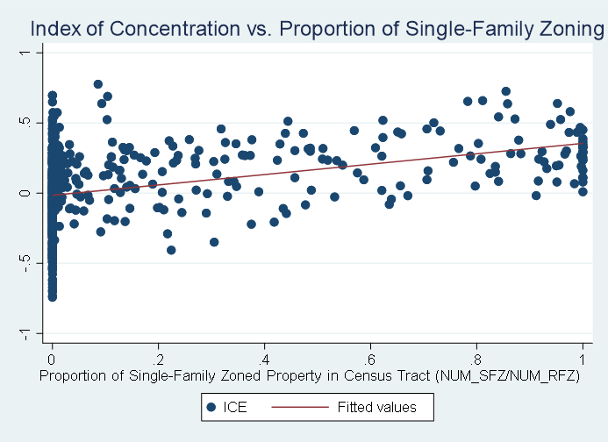

Appendix B: Zoning Maps
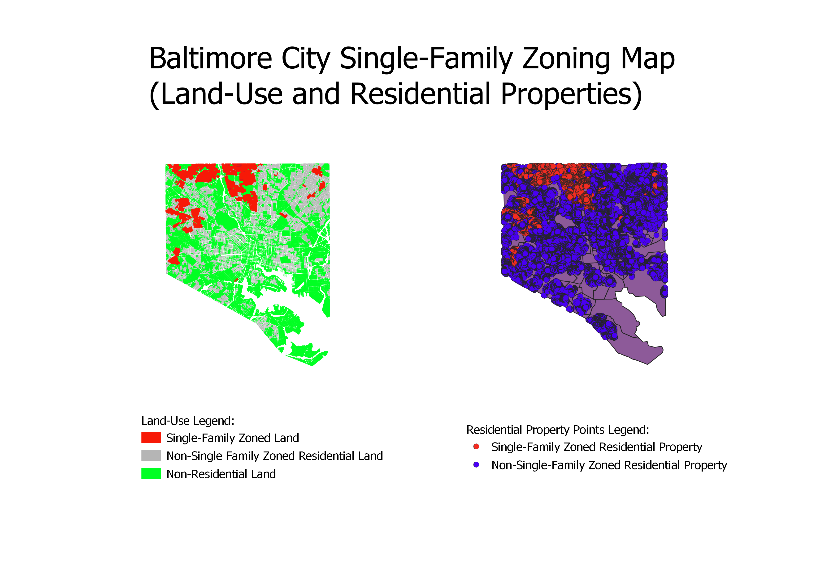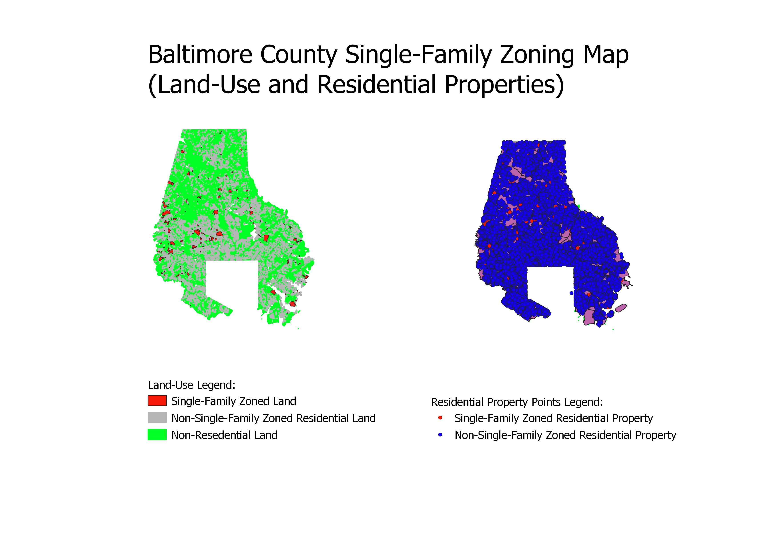
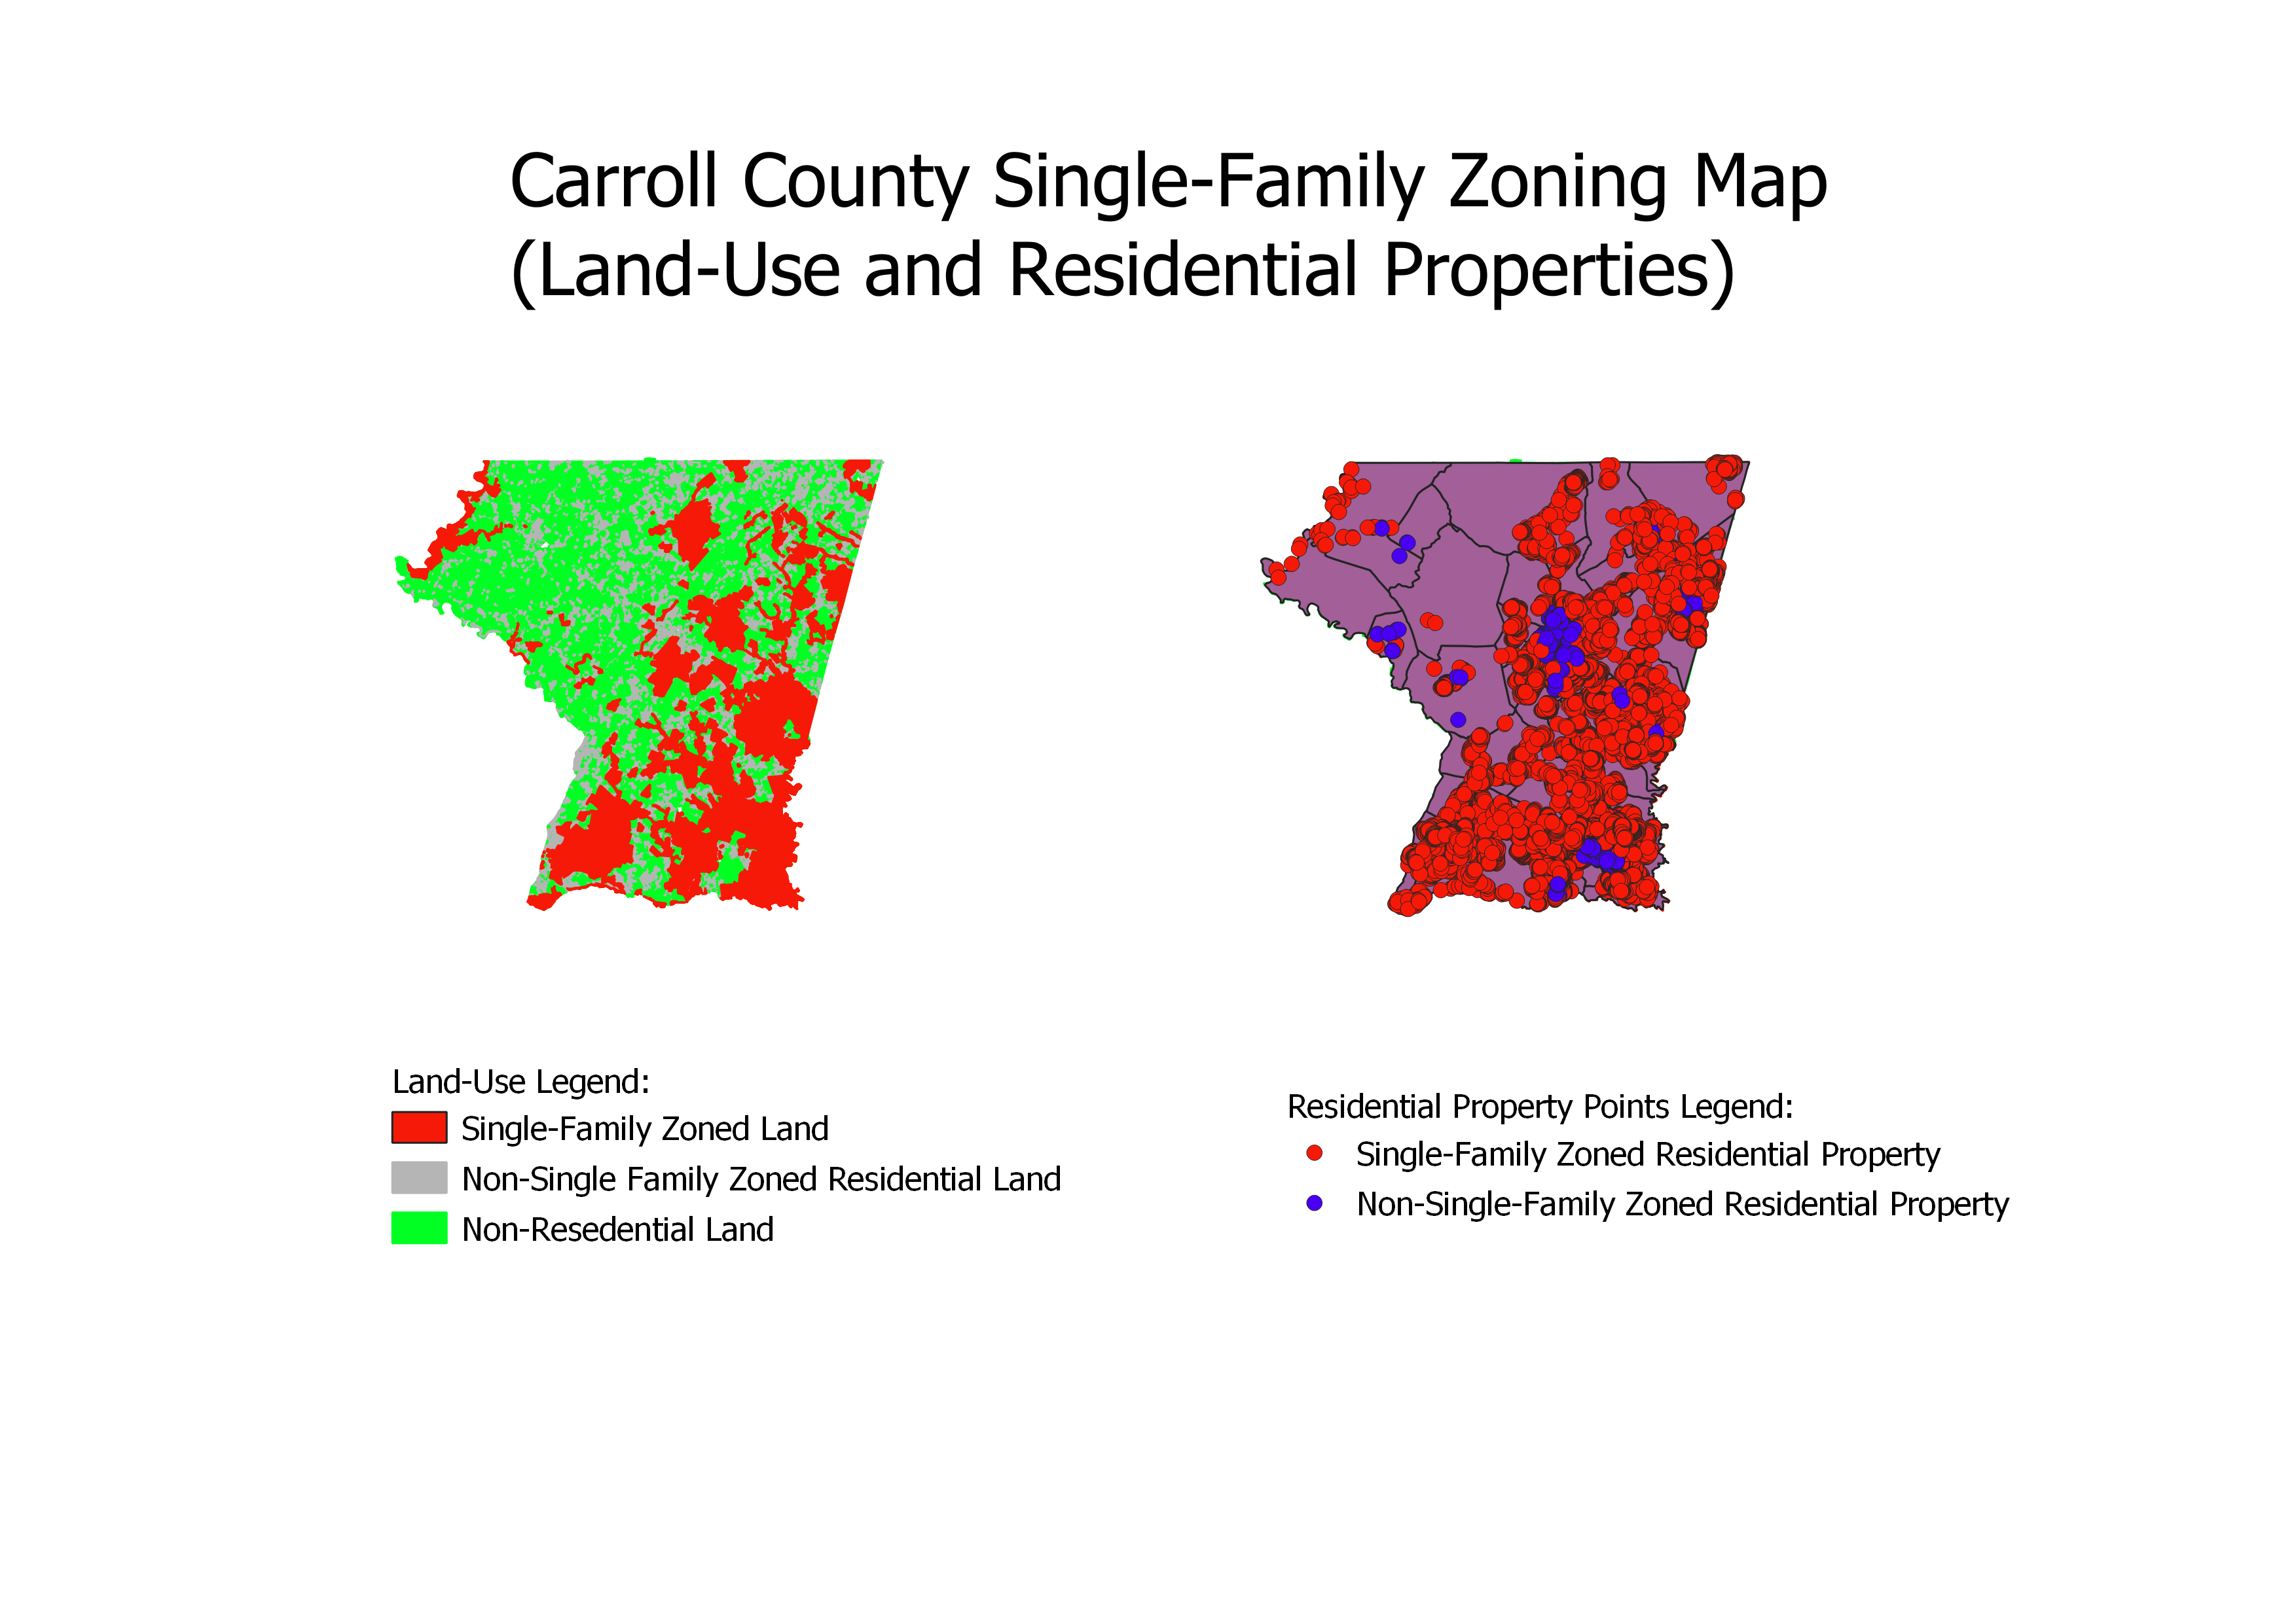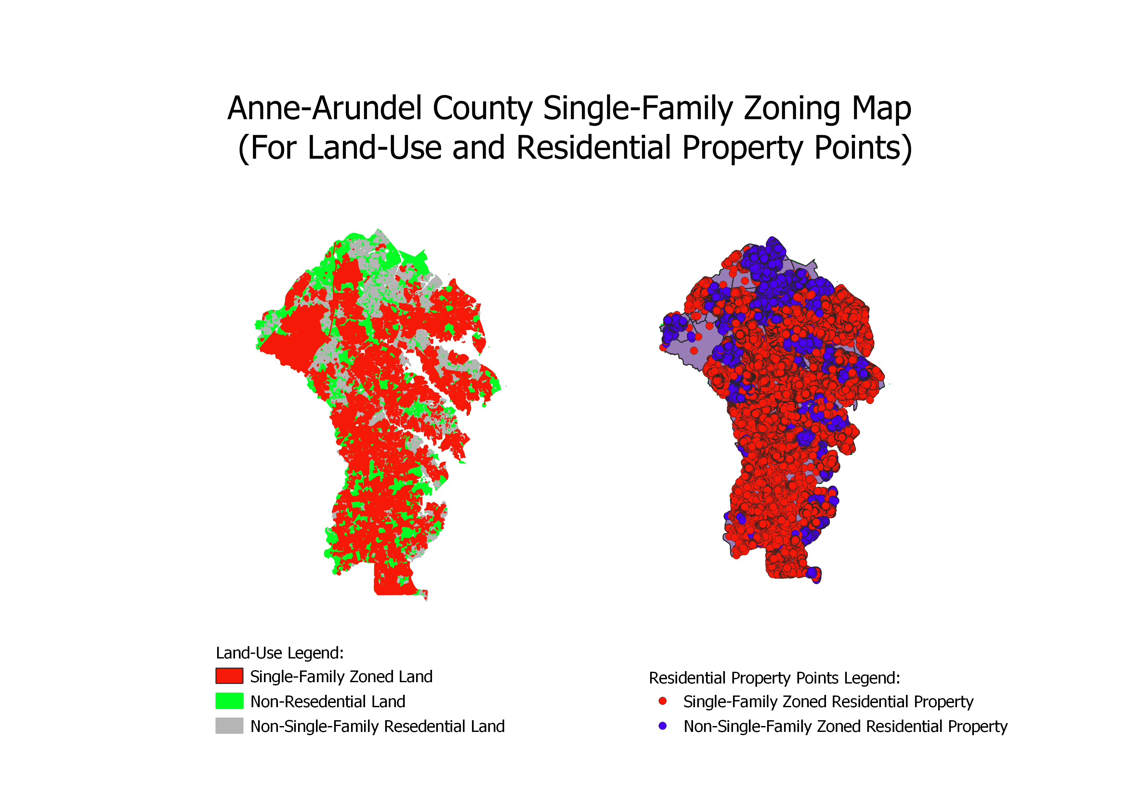
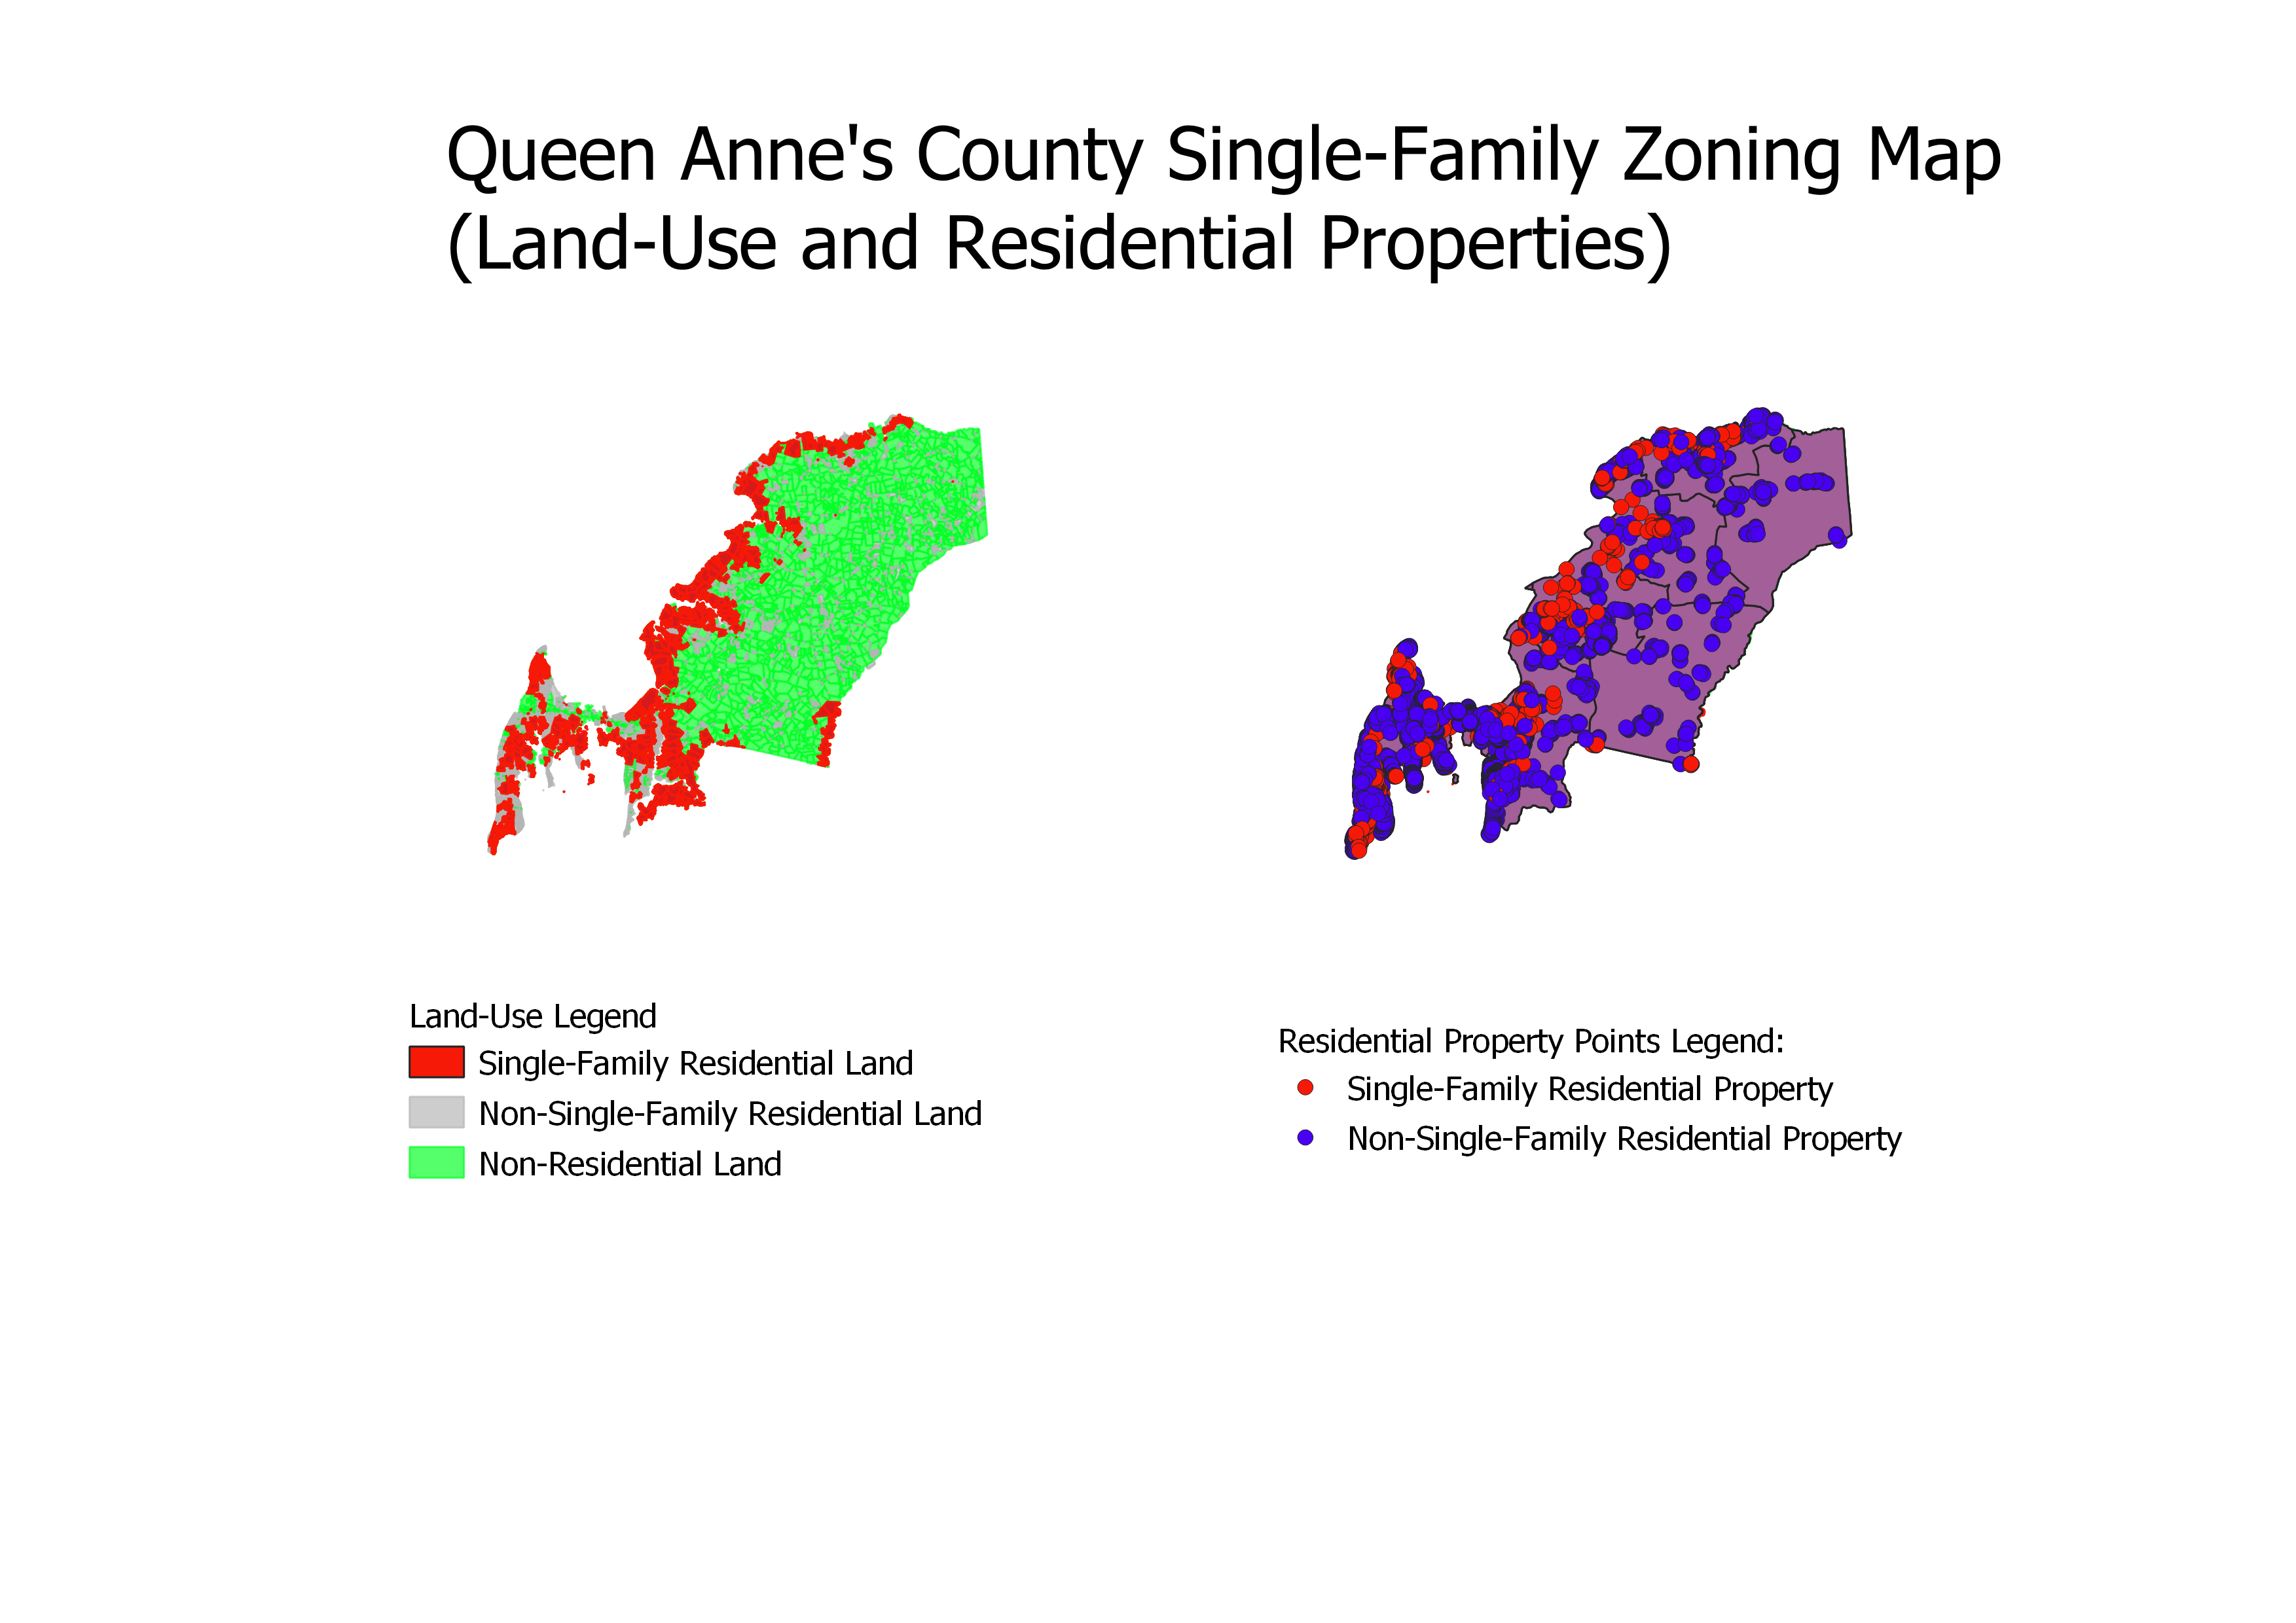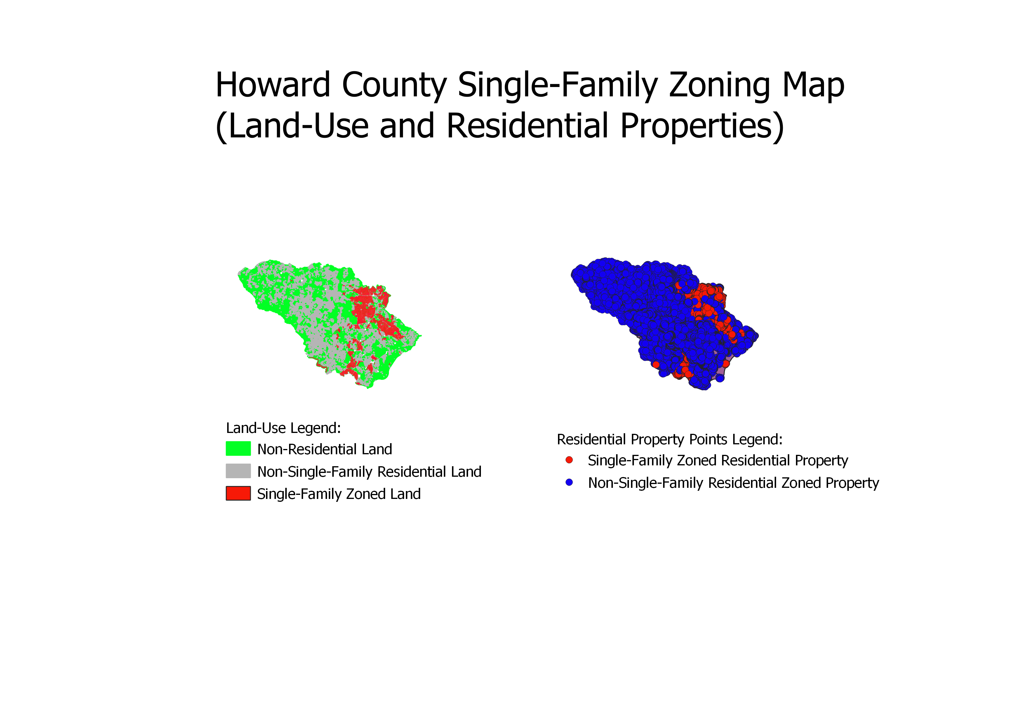
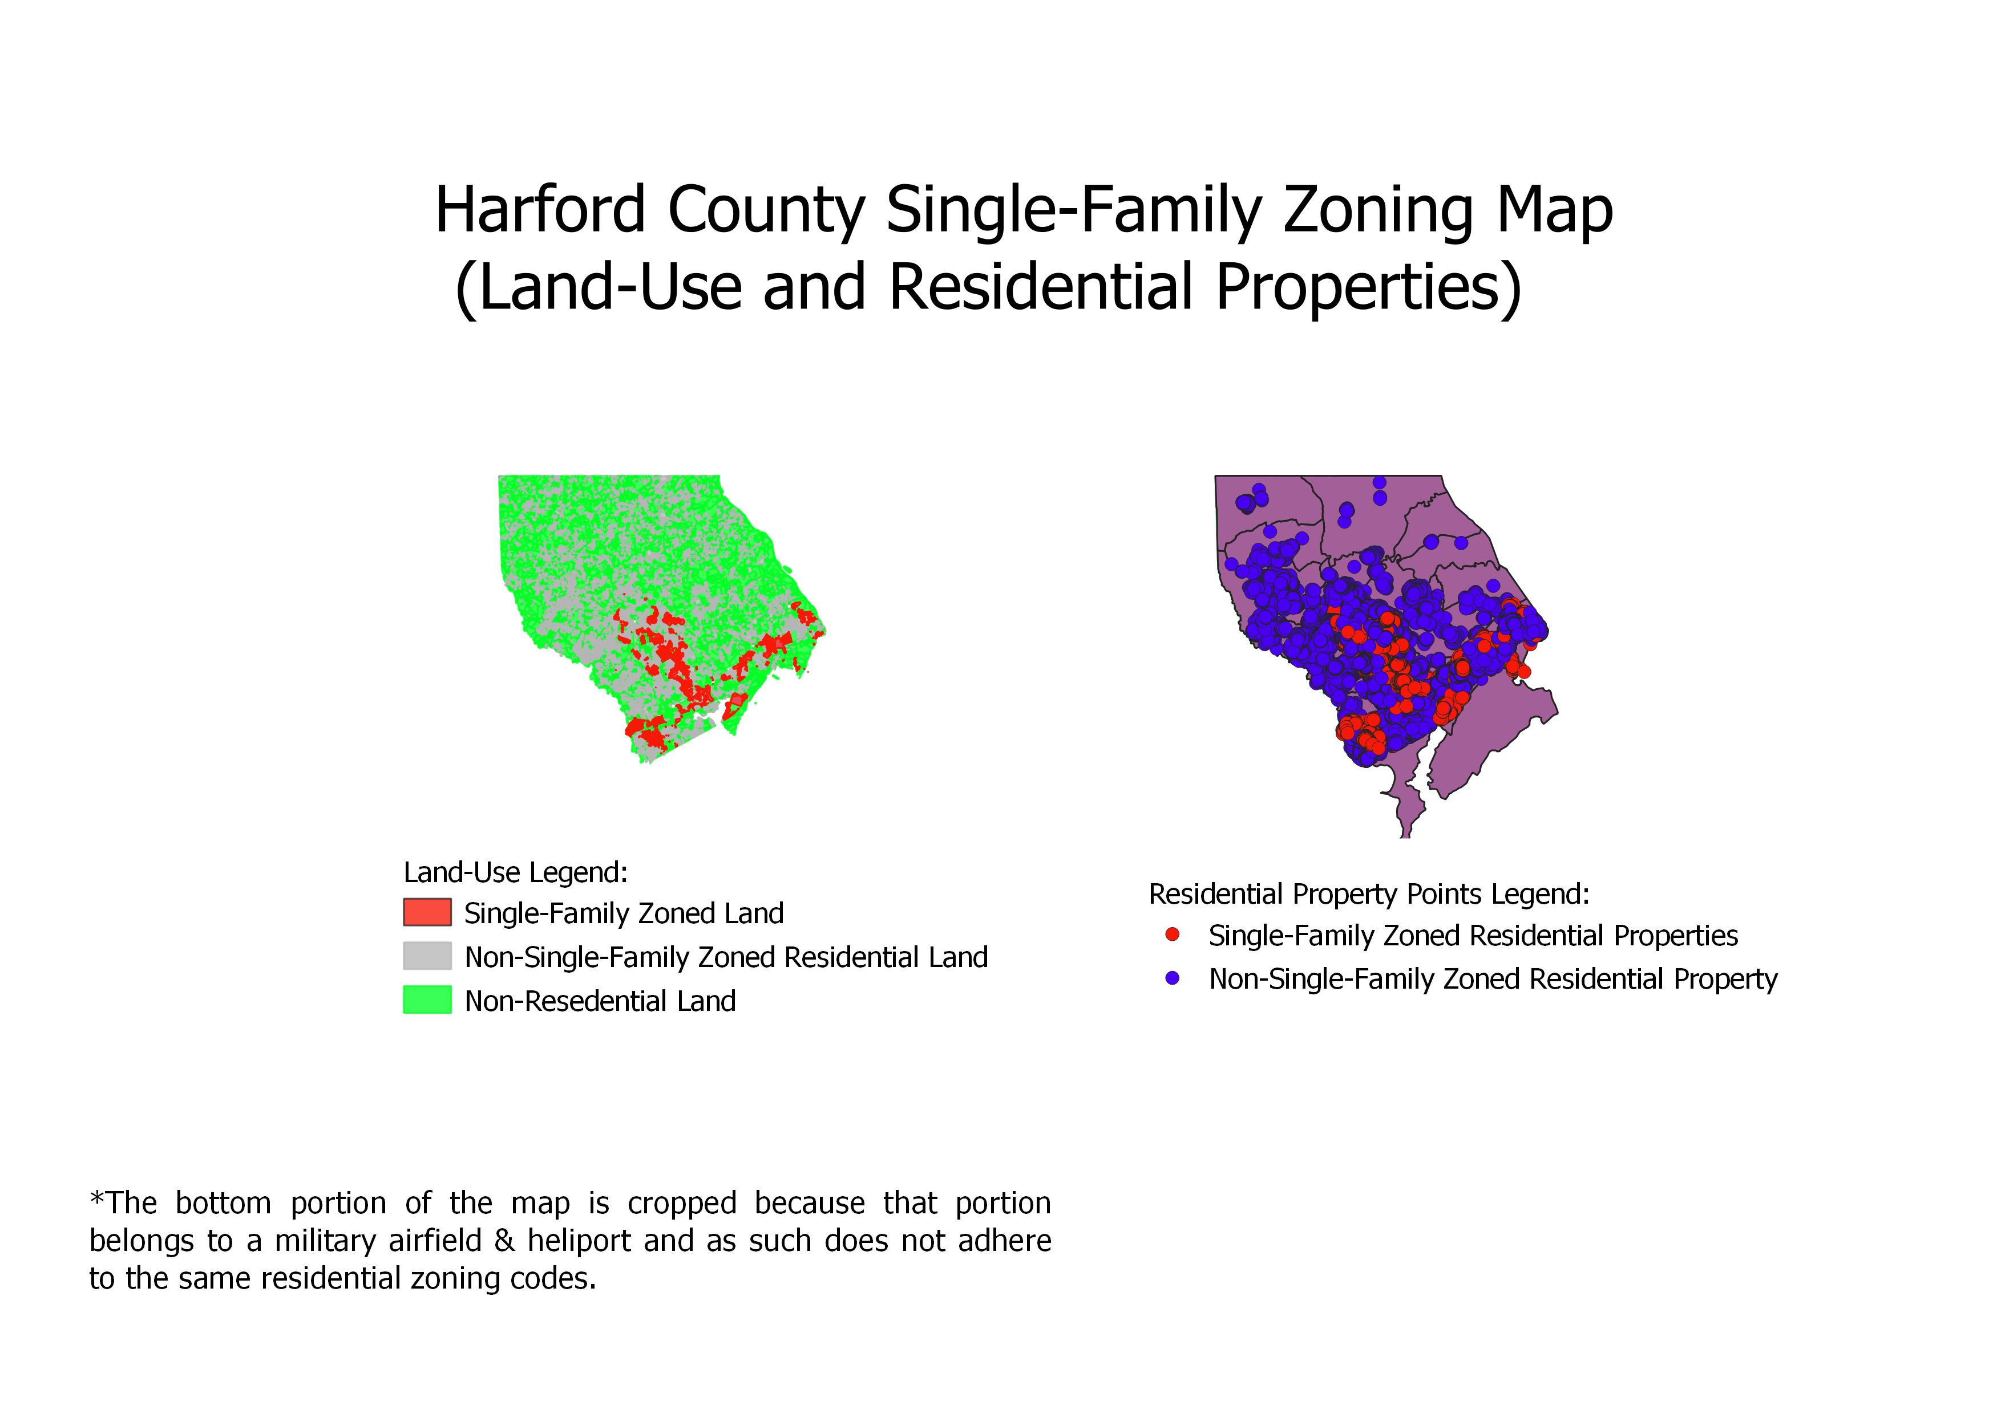
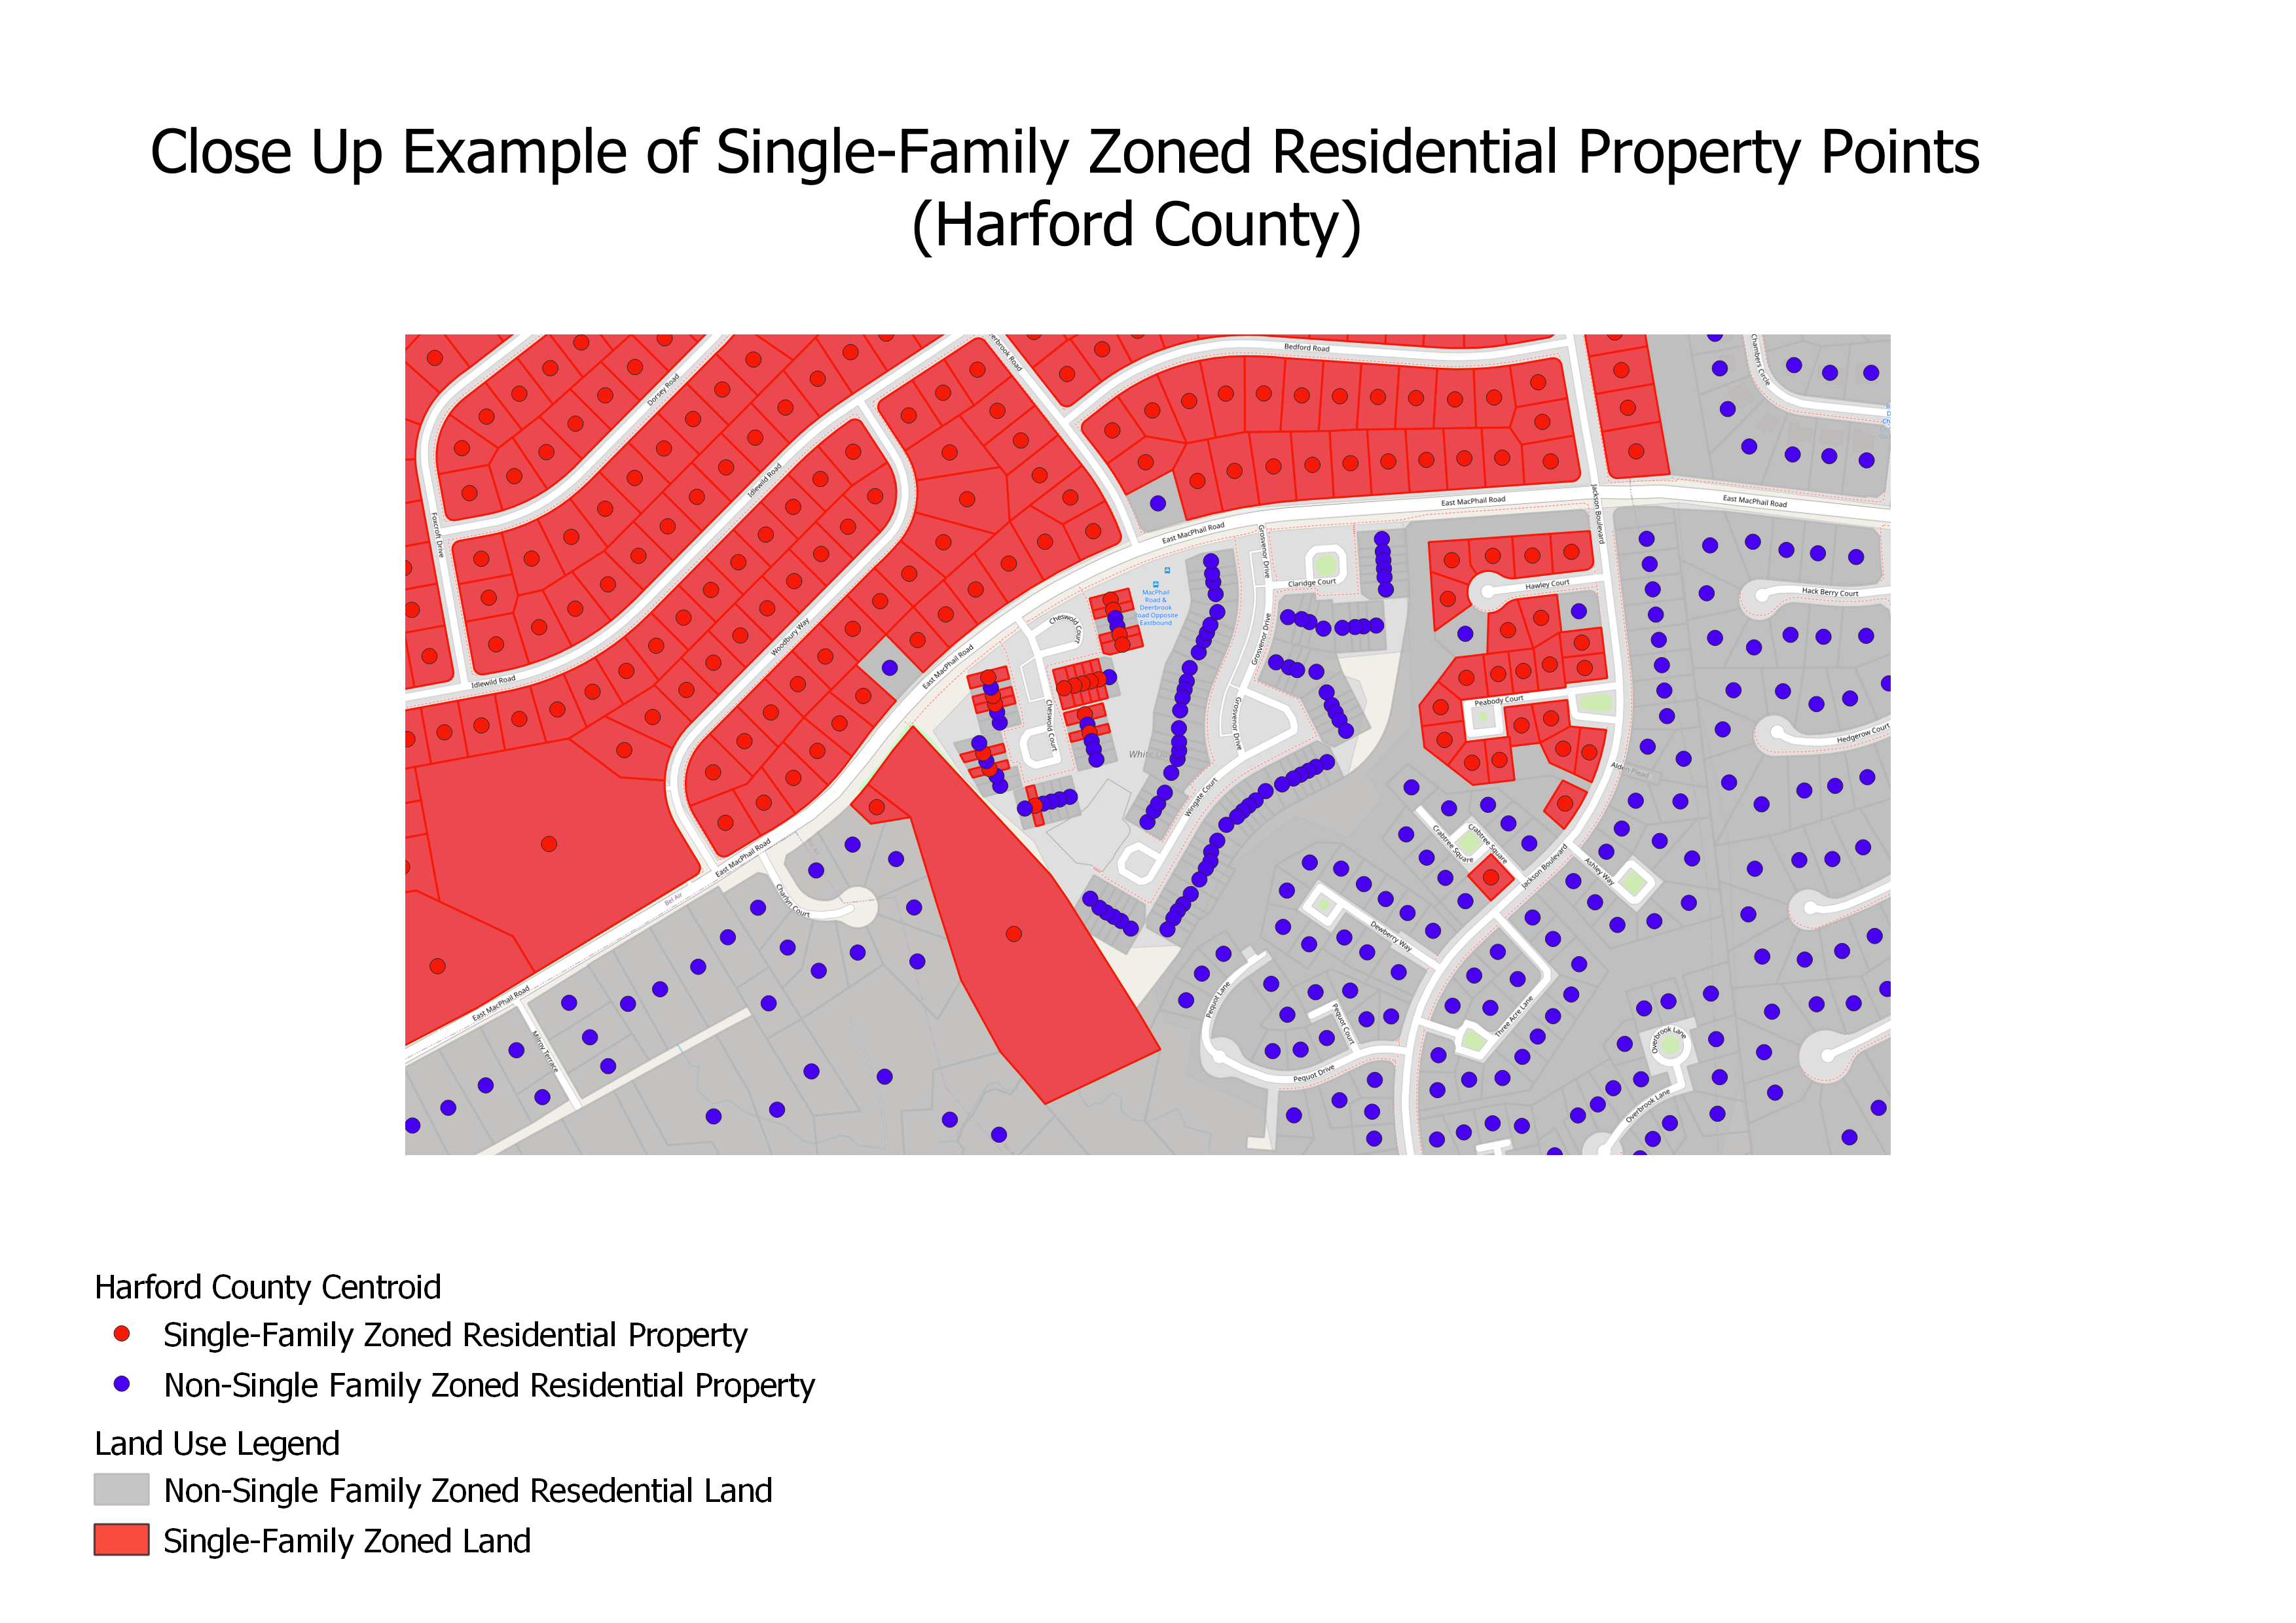

Reference List (APA)

- Silver, C. (1991). The racial origins of zoning: Southern cities from 1910–40. Planning Perspectives, 6(2), 189-205
- Wilson, M. H. (2019, May 21). The racist history of zoning laws. Retrieved from https://fee.org/articles/the-racist-history-of-zoning-laws/
- Bui, Q. (2018, August 21). Cities start to question an American ideal: A house with a yard on every lot. Retrieved from https://www.nytimes.com/interactive/2019/06/18/upshot/cities-across-america-question-single-family-zoning.html
- Bassett, E. M. (1920). Zoning: By Edward M. Bassett. Franklin Classics.
- Rothstein, R. (2017). The color of law: A forgotten history of how our government segregated America. Liveright Publishing.
- White, G. B. (2015, November 23). How zoning laws exacerbate inequality. Retrieved from https://www.theatlantic.com/business/archive/2015/11/zoning-laws-and-the-rise-of-economic-inequality/417360/
- Weiss, M. A. (2012). Urban land developers and the origins of zoning laws: The case of Berkeley. Berkeley Planning Journal,
- Urban Institute. (2019). "The Black butterfly". Retrieved from https://apps.urban.org/features/baltimore-investment-flows/
- Taylor, J. (2015, December 31). Retrieved from https://www.washingtonpost.com/opinions/in-baltimore-few-home-loans-for-african-americans/2015/12/31/bc4e1f4a-adb0-11e5-b711-1998289ffcea_story.html
- The Othering & Belonging Institute. (n.d.). Racial segregation in the San Francisco Bay Area. https://belonging.berkeley.edu/segregationinthebay
- Jud, G. D. (1980). The effects of zoning on single-family residential property values: Charlotte, North Carolina. Land Economics.
- Maryland Department of Planning. (n.d.). Digital Parcel Mapping Files. Retrieved from https://planning.maryland.gov/Pages/OurProducts/DownloadFiles.aspx
- Maryland Department of Planning. (n.d.). Digital Parcel Mapping Files. Retrieved from https://planning.maryland.gov/Pages/OurProducts/DownloadFiles.aspx
- Pew Research Center. (2020, May 30). America’s shrinking middle Class: A close look at changes within metropolitan areas. Retrieved from https://www.pewresearch.org/social-trends/2016/05/11/americas-shrinking-middle-class-a-close-look-at-changes-within-metropolitan-areas/
- Alto, V. (2019, August 17). Understanding the OLS method for simple linear regression. Retrieved from https://towardsdatascience.com/understanding-the-ols-method-for-simple-linear-regression-e0a4e8f692cc
- Roberto, E. (2016). The Divergence Index: A Decomposable Measure of Segregation and Inequality. Princeton University.
- Massey, D. (1998). American apartheid: Segregation and the making of the underclass. Harvard University Press
- Glotzer, P. (2020). How the suburbs were segregated: Developers and the business of exclusionary housing, 1890–1960. Columbia University Press.
- Hunter, M. A., & Robinson, Z. (2018). Chocolate cities: The Black map of American life. University of California Press.
- Pietila, A. (2012). Not in my neighborhood: How bigotry shaped a great American city. Rowman & Littlefield.
- Cassie, R. (2021, February 27). Twelve bold ideas for breaking down Baltimore’s barriers. Retrieved from https://www.baltimoremagazine.com/section/businessdevelopment/how-to-fix-baltimore/
- U.S. Census Bureau. (2019). American community survey tables: 2015 -- 2019 (5-year estimates) (2270 tables)-Social explorer. Retrieved from https://www.socialexplorer.com/data/ACS2019_5yr/metadata/?ds=ACS19_5yr
- Fischel, W. A. (2015). Zoning rules!: The economics of land use regulation. CA.
- Charles, J. (2019, July 2). Will eliminating single-family zoning make housing more affordable? Retrieved from https://www.governing.com/topics/urban/gov-zoning-density.html
- White, G. B. (2015, November 23). How zoning laws exacerbate inequality. Retrieved from https://www.theatlantic.com/business/archive/2015/11/zoning-laws-and-the-rise-of-economic-inequality/417360/
- Urban Institute. (2015, December 28). The link between land-use restriction and growing inequality. Retrieved from https://www.urban.org/urban-wire/link-between-land-use-restriction-and-growing-inequality
- Fernandez, R., & Rogerson, R. (1993). Keeping people out: Income distribution, zoning and the quality of public education. https://doi.org/10.3386/w4333
- Danielson, M. N. (1976). The Politics of Exclusionary Zoning in Suburbia. Political Science Quarterly.

Silver, C. (1991). The racial origins of zoning: Southern cities from 1910–40. Planning Perspectives, 6(2), 189-205
Wilson, M. H. (2019, May 21). The racist history of zoning laws. Retrieved from https://fee.org/articles/the-racist-history-of-zoning-laws/
Bui, Q. (2018, August 21). Cities start to question an American ideal: A house with a yard on every lot. Retrieved from https://www.nytimes.com/interactive/2019/06/18/upshot/cities-across-america-question-single-family-zoning.html
Bassett, E. M. (1920). Zoning: By Edward M. Bassett. Franklin Classics.
Rothstein, R. (2017). The color of law: A forgotten history of how our government segregated America. Liveright Publishing.
White, G. B. (2015, November 23). How zoning laws exacerbate inequality. Retrieved from https://www.theatlantic.com/business/archive/2015/11/zoning-laws-and-the-rise-of-economic-inequality/417360/
Weiss, M. A. (2012). Urban land developers and the origins of zoning laws: The case of Berkeley. Berkeley Planning Journal,
Urban Institute. (2019). "The Black butterfly". Retrieved from https://apps.urban.org/features/baltimore-investment-flows/
Taylor, J. (2015, December 31). Retrieved from https://www.washingtonpost.com/opinions/in-baltimore-few-home-loans-for-african-americans/2015/12/31/bc4e1f4a-adb0-11e5-b711-1998289ffcea_story.html
Brown, N. (2020, February 7). The details of a bill that would transform single-family zoning in Maryland. Retrieved from https://dc.urbanturf.com/articles/blog/the-details-of-a-bill-that-would-transform-zoning-maryland/16436
The Othering & Belonging Institute. (n.d.). Racial segregation in the San Francisco Bay Area. https://belonging.berkeley.edu/segregationinthebay
Maryland Department of Planning. (n.d.). Digital Parcel Mapping Files. Retrieved from https://planning.maryland.gov/Pages/OurProducts/DownloadFiles.aspx
Pew Research Center. (2020, May 30). America’s shrinking middle Class: A close look at changes within metropolitan areas. Retrieved from https://www.pewresearch.org/social-trends/2016/05/11/americas-shrinking-middle-class-a-close-look-at-changes-within-metropolitan-areas/
Alto, V. (2019, August 17). Understanding the OLS method for simple linear regression. Retrieved from https://towardsdatascience.com/understanding-the-ols-method-for-simple-linear-regression-e0a4e8f692cc
Krieger, N. (2018). Using the index of concentration at the extremes at multiple geographical levels to monitor health inequities in an era of growing spatial social polarization: Massachusetts, USA (2010–14). International Journal of Epidemiology
Roberto, E. (2016). The Divergence Index: A Decomposable Measure of Segregation and Inequality. Princeton University.

