Has post-2008 Monetary Policy been successful?: The Fed’s Unconventional policy versus the Taylor rule from 2008-2017
Jonathan Yoe
Final Draft: ECPA Capstone
University of Maryland, Baltimore County
July 28, 2018

Abstract:
In a 2012 paper entitled “Monetary Policy Rules Work and Discretion Doesn’t: A Tale of Two Eras”, Stanford economist John Taylor argued that rules-based monetary policy from 1985-2003 led to good economic performance. Conversely, Taylor claimed that, since 2003, the Federal Reserve deviated from rules-based policy and began using discretion to guide monetary policy decision making, likely leading to the financial crisis of 2008. Taylor has since been an advocate for a return to rules-based monetary policy. In 2017, Minneapolis Federal Reserve Bank (FRB) President Neel Kashkari discussed the harm that mechanically following a Taylor rule can do to the economy, estimating that, had the Fed mechanically followed the Taylor rule from 2012-2017, 2.5 million more Americans would be unemployed today than under the discretionary scenario that has actually played out. This paper looks to add to the discussion of rules versus discretion in the context of the Fed’s unconventional, post-2008, monetary policy. I estimate two different Taylor rules and examine whether or not strict adherence to either would have had a positive or negative effect on real GDP. I find that had the Fed set the FFR according to either version of the Taylor rule specified in this paper it would have negatively affected real GDP. The results of this paper support the argument that the discretion of the Fed in carrying out unconventional policy since 2008 was likely a better alternative than setting the FFR according to a Taylor rule.

- Introduction
In a 2012 paper entitled “Monetary Policy Rules Work and Discretion Doesn’t: A Tale of Two Eras”, published in the Journal of Money, Credit and Banking, Stanford economist John Taylor argued that rules-based monetary policy from 1985-2003 led to good economic performance. Conversely, beginning in 2003, Taylor has claimed that the Federal Reserve (hereafter the Fed) deviated from rules-based policy and began using discretion to guide monetary policy decision making. This led to a federal funds rate (FFR) that was too low for too long and that “likely led to the financial crisis.” In response to the crisis and ensuing Great Recession, the Fed undertook many unconventional activities that were meant to supply much-needed liquidity to the financial sector and to stop credit from freezing. However, as early as 2009, Taylor suggested that the Fed exit their unconventional regime and return to a rules-based monetary policy: “One way to determine when to exit is to use standard monetary policy rules. …they can serve as a natural guideline for exiting. For example, if policy rules say that the interest rate should be raised above zero at a particular date, or a particular time interval, then that is when the Fed should exit.” Taylor calculated an FFR of close to 2% in 2009, using his original specifications and challenged the assertion that the Fed “had a long way to go” before raising the FFR. However, the Fed did not raise the FFR according to the Taylor rule. They maintained their discretionary approach and continued with their unconventional monetary policy practices.
In 2017, Minneapolis Federal Reserve Bank (FRB) President Neel Kashkari discussed the harm that mechanically following a Taylor rule can do to the economy. Kashkari’s staff at the Minneapolis branch ran simulations that estimated how following a Taylor rule would have affected the economy using the Fed’s FRB/US macroeconomic model. This model is regularly used by the Fed “for forecasting, simulating alternative scenarios, and evaluating policy options.” Kashkari concluded that following a Taylor rule from 2012-2017 would have resulted in significant economic damage, specifically: 2.5 million more Americans would be unemployed today than under the discretionary scenario that has actually played out.
Did the Fed make the right decision? Did the unconventional monetary policy work, or would the Fed have been better off following a Taylor rule from 2008 and going forward? This paper examines these questions. In section II, I go over the history of monetary policy and provide background information on open market operations (hereafter, OMO). In section III, I discuss the Taylor rule’s origins within the context of the rules versus discretion debate that ultimately led John Taylor to estimate his monetary policy rule. In section IV, I explore the unconventional monetary policy that came out of the financial crisis and Great Recession and introduce the counterfactual of whether or not adhering to a Taylor rule would have been beneficial in an unconventional era—specifically, the era of interest on excess reserves (hereafter IOER). In section V, I examine the argument for and against using a Taylor rule in an unconventional IOER regime. In section VI, the methodology section, I use the FFR, the inflation gap, and the output gap to estimate a synthetic FFR that will be used to examine the counterfactual scenario of the Fed having followed a Taylor rule from 2009-onward. After estimating the synthetic FFR with OLS, I use a VAR to estimate the effect that sticking to the rule would have had on real GDP. In other words, I am using a counterfactual to look at whether or not the unconventional monetary policy that the Fed implemented in response to the financial crisis and resulting Great Recession has been successful. In section VII, I present the results, focusing on the Impulse Response functions generated by the VAR analyses and offer a discussion, and, in section VIII, I conclude.
2.1 Traditional Monetary Policy
The 63rd Congress of the United States produced and, on December 23, 1913, President Woodrow Wilson signed the Federal Reserve Act. This act created the Federal Reserve, which is the central bank of the United States. The Fed is in charge of monetary policy in the United States. The Banking Act of 1933 created the Federal Open Market Committee (FOMC), which is responsible for open market operations (OMO).
In the beginning, the Real Bills Doctrine was the dominant theory of monetary policy—which was based on the idea that loans made for the purpose of producing goods and services would not be inflationary—and the Fed’s primary tool of monetary policy was the discount rate. The market for federal funds was only a way for banks to “adjust reserve positions” to meet reserve requirements and facilitate payment flows between banks. In the early 1920s, the Fed “accidently discovered [OMO].” After the 1920-21 recession, discount loans decreased “dramatically and the Fed was pressed for income, so they purchased income-earning securities” and found that banking reserves grew and that loans and deposits increased. By the end of the 1920s, OMO was the primary tool of the Fed to carry out monetary policy.
After 1933, the FOMC was tasked with carrying out OMO—the buying and selling of treasury securities in order to manipulate the FFR. Even with OMOs as the primary tool of monetary policy, throughout the years, the Fed has gone through different monetary policy regimes since the Real Bills Doctrine: (1) the interest rate pegging of the World War II era; (2) The procyclical monetary policy under William McChesney Martin in the 1950s and 1960s; (3) The targeting of money growth in the 1970s under Arthur Burns; (4) Volcker’s targeting of non-borrowed reserves to combat out-of-control inflation; (7) and finally, the FFR became the principle target of monetary policy. Additionally, since 1977, the Fed has conducted monetary policy under a dual mandate: to maintain stable prices and full employment. While Congress officially issued a mandate for the Fed to "promote effectively the goals of maximum employment, stable prices, and moderate long-term interest rates," it is generally believed that the achievement of the first two will lead to moderate long-term interest rates, which is why it is referred to as a “dual” mandate.
Since 1993, it has been officially known that the FOMC has targeted the FFR in order to carry out their monetary policy objectives. Furthermore, beginning with Greenspan in 1994, the Fed began to announce changes in the FFR. The FFR is the overnight interbank lending rate that surfaces in the market for federal funds as a result of banks negotiating with one another. This rate has become the standard target for monetary policy because of its far-reaching effects, as different markets’ short-term rates tend to move with the FFR. Traditionally, the Fed targeted the FFR via OMO.
There is a quantity of reserves that is consistent with a specific short-term rate in the market for reserves. The Fed will intervene in the market for reserves by buying or selling treasury securities until the FFR that they desire is reached. There are two types of OMO: defensive OMO and dynamic OMO. There are a few factors that influence a bank’s demand for reserves, such as reserve requirements and precautionary demand. Banks need to comply with the Fed’s mandate that they keep a fraction of their demand deposits at the Fed, and also must have enough money on-hand to facilitate the flow of payments between banks. Not being able to meet either of these requirements results in a penalty. Banks also want to limit the implicit tax associated with holding reserve balances. Milton Friedman recognized this issue long ago. The demand curve in the market for federal funds is downward-sloping, as the quantity of reserves demanded by banks varies inversely with the FFR; the FFR is the opportunity cost of holding reserves. If the FFR is elevated, then the banks are incentivized to loan money out into the markets as they can receive a higher return. However, when the interest rate is lower, the banks face a smaller opportunity cost of holding reserves. Taken together, this all creates a very active market for reserves.
Dynamic OMO are OMO that are intended to change the level of reserves and the FFR. These are the OMO on which this paper will focus. The FOMC meets eight times a year, for two days each, to discuss the economy and decide whether the FFR is at the desired level or whether it needs to be changed. If they decide to change the FFR, they will conduct countercyclical OMO until the desired FFR is reached. For example, if the United States is in a recession, the FOMC will direct the bond traders at the NY Fed open market desk to buy treasury securities, thereby injecting reserves into the banking system that can be used to make loans and create deposits, until the FFR lowers to the target level. If the economy heats up and inflation starts rising, the NY Fed open market desk will sell treasury securities back to banks, thereby removing money from the banking system, which will decrease loans and slow down deposit creation.
2.2 Rules versus Discretion
In order to comply with their dual mandate, the Fed has goal independence and instrument independence. Instrument independence is the freedom of the Fed to choose the appropriate monetary policy tool to achieve their goals. Traditionally (pre-2008), this had been OMO. Goal independence implies that the Fed can choose between addressing the goals of price stability and full employment. These goals, however, can conflict with one another in the short-run. The Phillips Curve captures the implied tradeoff between unemployment and inflation. If unemployment is low, then a tight labor market implies rising wages and prices. In order to quell inflation, the Fed must raise the FFR, which raises unemployment, all else equal. And, if unemployment is high, this implies a labor market with extra slack. The Fed will lower the FFR to stimulate aggregate demand, which causes unemployment to decrease, but causes inflation to increase, all else equal. The Fed decides which goal is the most important to pursue in the moment. How to choose the appropriate goal is controversial. Should the Fed follow a rule or use their discretion? This is the crux of the rules vs. discretion debate.
The rules vs. discretion debate is not a new one. University of Chicago economist Henry Simons advocated for a rules-based approach to monetary policy in his 1936 paper entitled Rules versus Authorities in monetary policy. More recently, John Taylor, among others, have argued for a “predictable, rules-based approach to monetary policy.” It is argued that a commitment to a monetary policy rule increases the accountability and transparency of the Fed, can help anchor inflation expectations, and can “reduce the spillover of supply shocks.” In 1993, Taylor introduced a hypothetical monetary policy rule that would become highly influential.
3.1 The Taylor Rule
The significance of the Taylor rule is best summed up by Asso, Kahn, and Leeson (2007): “Taylor-type Rules have become the standard by which monetary policy is introduced in macroeconomic models…they have been used to explain how policy has been set in the past and how policy should be set in the future…they serve as benchmarks for policymakers in assessing the current stance of monetary policy and in determining a future policy path.”
The Taylor rule was introduced by economist John Taylor in his 1993 paper Discretion versus policy rules in practice. Taylor was making an argument for using monetary policy rules over discretion when setting monetary policy. He proposed a hypothetical monetary policy formula that indicated the path of the FFR in response to both the inflation and output gaps. As it turned out, the function that he presented modeled Fed behavior very closely from 1987-1992. After this, his rule took off in popularity and has been at the center of monetary policy discussions ever since.
The original rule was proposed as follows:
$$r=p+α\left(p-p^{*}\right)+βy+2$$
$r≡FFR; α=β=0.5$
$p≡the rate of inflation over the previous four quarters$
$p^{*}≡the expected rate of inflation$
$y≡the percent deviation of real GDP from a target$
$y=\frac{(y-y*)}{y^{*}}*100$, where $y=real GDP, y^{*}=potential GDP$
$2=the real rate of interest$
Meyer (2002), in discussing the Taylor rule, highlights the accompanying Taylor Principle: the $α$ coefficient on the inflation gap must be greater than one, which is what occurs when the two inflation terms are added in the Taylor rule equation. The Taylor Principle says that the coefficient on the inflation gap should be positive. If $α>0$, then for a one-percentage point increase in inflation, the FFR will increase by more than one-percentage point, $1+α$. The failure of the Fed to adhere to the Taylor principle is one of the reasons that is regularly cited to explain the stagflation of the 1970s. Clarida, Gali, and Gertler (2000) estimated the reaction coefficient to inflation in the pre-Volcker era beginning in 1960. They estimated the Taylor rule several times, varying the model slightly, and each time, they calculated an inflation coefficient of less than one. This implies that inflation rose faster than the FFR, which was, in effect, an “easing of monetary policy” that caused the stagflation of the 1970s.
The linear nature of the Taylor rule has proven to be appropriate. Clarida, Gali, and Gertler (2000) estimated a forward-looking monetary policy rule based on the Volcker-Greenspan period of monetary policy and found that linear specifications of policy rules were “…optimal for a central bank that has a quadratic loss function in deviations of inflation and output from their respective targets…”. The implications of this rule are that any deviations from either the output gap or inflation gap, whether positive or negative, elicit a response from the FOMC. Taylor (1993) cited a 1993 study by Bryant, Hooper, and Mann, in which they analyzed several different monetary policy rules, and concluded that the rules that focused on both the inflation and output gaps—the quadratic loss function—were the ones that performed best in terms of economic stabilization policy. This is why Taylor (1993) wrote, “…placing some weight on real output in the interest-rate reaction function is likely to be better than a pure price rule.” He states that he is unsure of the specific weights that should be applied to each gap, so he arbitrarily applies weights of 0.5 to both the inflation and output gaps, to highlight the response of the FOMC to both. However, Clarida et al. (2000) estimated these coefficients and found the one that was attached to the inflation gap to be much larger than the one on the output gap. Using the GDP deflator and CBO estimates of the output gap, Clarida et al. (2000) found the inflation coefficient in the Volcker-Greenspan era to be 2.15, while the output gap coefficient was estimated at 0.93. Orphanides (1997) also estimated coefficients for the inflation gap that were 1.36-1.51 between 1993 and 1994, while his output gap coefficients were 0.54-0.60.
When Taylor (1993) proposed his rule, he was making an argument for systematic, rule-based monetary policy. He stated, “if there is anything about which modern macroeconomics is clear however—and on which there is substantial consensus—it is that policy rules have major advantages over discretion in improving economic performance.” However, Taylor didn’t necessarily expect his rule to be followed in a mechanical way. He suggested that the Fed could use the Taylor rule in two specific ways: (1) as one of the many factors, in addition to yield curves and forecasts, that help guide Fed economists in their decisions on monetary policy; (2) using the underlying properties of the rule, without having to follow the “particular algebraic formulation.” However, Taylor (2012) has since made stronger statements advocating for a stricter adherence to a Taylor rule.
3.2 The Case for the Taylor Rule
Robert Lucas (1976) advocated for the use of rules over discretion in monetary policy decision making. Lucas, in his famous critique, argued that
“…given that the structure of an econometric model consists of optimal decision rules of economic agents, and that optimal decision rules vary systematically with changes in the structure of series relevant to the decision maker, it follows that any change in policy will systematically alter the structure of econometric models.”
Lucas insisted that discretionary monetary policy would change the expectations of economic agents and that this would render any econometric policy predictions obsolete. Kydland and Prescott (1977) reinforced Lucas’ argument, prescribing the use of monetary policy rules.
One of the main reasons for a preference of rules over discretion is the time-inconsistency problem. Meyer (2002) defined time inconsistency as “…the incentive of policymakers to commit to one policy and then to later pursue another, different policy that is inconsistent with that commitment.” Time inconsistency is a myopic strategy that often leads to the choice of short-run policies with inflationary bias that are used to reduce unemployment. Thus, discretionary monetary policy, especially if influenced by politicians, can be incompatible with the long-term goal of an environment of low and stable inflation and interest rates. Taylor (2012) states that following a rules-based approach to monetary policy makes decisions more “predictable and systematic”, and less-focused on “short-term fine-tuning.”
Academic and Fed economists believe that the theory that underlies the Taylor rule is strong. Pierdzioch, Rulke, and Stadtmann (2012) “…interest-rate rules have become ubiquitous building blocks of monetary macroeconomic models.” Former Fed Governor Meyer (2002) stated that, “the focus on simple rules is justified by the finding that simple, well-designed rules are robust across a range of empirical macro models…”. This result bolsters the argument for a linear specification in which the interest rate responds to a quadratic loss function as described above. Orphanides (2007) said, “Taylor rules offered a simple and transparent framework with which to organize the discussion of systematic monetary policy…and [have] proved an important advance for both positive and normative analysis.” Further, Asso et al. (2010) argued that the Taylor “rule has advanced the practice of central banking.
3.3 The Case Against the Taylor Rule
Kocherlakota (2016) wrote that the majority of macroeconomists seem to state a preference for rules over discretion to their detriment. He postulated that the Fed’s adherence to rules-based monetary policy caused them to “react too timidly in the wake of the Great Recession.” One problem with applying the Taylor rule is that it is hard to get accurate, real-time data regarding inflation and the output gap. Orphanides (1997) points out that “…real-time policy recommendations differ considerably from those obtained with ex-post revised data.” In other words, the best policy might not be known in real-time.
Additionally, the output gap is unobservable, even under the best ex-post analysis. Orphanides (2007) states that the output gap’s “mismeasurement is often substantial” and Hetzel (2000) argued that there is no consensus among economists on how to make the concept of the output gap operational. Some economists have used unemployment estimates such as the non-accelerating inflation rate of unemployment (NAIRU), while others have preferred the difference between real and potential output as a measure of the output gap. In addition to measurement preference, economists can choose output gap estimates from different sources. The possibility of mismeasurement is great. As previously noted, during the 1970s, many economists have argued that the FOMC did not raise the FFR on a more than one-for-one basis with the inflation rate and, thus, the real interest rate did not rise enough to curb inflation. However, Clarida, Gali, and Gertler (2000) raised the possibility that “the Fed thought that the…output gap was much smaller” than it actually was, which implies that the problem was not with the Taylor rule coefficients, but with the measurement of the output gap. However, Meyer (2002) stated that, while the output gap presents measurement challenges, “a rule that totally eliminated any response to the output gap would seriously underperform rules that included responses…” to an output gap.
The Taylor rule also runs into problems when the nominal interest rate falls to zero, which is a situation known as the zero lower bound. Nominal rates, such as the FFR, cannot fall below zero because people always have the option to hold cash rather than negative-yielding assets. The FFR reached the zero lower bound in December, 2016. Chattopadhay and Daniel (2017) discussed the implications for the Taylor rule by saying, “the monetary authority loses the ability to implement a Taylor rule…” at the zero lower bound. Hakkio and Kahn (2014) added that, when “the FOMC turned to unconventional monetary policies, [in 2008], the funds rate could no longer fully characterize the stance of policy.”
Choi and Wen (2010) suggested that the Taylor rule was suboptimal. They argue that optimal monetary policy is more discretionary than a Taylor rule suggests. They argued that shocks would not immediately show up in inflation or output; however, these are the variables to which the Taylor rule responds. In contrast, it would be better to respond to the “causes of the fluctuations (that is, the shocks) rather than indirectly to the consequences of the fluctuations (that is, the movements in output and inflation).” Choi and Wen go on to argue that demand and supply side shocks—credit expansions versus oil shocks, in their example—should not be treated the same, implying that more discretion is needed in policy response. Bernanke (2015) admitted that, during his time as Fed Chairman, he often referred to monetary policy rules when thinking about the appropriate FFR; however, he also wrote about the need for discretion by stating, “it seemed to me self-evident that such rules could not incorporate all the relevant considerations for making policy in a complex, dynamic economy.” George Khan (2012) added that the “unique features of the current economic situation…may suggest a need for flexibility in following the prescription of any rule based on past performance.” Their concerns are more relevant than ever now, as the United States is in an era of unconventional monetary policy.
4.1 The Financial Crisis
From April of 2000 to April of 2006, the Case-Shiller 20-city Home Price Index ($index=100$ in January, 2010) rose from 104 to 206.65 and the “housing inflation rate…reached 10% at an annual rate in the fourth quarter of 2004 and remained…[there] for two years;” and housing inflation “measured by the Case-Shiller index…surpassed 20% during parts of this period.” Mortgage-backed securities (MBS) seemed a sure bet and were in high demand. To satisfy this demand, subprime mortgages became a larger part of the market. Segoviano, Jones, Linder and Blankenheim (2013) found that, from 2000–2006, “the subprime share of the mortgage market in the U.S. went from 6.9% to 20.1%.” IndyMac, Countrywide, and New Century (among others), lent money to people who could not qualify for a prime loan. They were originating mortgages without reviewing credit histories, without asking for down payments, or even demanding proof of income. They were incentivized to do so because they would quickly turn around and sell the mortgages to big banks who would roll them into MBS and sell them to investors. Even Fannie Mae and Freddie Mac invested in risky MBS. It seemed safe as the pooled mortgages were supposed to dilute the risk. And, even in the case of default, the investor got the house, whose price was rising.
With high demand for MBS, the big banks began throwing mortgages together and further “sliced and diced” the risk through derivatives, as CDOs-squared and CDOs-cubed appeared in the market. Everyone lost track of what was what. Rating agencies, such as Standard and Poor’s, Moody’s, and Fitch Ratings, had helped big banks design the securities and then rated them, which was a clear conflict of interest. Now, many banks had no clue which type of mortgages they had in a security, and this made the securities impossible to price. Many of the securities that were thought to be the safest were just as bad as the riskiest. The banks had no incentive to keep track of what was what because they were insured. Big banks had paid AIG a lot of money for Credit Default Swaps, which is insurance in the event of default. Mishkin (2013) points out that AIG had written “hundreds of billions of dollars of these risky contracts” assuming that the housing market was immune to any crisis that could hurt their position.
But the housing market crashed. When the Fed began to raise the FFR, subprime adjustable-rate mortgages (ARMs) “reset” and once affordable payments became impossible to pay and borrowers defaulted. It was discovered that many of these MBSs had little or no value; they were largely “worthless.” Highly-levered banks that had invested heavily in MBS—sometimes with debt accounting for more than 90% of all assets—were close to collapse. Subprime mortgage lenders failed and disappeared, JPMorgan Chase absorbed Bear Stearns with the Fed providing $29 billion to facilitate the deal, Fannie Mae and Freddie Mac were taken into conservatorship, Bank of America took over Merrill Lynch, and, in September, 2008, Lehman Brothers failed. The market was full of uncertainty, asymmetric information problems and mistrust, and credit was frozen. Action was needed.
Chairman Ben Bernanke and the Fed went to great lengths to try to stimulate the economy and provide much-needed liquidity to financial markets. The Fed used Section 13(3) of the Federal Reserve Act of 1932, which gave the Fed the authority to extend loans to nonbank institutions provided that the Fed believed the loans “were secured to (their) satisfaction.” They created an alphabet soup of lending facilities: TAF, TSLF, PDCF, AMLF, MMIFF, and TALF.
The Fed also pursued large-scale asset purchases (LSAPs) that would come to be known as quantitative easing (QE). QE came in three separate waves— (1) Dec 2008-March 2010, (2) Nov 2010-June 2011, and (3) Oct 2012-Oct 2014—that sought to take toxic assets off of bank balance sheets and to affect the long-term interest rate, as the short-term was at the zero lower bound. The Fed’s balance sheet ballooned from roughly $900 billion pre-crisis to $4.5 trillion post-crisis. In all, QE resulted in the Fed’s purchase of $1.6 trillion in government treasuries, $2.07 trillion in MBS, and $170 billion in agency debt from Fannie and Freddie. With such an expanded balance sheet, no one was sure what would happen—and they still aren’t. Taylor, Meltzer, and many others worried about inflation—caused by the QE money that banks had entering the mark in giant waves; this hasn’t materialized. OMO have been replaced by paying IOER in order to move the FFR and, as a result, the Fed has not had to wind down the balance sheet as fast as they would have to bring the current FFR to its 1.50-1.75% level.
4.2 Interest on Excess Reserves (IOER)
Congress passed the Financial Services Regulatory Relief Act of 2006, which granted the
Fed the right to pay interest on both required and excess reserves held by banks at the Fed’s different branch locations. The ability to pay interest on reserves was set to begin on October 1, 2011, but the financial crisis and the Great Recession that followed would lead former Fed Chairman Ben Bernanke and former Secretary of the Treasury Henry “Hank” Paulson to request that Congress allow early implementation of the ability to pay interest on reserves, which we will refer to as the ability to pay IOER, which is what gets the most attention for its ability to keep reserves contained in banks’ accounts at the Fed, thereby not causing inflation to rise. Congress passed the Emergency Economic Stabilization Act of 2008, which was part of the Troubled Asset Relief Program legislation of 2008. This legislation granted the Fed the power to begin making IOER payments in October of 2008.
In the wake of the financial crisis, the Fed and the Treasury were injecting liquidity into the financial market, in an attempt to “unfreeze” credit. However, as we know from OM purchases, when the Fed increases the amount of reserves that banks have, the banks have less of a need to borrow reserves from other banks and this drives the FFR downward. To avoid driving the FFR downward, the Fed sterilized their liquidity injections through open market sales, which “…offset the injections’ effect on the monetary base…keeping the total supply of reserves largely unchanged and the fed funds rate at its target.” After Lehman’s collapse and the rescue of AIG, the Fed had to provide such large amounts of liquidity that they ran out of treasury securities with which to sterilize liquidity injections. This was a problem, as the Fed had not yet lowered the FFR to zero and the injection of credit into the economy was making it hard for the New York Open Market Desk to maintain the FFR target rate. This is the reason that Bernanke and Paulson requested the early implementation of IOER payments.
Keister, Martin, and McAndrews (2008) wrote, “the quantity of money and monetary policy remain[ed] fundamentally linked,” because the Fed was adjusting the supply of reserves to achieve their desired interest rate target, as there was “a unique level of reserve supply that [would] lead the market to clear at the FOMC’s announced target rate.” The authors explained this link and the resulting conflict within the context of the market for daylight and overnight reserves. In times of conventional OMO, the amount of reserves needed to facilitate payments between banks during the day was much larger than the amount of reserves that was needed to achieve a specific FFR. This drove down the FFR, away from the Fed’s target. The Fed had to constantly perform defensive OMO, in order to maintain the target FFR. The Fed supplied daylight reserves and then pulled those reserves from the system in order to maintain the target FFR. There was a constant tension between daylight and overnight reserves. IOER payments now “divorced” the quantity of reserves from monetary policy.
In the era of unconventional monetary policy, and with the FFR at the zero lower bound, the Fed has a new mechanism by which to adjust the FFR: IOER payments. From 2008 to 2015, the FFR sat at zero, as the Fed has had to satiate the market with reserves in order to meet the liquidity needs of financial markets. Now, when the Fed wants to adjust the FFR, they raise the IOER payment rate without having to adjust the quantity of reserves. The IOER rate, which is now equal to the FFR, will provide a floor for the FFR. If the FFR were below the IOER rate, banks could borrow at the lower rate and then leave the money at the Fed to earn the higher interest rate; this arbitrage would drive the FFR back up to the IOER rate. Therefore, no bank would be incentivized to lend below the IOER. Paying IOER allows the Fed to increase the supply of reserves in order to meet the liquidity needs of the financial market, while also providing a “floor” for the target FFR. The Fed can expand their balance sheet all they want without causing downward pressure on the FFR. With their liquidity injections since 2008, the Fed drove the FFR to zero, where it sat from December 2008 to December 2015. Since then, they have used IOER to move the FFR up to 1.50-1.75%, where it now sits.
5.1 Taylor’s Argument about the Great Moderation versus the Ad hoc era
John Taylor has been an outspoken critic of the Fed since the financial crisis and the ensuing recession. He has criticized the Fed for its deviation from the Taylor rule, which he claims began in 2003. Taylor (2012) attributes the Great Moderation, a period of economic stability that lasted from 1985-2003, to the Fed having followed rules-based policy, saying there is “considerable evidence” backing this position. In 2003, however, the Fed deviated from rules-based policy and, according to Taylor, kept the FFR too low for too long: “the discretionary period…included a massive housing boom and bust with excessive risk taking, a financial crisis, and a Great Recession whose depth was much greater than any recession in the Great Moderation period.” Furthermore, Taylor said, “had policy adhered more closely to the Taylor rule, much of the housing boom would have been avoided. Moreover, the reversal of the boom, with its resulting financial turmoil, would not have been as sharp.” Taylor believes that the Fed should not have deviated from the Taylor rule and, furthermore, that the Fed should have returned to a Taylor rule immediately after the crisis and that the Fed should be following the rule now. However, Minneapolis Fed President Neel Kashkari disagrees. He and his staff looked at the counterfactual scenario of the Fed having followed a Taylor rule from 2012-2017. The Minneapolis staff estimates that doing so would have resulted in 2.5 million Americans being unemployed. What would have been the effect of adhering closely to a Taylor rule? How would it have affected real GDP?
5.2 Unconventional Monetary Policy and the Taylor Rule
In Ben Bernanke’s memoir on the financial crisis and the resulting Great Recession, he states, “most evidence…finds that unconventional monetary policies—including both quantitative easing and communication about policy plans—promoted economic growth and job creation and reduced the risk of deflation.” Some economists, such as Joyce, Miles, Scott, and Vayanos (2012), have found that unconventional monetary policy such as QE does have a positive effect on the economy. D’Amico and King (2010) found that the Fed’s purchase of treasury securities had the desired effect of lowering long-term rates. Yu (2016) examined the empirical effects of QE and found that “there is some evidence” that QE lowered the long-term interest rate and that it had a lasting effect on the overall economy. However, others are skeptical. Stephen Williamson (2017), a former vice-President at the Federal Reserve Bank of St. Louis said, “QE is controversial, the theory is muddy and the empirical evidence is open to interpretation, in part because there is little data to work with.” John Taylor, in 2014 Congressional testimony, said, “quantitative easing has not fulfilled its stated objective of stimulating the economy, and at best it has reached diminishing returns.”
In summation, Lucas (1976), Kydland and Prescott (1977), (Pierdzioch, Rulke, and Stadtmann, 2012), Asso, et al (2010), Orphanides (2007), and Taylor (1993; 2008; 2012) all make strong arguments for rules-based monetary policy over the use of discretion, especially in the face of the time inconsistency problem. Additionally, academic and Fed economists believe that the theory behind the Taylor rule is strong. However, the usefulness of following a Taylor rule during a time of crisis and unconventional monetary policy is questionable. The Fed, under Bernanke, deviated from a rules-based approach and relied on discretion in response to the financial crisis and the subsequent Great Recession. Although Bernanke was an advocate for rules-based monetary policy, he also advocated for the use of discretion in times of extraordinary circumstances. Chattopadhyay and Daniel (2017) and Hakkio and Khan (2014) have discussed the difficulties that Taylor rules encounter at the zero lower bound.
Hence, I look at the effects of this unconventional monetary policy from another perspective. I examine what would have happened if the Fed had followed a Taylor rule during the crisis and the proceeding Great Recession. How would the Taylor rule have affected real GDP? If the Taylor rule would have adversely affected real GDP, then that could be an argument for the use of discretion over rules-based monetary policy in unconventional times. If a Taylor rule does not make real GDP worse off, then that is an argument for maintaining a rules-based policy even in the face of extraordinary circumstances.
6.1 Methodology
First, I use OLS to estimate the Taylor rule for the United States for the era of conventional monetary policy, which I define as being from 1985Q1 to 2007Q4, when OMO were the primary tool of monetary policy. Per the literature, I also consider the exchange rate and housing asset prices as possible variables to be included. I estimate six different Taylor rules. I then use the estimated Taylor rule coefficients from 1985Q1 to 2007Q4 to calculate the FFR for the 2008-2017 period as if the Fed had set the FFR according to the Taylor rule for that era. I refer to this FFR for 2008-2017 as the synthetic FFR. Then, I employ a vector autoregression (VAR) to examine how the synthetic FFR would have affected the economy. By way of this analysis, I attempt to analyze the effectiveness of the unconventional monetary policy that the Fed has been operating since 2008.
6.2 Taylor rule estimation with OLS
Molodtsova and Papell (2012) found that Taylor rules estimated with credit spreads and financial condition indices outperformed most Taylor rule specifications. Brusuelas and Sweet (2009) argued for the inclusion of a measure of asset prices and Kurihara (2016) contends that the exchange rate should be included. Consider the following extended version of the Taylor rule (Kurihara, 2016):
$$i_{t}=p+απ_{t}+βy_{t}+φX_{t}+ε_{t}$$
$X_{t}$ represents a vector of variables that affect monetary policy besides inflation, $π_{t}$, and the output gap, $y_{t}$; $ε_{t}$ is an error term. Two of the more oft-mentioned candidates for $X_{t}$ are exchange rates and asset prices, which are the ones that I add to the Taylor rule that I am estimating. Xiao (2012) measures asset prices by using a measure of housing prices. He found that, if housing prices are known and the inflation and output gaps have to be forecasted, then the addition of housing prices has a stabilizing effect. Meyer (2002), Ball (1999) and Batini and Haldane (1999) suggested exchange rates be included in the Taylor rule.
All data was taken from the Federal Reserve of St. Louis’s FRED website. Taylor, in his original rule specification, used the GDP Deflator to measure inflation; however, I use the PCE, as the PCE is the measure that the Fed primarily uses in its policy decisions. The PCE is the quarterly, seasonally-adjusted percent change from a year ago, and the FFR is the quarterly effective federal funds rate. I use the trade-weighted U.S. dollar index (broad) as a measure of the exchange rate. As for asset prices, I use two separate measures of housing prices: household and non-profit organizations (net worth, level) and all-transactions house price index for the United States. All three variables are represented as quarterly, not seasonally-adjusted percent changes from a year ago.
The results from different estimations of the Taylor rule are seen in Figure 1 below. Figure 1 reports OLS estimates of the Taylor Rule coefficients for the period between 1985Q1 and 2007Q4. Standard errors are reported in parentheses. In all specifications of the Taylor rule, the inflation coefficient is greater than one, which satisfies the Taylor Principle that the FFR must be raised on more than a one-for-one basis with the inflation rate. Using model 1 as an example, if the inflation rate, infl_gap, increases by one unit, then the FFR will increase by 1.386 units. Also, in all specifications of the Taylor rule, the output gap, y_gap, is found to be between .685-.801. Clarida, Gali, and Gertler (2000) also estimated output gap coefficients within a similar range.
Figure 1: Taylor rule estimations for six models
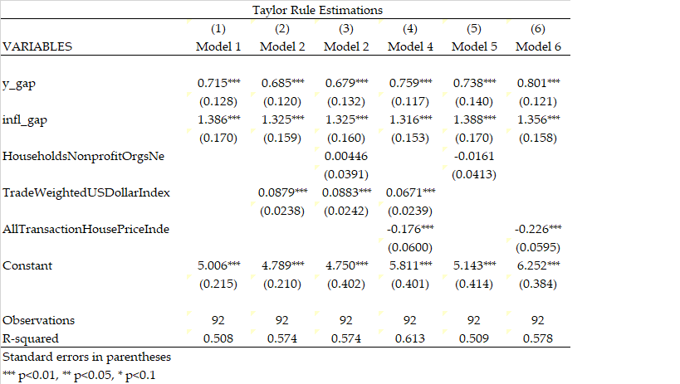
Source: Adapted from FRED data
All results are statistically significant except for the measure of housing asset prices: households and nonprofit organizations. Additionally, three out of the four measures of housing asset prices have negative coefficients, meaning that a unit increase in the price of the housing asset would result in a unit decrease in the FFR. It is not exactly clear how to interpret these coefficients for the Taylor rule in the U.S., especially as the Fed has stated that they do not respond to housing prices or to exchange rates—not in a regime that has a floating interest rate—in their policy decisions. Taylor’s original specification of the Taylor Rule has been subject to many studies since his 1993 paper, and Taylor (2008) stated that, “a common finding of this research [on Taylor rules] is the excellent performance of simple policy rules which do not react to asset prices, whether stocks, bonds, or exchange rates.” In addition, there may be a simultaneity issue here, as I am unsure in which direction causation runs with respect to housing prices and the FFR. Taylor (2001) found that adding the dollar/euro exchange rate to his simple monetary policy rule did not improve the rule’s performance, and added that, “rules that react directly to the exchange rate…do not work much better in stabilizing inflation and real output and sometimes work worse than policy rules that do not react directly to the exchange rate.” He used an example of the appreciation of the currency to hypothesize that an appreciation would affect GDP and inflation and is already accounted for indirectly in the Taylor rule. Meyer (2002) stated that simple monetary policy rules consistently performed just as well as more complex, extended Taylor rules. Therefore, for the counterfactual analysis that follows, I will use Model 1, which is the simplest and most appropriate form of the Taylor rule. I will also use a Taylor rule that uses Taylor’s original, arbitrary weights of 0.5 for both the inflation and output gap coefficients as a point of comparison.
Figure 2 shows the difference between real and potential GDP from 1985Q1 to 2017Q4. The output gap can be seen to dip into negative territory right around the recession of 1991, followed by a positive gap of around 2% at the height of the technology boom before going negative again in the wake of the 2001 recession, and finally, the output gap recovers just before
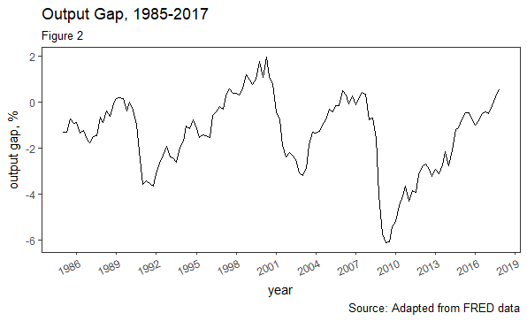
its precipitous drop in the aftermath of the financial crisis and the ensuing Great Recession. The output gap was negative until 2017Q3 and, in 2017Q4, it registered at 0.54%. This would seem to imply that the output gap would have a depressing effect on the FFR in the context of the Taylor rule. Examining the trajectory of the output gap in Graph 1 also leads me to believe that an FFR that rises between 2008 and the beginning of 2017 might have adverse effects on real GDP, as Keynesian theory would dictate that the government should be active with expansionary fiscal policy and that the Fed should keep the FFR low to attempt to stimulate the economy. If the FFR were raised too soon, according to some monetary policy rule, then this could have a negative effect on real GDP.
Figure 3 shows the behavior of the inflation gap from 1985Q1 to 2017Q4. A big drop in the price level is evidenced by the negative inflation gap that appears around 2009. The inflation gap remains relatively close to zero for much of the unconventional period with the exception of another pronounced negative gap that appears in 2015. A negative inflation gap would seem to
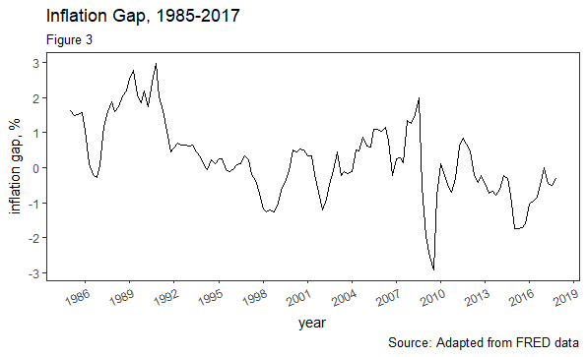
suggest that a monetary policy rule would recommend a lower FFR, possibly in line with the actual behavior of the FFR. This might suggest that any rise in the FFR that came too soon could have adverse effects on the economy.
Figure 4 shows the actual path of the FFR from 1985Q1 to 2017Q4. The graph shows the FFR moving in the expected direction from what we know of past business cycles. It decreases after the 1991 and 2001 recessions and drops to the zero lower bound after the financial crisis. Figure 5 shows the actual path of the FFR and the hypothetical paths of the synthetic FFR and the Taylor rule FFR. All three FFRs drop after the 1991 and 2001 recessions and are relatively close from 1985 to around 2001 or 2002, when, as Taylor (2008, 2012) mentioned, the monetary policy rule prescription has the FFR higher than the actual FFR. From this point, the behavior
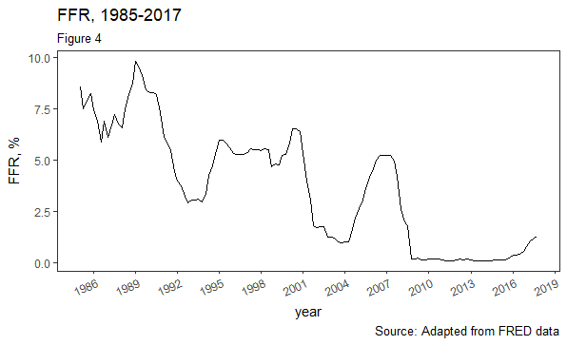
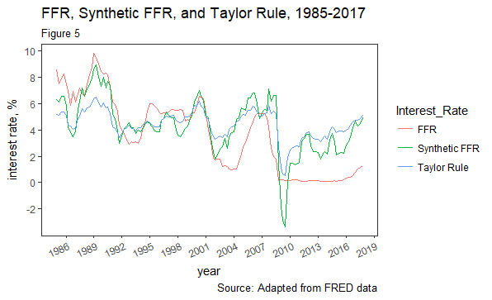
of the actual FFR compared to the two estimated FFRs is different, with the actual rate staying lower for longer. Additionally, the synthetic FFR violates the zero lower bound condition and goes negative in response to the financial crisis and ensuing recession. The two estimations also leave the zero lower bound and begin to rise much before the actual FFR. I want to know what effect staying at the zero lower bound for so long had on real GDP. Was is better that the FFR remained low for a long time, or should it have been raised according to the rule?
6.3 VAR
Chris Sims (1980) criticized large-scale statistical macroeconomic models for their harmful restrictions and introduced the Vector autoregression (VAR). In his paper, he discussed the restrictive assumptions that, among other things, “prevent[ed] lagged dependent variables from playing the same kind of formal role as strictly exogenous variables.”Sims also stated that the way in which the model-builders “construct claims for a connection between these models and reality—the style in which identification is achieved for these models—is inappropriate, to the point at which claims for identification in these models cannot be taken seriously.” (p. 1)
VARs are “key empirical tools in macroeconomics…[and] can provide superior forecasts to univariate time series models” than large models with multiple simultaneous equations. VARs resolved many of the problems that Sims had with large-scale statistical macroeconomic models. They are able to show the joint dynamics of time-series data. Furthermore, VARs addressed Sims’ critique of large-scale models, as they took rational expectations into consideration by viewing economic actors as rational, forward-looking actors that considered the effects of today’s decision on their utility in the future. In doing so, it can be argued that “no variable can be deemed exogenous.”
VARs have been used much over the last 38 years, since Sims wrote Macroeconomics and Reality. Choi and Wen (2010) used structural, three-variable VARs to estimate the reaction functions of the Fed, and Bernanke, Gertler, and Watson (1997) stated, “if one takes the VAR evidence on monetary policy seriously (as we do), then any case for an important role of monetary policy in the business cycle rests on the argument that the choice of the monetary policy rule (the “reaction function”) has significant macroeconomic effects.” (pp. 92-93) Romer and Romer (2004) used VARs to analyze their own measure of monetary shocks versus the actual federal funds rate in an attempt to examine the effect of monetary policy on output and prices. Hoover and Jorda (2001) wrote that “most quantitative analysis of monetary policy is now conducted using VARs.”
In a VAR model, all variables are considered endogenous; each variable is a function of its own lagged values and the lagged values of the other variables. The VAR for this paper can be considered:
$${FFR}_{t}=α+{β_{11}FFR}_{t-k}+β_{12}{y_gap}_{t-k}+{β_{13}infl_gap}_{t-k}+ε_{t}$$
$${y_gap}_{t}=α+{β_{21}y_gap}_{t-k}+{β_{22}infl_gap}_{t-k}+{β_{23}FFR}_{t-k}+ε_{t}$$
$${infl_gap}_{t}=α+{β_{31}infl_gap}_{t-k}+{β_{32}FFR}_{t-k}+{β_{33}y_gap}_{t-k}+ε_{t}$$
Where $k$ is the number of lags.
The matrix form of the proposed VAR is as follows:
$$\left(\begin{matrix}FFR_{t} \\ {y_gap}_{t} \\ {infl_gap}_{t}\end{matrix}\right)=\left( \begin{matrix}α \\ α \\ α\end{matrix}\right)+\left( \begin{matrix}β_{11} & β_{12} & β_{13} \\ β_{21} & β_{22} & β_{23} \\ β_{31} & β_{32} & β_{33}\end{matrix}\right)\left(\begin{matrix}{FFR}_{t-k} \\ {y_gap}_{t-k} \\ {infl_gap}_{t-k}\end{matrix}\right)+\left(\begin{matrix}ε \\ ε \\ ε\end{matrix}\right)$$
There are various selection criteria that can be used to decide on the number of lags. I estimated the number of lags using four of the more standard measures seen in Figure 6.

Figure 6: Lag Criteria and Selection for VAR
Selection-order criteria
Sample: 5 – 132 |  |  |  |  |  | Number of obs = 128
Lag | LL | LR | Df | p | FPE | AIC | HQIC | SBIC
0 | -203.414 |  |  |  | 0.00505 | 3.22522 | 3.25238 | 3.29206
1 | 51.663 | 510.15 | 9 | 0 | 0.00011 | -0.619734 | -0.5111 | .352356*
2 | 69.1992 | 35.072* | 9 | 0 | .000095* | -.753112* | -.562998* | 0.2852
3 | 77.2111 | 16.024 | 9 | 0.07 | 9.6E-05 | -0.737673 | -0.46608 | 0.06923
4 | 82.1235 | 9.8248 | 9 | 0.37 | 0.0001 | -0.673805 | -0.32073 | 0.19517

Source: Adapted from FRED data

The above table reports four lag selection criteria: Akaike’s final prediction error (FPE), Akaike’s information criterion (AIC), Hannan and Quinn’s information criterion (HQIC), and Schwarz’s Bayesian information criterion (SBIC). The FPE, AIC, and HQIC imply two lags, while the SBIC indicates one lag. Even though they are not equal, the results are close enough to indicate a lag length range. Stock and Watson (2001) suggested that the Akaike and Bayes criterion are standard in VAR analyses. However, they recommend different lag lengths. Becketti (2013) stated that the HQIC and SBIC provided “consistent estimates of the true lag
order, while the FPE and AIC overestimate the lag order with positive probability.” (p. 307) All things considered, I choose to estimate the model with two lags, per the HQIC and AIC.
The next step is to test the three variables of the reduced-form VAR equations for stationarity. The results of the augmented Dickey-Fuller test are seen below.
Figure 7: Augmented Dickey-Fuller test for unit root
variable | McKinnon Approximate p-value for Z(t)
Synthetic FFR | .1067
infl_gap | .0483
y_gap | .4393
Source: Adapted from FRED data
I cannot reject the null that the FFR contains a unit root. However, when I take the first difference, the results do not fit the Taylor rule analysis anymore. Therefore, I am simply stating that the FFR is non-stationary. The inflation gap is stationary at the 5% significance level and the output gap is stationary at the 11% significance level. I am uncertain of how to explain the inability to reject the null hypothesis that Synthetic FFR and output gap have unit roots, as they are percentage changes of the original variables, and are mean-reverting and should, by my estimation, have had the unit roots removed. Therefore, I move to another test of stationarity.
To further test the stationarity of the variables, I follow Becketti (2013) that “a VAR is stationary if all of the roots of
$$\left|Φ\left(z\right)\right|=0$$
lie outside the unit circle,” where the above equation represents our VAR. He further states that, “equivalently, all the eigenvalues of the companion matrix must lie inside the unit circle. To test this condition, I use the Eigenvalue stability condition. The results can be seen below.

Figure 8: Eigenvalue stability condition
Eigenvalue stability condition
Eigenvalue | Modulus
0.9116872 | 0.911687
.6574832 + .09934912i | 0.664947
.6574832 - .09934912i | 0.664947
0.2373944 | 0.237394
.00404196 + .1364617i | 0.136522
.00404196 - .1364617i | 0.136522
All the eigenvalues lie inside the unit circle
VAR satisfies stability condition.
Source: Adapted from FRED data.
While the three variables did not yield optimal results for the augmented Dickey-Fuller test, the above table confirms that the VAR under consideration does satisfy the eigenvalue stability condition that is “equivalent” to stationarity.
Now, I will turn to the VAR. I will discuss the theory implied by the Taylor rule and justify the ordering of the variables and how this will enable me to make more causal inferences when analyzing the OIRFs.
A reduced-form VAR can give useful information, but it is not much more than a correlation because of two-way feedback between the variables. For example, a reduced-form VAR would have the lagged synthetic FFR affecting the output gap, and the lagged output gap affecting the synthetic FFR. It is not possible to extract a meaningful causal relationship when this two-way feedback is present. Stock and Watson (2001) said that a structural VAR is able to identify relationships between variables by adding economic theory to the VAR model.
To impose structure on the VAR system, I use well-known and documented relationships between these three variables and the theory of the Taylor rule to justify the ordering of the VAR, which provides the structure. The dual mandate of the Fed implies that the Fed responds to both the inflation and output gaps when setting the FFR. The Taylor rule accounts for this well-known relationship between the three variables. Taylor (1993), in arguing for the use of rules over discretion, stated that the best rules are “responsive, calling for changes in the money supply, the monetary base, or the short-term interest rate in response to changes of the price level or real income.” This is why the FFR is ordered last in the equation, because it responds to the output gap, y_gap, and the inflation gap, infl_gap, in time t; however, the two gaps are only affected by the lagged value of the FFR. This policy lag is also well-known, as Mishkin states, “macroeconometric models of the U.S. economy, for example, suggest that monetary policy takes over a year to affect output and over two years to have a significant impact on inflation.” The output gap is the first term and the inflation gap is the middle term of my VAR. This order is motivated by the theory behind the short-run aggregate supply curve’s move from the short-term to the long-term. Let’s say that the economy is heating up and production is above the long-run aggregate supply curve. This implies that the labor market is tight and firms have to increase wages to keep up with increased aggregate demand. Eventually, most likely after a period of nominal stickiness, prices will have to rise, which will bring the economy back to the long-run aggregate supply curve, albeit at a higher price. In this model, the inflation gap is affected by output in time t, but output is not affected by inflation in time t. This theory justifies the ordering of the variables in the VAR. With the output gap first, the feedback from the FFR can be “shut off” and we can isolate and examine the response of the output gap to a shock in the FFR.
Hoover and Jorda (2001) stated that, in a VAR, “the action in the economy can be attributed to the error terms,” as the other variables are endogenous. However, these error terms are correlated with one another. In other words, the non-diagonal terms of the variance-covariance matrix are likely to be something other than zero:
$$E\left(ε_{tf},ε_{ty},ε_{ti}\right)=\left(\begin{matrix}Var\left(ε_{tf}\right) & Cov\left(ε_{tf},ε_{ty}\right) & Cov\left(ε_{tf},ε_{ti}\right) \\ Cov\left(ε_{tf},ε_{ty}\right) & Var\left(ε_{ty}\right) & Cov\left(ε_{ty},ε_{ti}\right) \\ Cov\left(ε_{tf},ε_{ti}\right) & Cov\left(ε_{ty},ε_{ti}\right) & Var\left(ε_{ti}\right)\end{matrix}\right)$$
The covariance between error terms in the above matrix implies that one “cannot distinguish the shocks…a shock [to one] equation would in general be associated with a correlated shock” to another equation. According to Hoover and Jorda (2001), with algebraic manipulation (and economic theory), the variance-covariance matrix can be transformed into a diagonal matrix, whose off-diagonal elements are equal to zero (as seen below).
This implies that the errors are now independent of one another and that the VAR can be used to examine causal relationships; now, the IRFs “could easily trace out the endogenous responses to the exogenous shocks.”
$$E\left(ε_{tf},ε_{ty},ε_{ti}\right)=\left(\begin{matrix}Var\left(ε_{tf}\right)… & 0 & 0 \\ 0 & Var\left(ε_{ty}\right)… & 0 \\ 0 & 0 & Var\left(ε_{ti}\right)…\end{matrix}\right)$$

7.1 Results: Impulse Response Functions
The ordering of the variables matters, as different orders can produce very different IRFs. Stock and Watson (2001) elaborate on this, saying, “the estimates of the structural impulse responses hinge on detailed knowledge of how the Fed sets interest rates.” There are six ways to order the VAR, meaning that I could manipulate the variance-covariance matrix in six different ways and, each time, this would result in different error terms and IRFs. However, the ordering I have chosen has been discussed and justified; therefore, the following IRFs can be understood as displaying the structural response of one variable to the impulse of another.
7.2 IRFs for the period 1985Q1 to 2007Q4
The IRFs below have the percentage change on the vertical axis and the steps on the horizontal axis. Each graph can be read as having the impulse first, followed by the variable that responds to the impulse. The IRF on which I focus in Figure 9, can be found in row 2, position 3, the last window moving left to right in row 2. Using this graph, we can analyze the response of the output gap to changes in the synthetic FFR for the period 1985Q1 to 2007Q4. Given a unit increase in the synthetic FFR, the output gap, y_gap, dips into negative territory by roughly 25 basis points within the first few quarters, after which, the slope flattens out and gradually rises but remains below zero throughout the entire period. This implies that, had the Fed set the FFR according to my estimated rule, it would have had a negative effect on monetary policy before the financial crisis and subsequent Great Recession ever began.
Figure 9: Impulse-Response Functions, synthetic FFR, the inflation gap, and output gap for period 1985Q1 to 2007Q4.
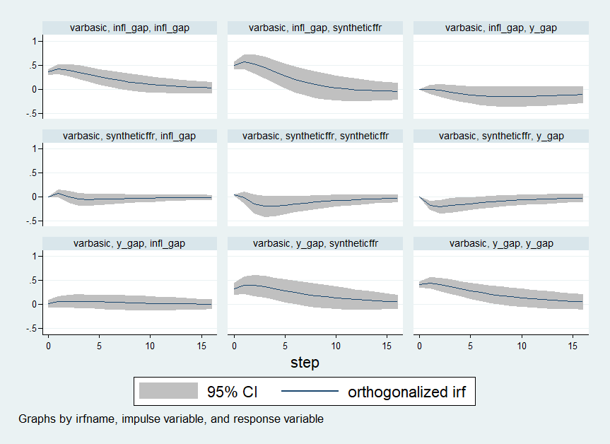
Source: Adapted from FRED data
Figure 10 below shows the IRFs for John Taylor’s original rule specifications in his 1993 paper during the period 1985Q1 to 2007Q4; the inflation and output gap coefficients are both 0.5, while the real rate of interest constant is the same 5.01 that was estimated earlier through OLS. Looking at the IRF of interest, with the Taylor rule estimation of the FFR as the impulse and the output gap as the response, again in row 2, position 3, it seems very similar to the IRF seen when using the synthetic FFR. In the first few quarters, the output gap goes negative about .25, and then begins to recover upwards on a flatter trajectory, but never becomes positive.
Figure 10: Impulse-Response Functions, Taylor rule FFR, the inflation gap, and output gap for period 1985Q1 to 2007Q4.
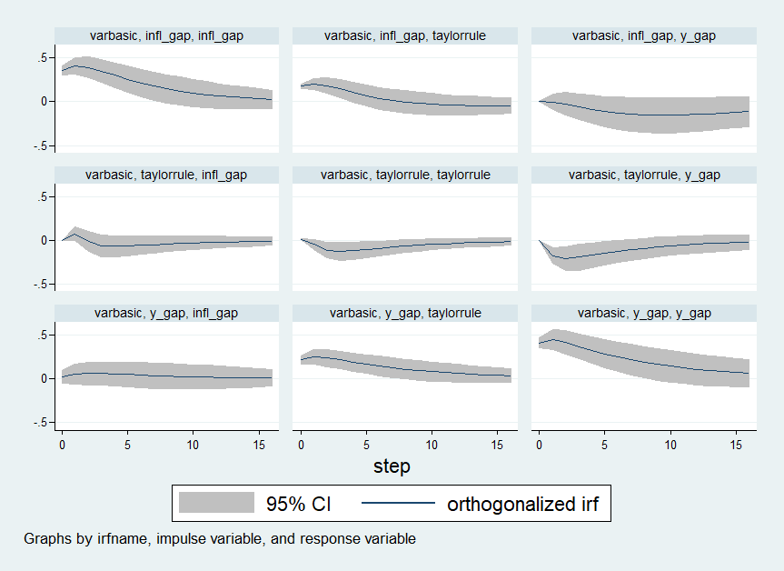
Once again, it seems that even though Taylor (1993) found that his monetary policy rule matched the actual behavior of the Fed from 1987-1992, it would not have necessarily been the best rule to follow for the entire period from 1985Q1 to 2007Q4. The drop in the first few quarters might be due to economic conditions that prevailed in the late 1970s and early 1980s. The Fed Chair at the time, Paul Volcker, was forced to fight out-of-control inflation that had built up throughout the 1960s and 1970s and the period between 1965-1982 became known as The Great Inflation. Inflation had risen from 1% to 14% during this period and unemployment was close to 10% in 1982. Beginning in 1979, Volcker took extraordinary measures to quash inflation; he targeted the money supply, cutting it drastically and causing the FFR to go above 20%. Poole (2005) points out that Volcker’s actions led to two recessions, but also got inflation back under control and laid the groundwork for The Great Moderation. By 1985Q1, the FFR was 8.42% yet the Taylor rule specifications recommend an FFR that differs by 3.5 percentage points: 5.16%. The actual FFR continues to be above the Taylor rule recommendation by a range of 2.38 to 3.42 percentage points until 1986:Q2. This implies that Volcker was still in the process of unwinding the Fed’s monetary policy of fighting inflation. In other words, the Fed was still using discretion to handle an extraordinary event and the imposition of a monetary policy rule would have had adverse effects on real GDP.
Both the IRF of the synthetic FFR and the Taylor rule FFR never become positive. Following the 1991 recession, the Fed kept the actual FFR lower for longer then the two rules under consideration would have called for from 1992Q3 to 1993Q3, as the synthetic FFR and Taylor rule FFR recommend rates that are between 1-1.5 percentage points higher than the actual FFR. Following the bursting of the tech bubble and the NASDAQ crash of 2001, in 2002, the Fed’s rate was 2 percentage points lower than the Taylor rule FFR and roughly 1.5 percentage points lower than the synthetic FFR. And, as Taylor (2012) mentioned, the Fed kept the rate a good deal lower than either estimated monetary policy rule recommended, with it being lower by 2.5-3.5 percentage points for a good deal of this period. Perhaps, the lower FFR led to an environment of easy money, in which economic actors became over-levered and this helped cause the housing boom and bust. However, maybe strict adherence to a rule, such as the two under consideration, would not have been the best policy either, as they would have had a negative impact on real GDP.
7.3 IRFs for the period 2008Q1 to 2017Q4
There is a debate among economists and politicians as to whether or not the unconventional monetary policy that the Fed has carried out since 2008 has been successful. As previously stated, I used data from what I defined as the conventional era of monetary policy, 1985Q1 to 2007Q4, to investigate the effects on real GDP of strict adherence to a monetary policy rule. In the second row and third position of Figure 11, the response of the output gap to changes in the synthetic FFR is negative. This implies that strict adherence to the monetary policy rule that produced the synthetic FFR would have had adverse effects on real GDP. The IRF shows the output gap becoming negative immediately and remaining in negative territory for the entire period. The drop in the output gap is not as pronounced as the drop during the 1985Q1 to 2007Q4 period; however, it is not that different either. This time, the slope of the drop is a little flatter and it drops to between 0.15-.20%. It then rises up along a relatively flatter slope, as the prior period did, but never becomes positive. In all, these results suggest that strict adherence to the Taylor rule that was estimated via OLS and that produced the synthetic FFR would have had negative effects on real GDP. Conversely, the Fed’s unconventional discretionary policy has led to one of the longest economic expansions in U.S. history.

Figure 11: Impulse-Response Functions, synthetic FFR, the inflation gap, and output gap for the post-2008 period, 2008:Q1 to 2017:Q4
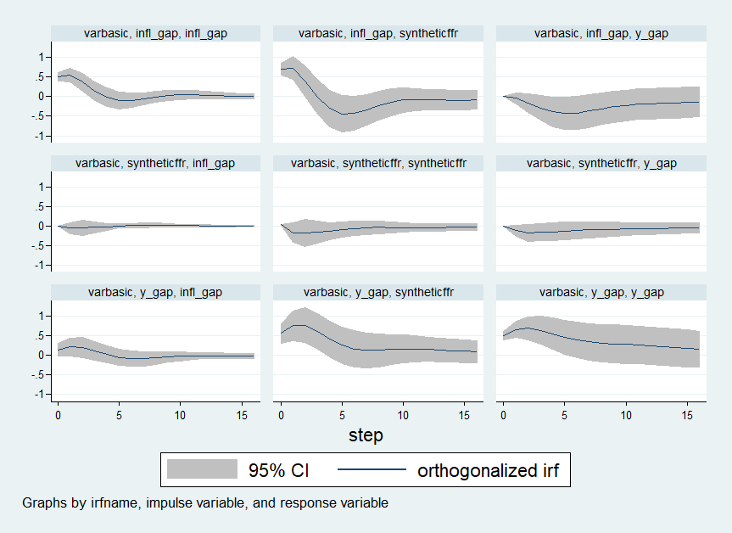
Source: Adapted from FRED data

Similarly, the IRF in the second row, third position of Figure 12 looks very similar to the above post-2008 graph of the IRF for the synthetic FFR and the output gap. In fact, it is almost identical. The reason that this is so most likely has to do with the fact that the discretionary policy of the Fed kept the FFR at zero for the better part of a decade, from 2008 and onward. Figure 13 zeros in on the FFR, synthetic FFR, and Taylor rule FFR together for the period 2008Q1 to 2017Q4. The graph shows that moving forward from 2010, the actual FFR remains at zero, while both he synthetic FFR and the Taylor rule FFR rise. The two monetary policy rule FFRs are closer to one another than is the actual FFR to either, which would explain the similarity of the two IRFs.
Figure 12: Impulse-Response Functions, Taylor rule FFR, the inflation gap, and output gap for the post-2008 period, 2008:Q1 to 2017:Q4
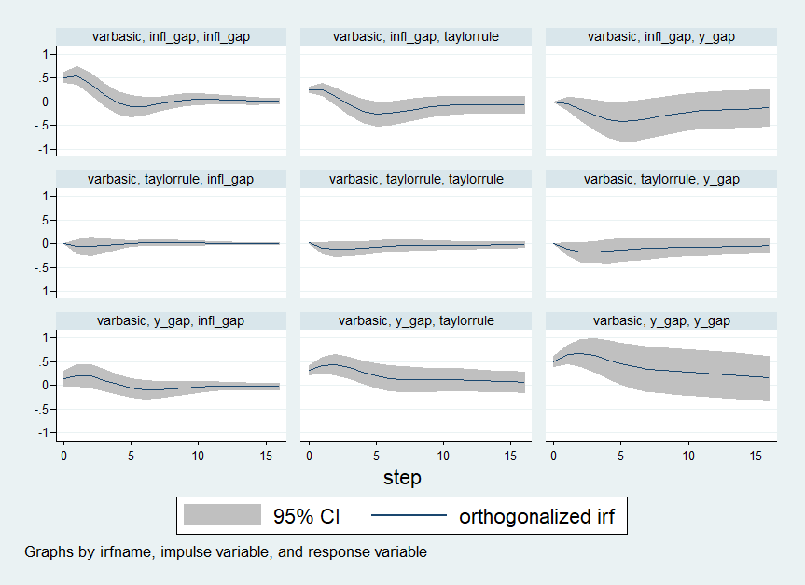
Source: Adapted from FRED data

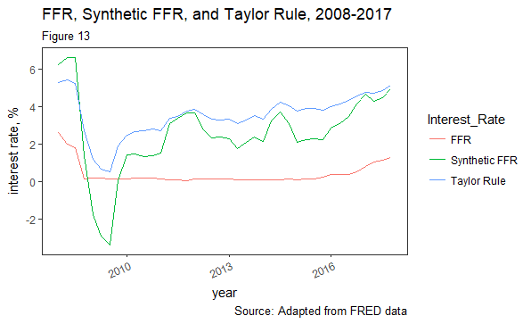

After reviewing the IRFs for both the synthetic and Taylor rule FFRs, it seems that strict adherence to either policy rule would have had a negative effect on real GDP, as measured by the output gap. It appears that the effect on real GDP was slightly more negative during the 1985Q1 to 2007Q4 period. During the unconventional post-2008 period, it appears that the discretionary policy of the Fed has been successful, as strict adherence to either monetary policy rule would have had negative effects on real GDP.
8.1 Conclusion
There has been a long-standing debate, going back to Simons (1936), over whether monetary policy should be rules-based or up to the discretion of the FOMC. This debate has become a controversial one in the context of the Fed’s response to the financial crisis and ensuing Great recession. Since 2009, John Taylor has argued for the Fed to shrink the balance sheet and return to rules-based monetary policy; that is, to set the FFR according to some version of the Taylor rule. Others, such as Neel Kashkari and Narayana Kocherlakota, argue that the Fed’s unconventional policy has been successful and that strict adherence to a Taylor rule would have led to adverse economic consequences.
In this paper, I looked at the effectiveness of the Fed’s unconventional monetary policy that was carried out in response to the extraordinary circumstances of 2008. I first examined monetary policy in some detail, in order to add sufficient context to the debate. Then, I addressed the rules versus discretion debate, after which, I turned to the financial crisis and the unconventional measures that the Fed took to unfreeze credit and keep the economy from collapsing. I then discussed Taylor’s 2012 paper criticizing the Fed’s unconventional policies and advocating for a return to rules-based monetary policy along with Kashkari’s 2017 paper claiming adherence to a Taylor rule would have damaged the economy and resulted in higher unemployment.
In order to determine what effect strict adherence to a monetary rule, a Taylor rule, would have had on real GDP, I used data from the Federal Reserve’s FRED website, focusing on the FFR, inflation, and output data from 1985Q1 to 2007Q4, which I defined as the conventional period. I used OLS to estimate the coefficients for a rule, and then used this rule to estimate a synthetic FFR. I also used the estimated constant of this model along with Taylor’s original coefficients of 0.5 for the inflation and output gaps in order to estimate the FFR that the Taylor rule would have recommended. From there, I estimated a VAR model, adding structure to it through ordering the output gap first, the inflation gap second, and the FFR, both the synthetic and the Taylor rule specification (in different analyses). This allowed me to examine the IRFs of the VAR and look at the effects that setting the FFR with a Taylor rule would have had on real GDP, as represented by the output gap. The results of the VAR and the IRFs implied that adherence to a Taylor rule would have had adverse effects on real GDP. The effects were in the range of 0.25% and lasted for multiple quarters, never reaching positive territory.
The analysis in this paper supports the idea that the discretion that the Fed used in implementing this unconventional policy was warranted and led to better results than adherence to a strict monetary policy rule. I am inclined to agree with Ben Bernanke, Janet Yellen, and others who have admitted that monetary policy rules, such as the Taylor rule, are valuable inputs into the policy decision-making process; however, there are “many factors to consider in [monetary policy] decisions,” and that the Fed must be allowed to use discretion to respond to extraordinary circumstances.

Bibliography
Admati and Hellwig, 2013, “The Bankers’ New Clothes: What’s Wrong with Banking and What to Do about It,” Princeton, New Jersey, Princeton University Press, 2013.
Asso, Kahn, and Leeson, 2010, “The Taylor Rule and the Practice of Central Banking,” The Federal Reserve Bank of Kansas City Economic Research Department, February, 2010. RWP 10-05.
Bech and Klee, 2009, “The Mechanics of a Graceful Exit: Interest on Reserves and Segmentation in the Federal Funds Market,” Federal Reserve Bank of New York Staff Reports, December, 2009, no. 416.
Becketti, Sean, 2013. “Introduction to Time Series Using Stata,” College Station, TX, Stata Press, 2013.
Benassy, 2009, “Interest Rate Rules and Global Determinacy: An Alternative to the Taylor Principle,” International Journal of Economic Theory, 5, no. 4, 2009. 1-26.
Bernanke, 2003, “Constrained Discretion and Monetary Policy,” speech before the Money Marketeers of New York University, New York, New York, February 3, 2003.
Bernanke, 2012, “How big a problem is the zero-lower bound on interest rates?”, Brookings, April 12, 2017. https://www.brookings.edu/blog/ben-bernanke/2017/04/12/how-big-a-problem-is-the-zero-lower-bound-on-interest-rates/
Bernanke, 2015, “The Taylor Rule: A Benchmark for Monetary Policy?” https://www.brookings.edu/blog/ben-bernanke/2015/04/28/the-taylor-rule-a-benchmark-for-monetary-policy/
Bernanke, 2015, “The Courage to Act,” New York, W.W. Norton and company, 2015.
Bernanke, Gertler, and Watson, 1997. “Systematic Monetary Policy and the Effects of Oil Price Shocks,” Brookings Papers on Economic Activity, 1:1997.
Board of Governors of the Federal Reserve System, “Open Market Operations,” last updated March 21, 2018. Retrieved May 27, 2018. https://www.federalreserve.gov/monetarypolicy/openmarket.htm
Bryan, 2013, “The Great Inflation: 1965-1982,” Federal Reserve Bank of Atlanta, November 22, 2013.
Carlin and Soskice, 2006, “Macroeconomics: Imperfections, Institutions, and Policies,” Great Clarendon Street, Oxford OX2 6DP, Oxford University Press, 2006. (142)
Chattopadhay and Daniel, 2017, “Taylor-Rule Exit Policies for the Zero Lower Bound,” MPRA paper 66076.
Choi and Wen, 2010, “Dissecting Taylor Rules in a Structural VAR,” Research Division of the Federal Reserve Bank of St. Louis Research Division Working Paper Series. January, 2010.
Choulet, 2015, “QE and Bank Balance Sheets: The American Experience,” Conjuncture, July/August, 2015, BNP Paribus.
Clarida, Gali, and Gertler, 2000, “Monetary Policy Rules and Macroeconomic Stability: Evidence and Some Theory,” The Quarterly Journal of Economics, February. 2000. 147-180.
D’Amico and King, 2010. “Flow and Stock Effects of Large-Scale Treasury Purchases,” Finance and Economics Discussion Series, Divisions of Research and Statistics and Monetary Affairs Federal Reserve Board, Washington, D.C., 2010.
Economist, The “The Origins of the Financial Crisis: Crash Course,” The Economist, September 7, 2013.
Federal Reserve Bank of St. Louis, “Does Quantitative Easing Work as Advertised?” On the Economy Blog, November 30, 2017. https://www.stlouisfed.org/on-the-economy/2017/november/does-quantitative-easing-work-advertised
Financial Crisis Inquiry Commission, The 2011, “The Financial Crisis Inquiry Report,” Government Publishing Office, 2011. (41)
Goodfriend, 2002, “Interest on Reserves and Monetary Policy,” The Federal Reserve Bank of New York, FRBNY Economic Policy Review, Forthcoming, 2002.
Guillen, 2011, “The Global Economic and Financial Crisis: A Timeline,” The Lauder Institute, Wharton Arts and Sciences, University of Pennsylvania, 2011. Retrieved May 27, 2018. http://unpan1.un.org/intradoc/groups/public/documents/apcity/unpan033507.pdf
Hetzel, 2000, “The Taylor Rule: Is It a Useful Guide to Understanding Monetary Policy?”, Federal Reserve Bank of Richmond, Economic Quarterly, 86, no. 2, 1-33.
Hakkio and Kahn, 2014, “Evaluating Monetary Policy at the Zero Lower Bound,” Federal Reserve Bank of Kansas City, Economic Review, Second Quarter.
Hoover and Jorda, 2001. “Measuring Systematic Monetary Policy,” Federal Reserve Bank of St. Louis Review, July/August 2001. (113-138)
Ihrig, Meade, and Weinbach, 2015, “Rewriting Monetary Policy 101: What’s the Fed’s Preferred Post-Crisis Approach to Raising Interest Rates?”, Journal of Economic Perspectives, 29, no. 4, Fall 2015, 177-198. (184)
Joyce, Miles, Scott, and Vayanos, 2012. “Quantitative Easing and Unconventional Monetary Policy – An Introduction,” The Economic Journal, vol. 122, issue 564, F271-F288.
Kashkari, 2017, “The Taylor Rule Would Kept Millions Out of Work,” last modified January 5, 2017. Retrieved May 27, 2018. https://medium.com/@neelkashkari/taylor-rule-would-have-kept-millions-out-of-work-9ab31fd826bf
Keister, Martin, and McAndrews, 2008, “Divorcing Money from Monetary Policy,” The Federal Reserve Bank of New York, FRBNY Economic Policy Review, September 2008.
Khan, 2012, “Estimated Rules for Monetary Policy,” The Federal Reserve Bank of Kansas City, Economic Review, Fourth Quarter, 2012.
Kocherlakota, 2016, “Rules Versus Discretion: A Reconsideration,” Brookings Papers on Economic Activity, Fall, 2016.
Kydland and Prescott, 1977, “Rules Rather than Discretion: The Inconsistency of Optimal Plans,” The Journal of Political Economy, 85, No. 3 (June, 1977), 473-492
Lucas, 1976, “Econometric Policy Evaluation: A Critique,” The Carnegie-Rochester Conference Series, vol. 1, 1976, 19-46.
Meyer, Laurence, 2002, “Rules and Discretion,” Presentation at the Owen Graduate School of Management, Vanderbilt University, Nashville, Tennessee January 16, 2002, https://www.federalreserve.gov/boarddocs/speeches/2002/200201162/default.htm
Mishkin, 2013, “The Economics of Money, Banking, and Financial Markets,” 10th ed. Upper Saddle River, New Jersey, Pearson, 2013) 411-12
Orphanides, 1997, “Monetary Policy Rules Based on Real-Time Data,” Board of Governors of the Federal Reserve System, December, 1997.
Orphanides, 2007, “Taylor Rules,” Board of Governors of the Federal Reserve System, January, 2007.
Pierdzioch, Rulke, and Stadtmann, 2012, “Who believes in the Taylor principle? Evidence from the Livingston survey,” Economics Letters, 117, no. 1, 96-98. (96)
Poole, 2005. “President’s Message: Volcker’s Handling of the Great Inflation Taught Us Much,” Federal Reserve Bank of St. Louis, The Regional Economist, January, 2005.
Popescu, Adina. “Module 5: Session 1: Introduction to Vector Auto Regression (VAR),” YouTube, January 15, 2016. https://www.youtube.com/watch?v=CCinpWc2nXA
Romer and Romer, 2004. “A New Measure of Monetary Shocks: Derivation and Implications,” The American Economic Review, September, 2004, 1055-1084.
Segoviano, Jones, Linder, and Blankenheim, 2013, “Securitization: Lessons Learned and the Road Ahead,” IMF Working Paper, Monetary and Capital Markets Department, WP/13/255, 1-74.
S&P Dow Jones Indices LLC, S&P/Case-Shiller 20-City Composite Home Price Index [SPCS20RSA], retrieved from FRED, Federal Reserve Bank of St. Louis; https://fred.stlouisfed.org/series/SPCS20RSA, May 27, 2018.
Simons, Henry C. "Rules versus authorities in monetary policy." Journal of political economy 44, no. 1 (1936): 1-30.
Sims, Christopher. 1980. “Macroeconomics and Reality,” Econometrica, 48, no. 1, January, 1980, 1-48.
Steelman, 2011, “The Federal Reserve's "Dual Mandate": The Evolution of an Idea,” The Federal Reserve Bank of Richmond Economic Brief, December, 2011, EB 11-12.
Stock and Watson, 2001. “Vector Autoregressions.” Journal of Economic Perspectives 15, no. 4 (2001): 101-115.
Taylor, 1993, “Discretion Versus Policy Rules in Practice,” Carnegie-Rochester Series on Public Policy 39. 195-214.
Taylor, 2001. “The Role of the Exchange Rate in Monetary-Policy Rules,” American Economic Review, 91, no. 2, May, 2001, 263-267.
Taylor, 2007, “Housing and Monetary Policy,” Policy Panel at the Symposium on Housing, Housing Finance, and Monetary Policy sponsored by the Federal Reserve Bank of Kansas City in Jackson Hole, Wyoming, 2007.
Taylor, 2008. “The Costs and Benefits of Deviating from the Systematic Component of Monetary Policy,” Keynote Address at the Federal Reserve Bank of San Francisco on Monetary Policy and Asset Markets, February 22, 2008, 1-10.
Taylor, 2008, “The Need for a Clear and Credible Exit Strategy,” in John Ciorciari and John Taylor, eds., The Road Ahead for the Fed. Chap. 6. Stanford, CA: Hoover Institution Press, 85-100.
Taylor, 2012, “Monetary Policy Rules Work and Discretion Doesn’t: A Tale of Two Eras,” Journal of Money, Credit, and Banking, 44, no. 6 (2012): 1017-1032.
Taylor, Congressional Testimony, March 26, 2014, “After Unconventional Monetary Policy,” Testimony before the Joint Economic Committee of Congress at the Hearing on “Unwinding Quantitative Easing: How the Fed Should Promote Stable Prices, Economic Growth and Job Creation” March 26, 2014.
Walter and Courtois, 2009, “The Effect of interest on Reserves on Monetary Policy,” The Federal Reserve Bank of Richmond Economic Brief, December, 2009, EB 09-12.
Wheelock, 2010, “Lessons Learned? Comparing the Federal Reserve’s Responses to the Crises of 1929-1933 and 2007-2009,” Federal Reserve Bank of St. Louis, Review, March/April 2010, 92, no. 2, 89-107.
Yu, 2016. “Did Quantitative Easing Work?”, Federal Reserve Bank of Philadelphia, Economic Insights, First Quarter, 2016.

Kashkari, 2017, “The Taylor Rule Would Kept Millions Out of Work,” last modified January 5, 2017. https://medium.com/@neelkashkari/taylor-rule-would-have-kept-millions-out-of-work-9ab31fd826bf
Taylor, 2012, “Monetary Policy Rules Work and Discretion Doesn’t: A Tale of Two Eras,” Journal of Money, Credit, and Banking, 44, no. 6 (2012): 1017-1032. (1025)
Taylor, 2008, “The Need for a Clear and Credible Exit Strategy,” in John Ciorciari and John Taylor, eds., The Road Ahead for the Fed. Chap. 6. Stanford, CA: Hoover Institution Press, 2009, pp. 85-100, (92)
Kashkari, 2017, “The Taylor Rule Would Kept Millions Out of Work,” last modified January 5, 2017. https://medium.com/@neelkashkari/taylor-rule-would-have-kept-millions-out-of-work-9ab31fd826bf
Bech and Klee, 2009, “The Mechanics of a Graceful Exit: Interest on Reserves and Segmentation in the Federal Funds Market,” Federal Reserve Bank of New York Staff Reports, December, 2009, no. 416.
Frederic Mishkin, 2013, “The Economics of Money, Banking, and Financial Markets,” 10th ed. Upper Saddle River, New Jersey, Pearson, 2013) 411-12
Mishkin, Frederic. 2013, “The Economics of Money, Banking, and Financial Markets,” 10th ed. Upper Saddle River, New Jersey, Pearson, 2013) 415-16
Steelman, 2011, “The Federal Reserve's "Dual Mandate": The Evolution of an Idea,” The Federal Reserve Bank of Richmond Economic Brief, December, 2011, EB 11-12. (1)
Keister, Martin, and McAndrews, 2008, “Divorcing Money from Monetary Policy,” The Federal Reserve Bank of New York, FRBNY Economic Policy Review, September 2008, 41-56. (45)
Walter and Courtois, 2009, “The Effect of interest on Reserves on Monetary Policy,” The Federal Reserve Bank of Richmond Economic Brief, December, 2009, EB 09-12. (2)
Walter and Courtois, 2009, “The Effect of interest on Reserves on Monetary Policy,” The Federal Reserve Bank of Richmond Economic Brief, December, 2009, EB 09-12. (2)
Mishkin, 2013, “The Economics of Money, Banking, and Financial Markets,” 10th ed. Upper Saddle River, New Jersey, Pearson, 2013 415-16; Asso, Kahn, and Leeson, 2010, “The Taylor Rule and the Practice of Central Banking,” The Federal Reserve Bank of Kansas City Economic Research Department, February, 2010. RWP 10-05.; Orphanides, 2007, “Taylor Rules,” Board of Governors of the Federal Reserve System, January, 2007.
Simons, Henry. 1936. “Rules versus Authorities in monetary policy,” Journal of Political Economy, 44, no. 1, February, 1936. (1-30)
Taylor, 2012, “Monetary Policy Rules Work and Discretion Doesn’t: A Tale of Two Eras,” Journal of Money, Credit, and Banking, 44, no. 6 (2012): 1017-1032, (abstract)
Laurence Meyer, 2002, “Rules and Discretion,” Presentation at the Owen Graduate School of Management, Vanderbilt University, Nashville, Tennessee January 16, 2002, https://www.federalreserve.gov/boarddocs/speeches/2002/200201162/default.htm, (5)
Asso, Kahn, and Leeson, 2010, “The Taylor Rule and the Practice of Central Banking,” The Federal Reserve Bank of Kansas City Economic Research Department, February, 2010. RWP 10-05., (abstract)
Asso, Kahn, and Leeson, 2010, “The Taylor Rule and the Practice of Central Banking,” The Federal Reserve Bank of Kansas City Economic Research Department, February, 2010. RWP 10-05., (5)
Taylor, 1993, “Discretion Versus Policy Rules in Practice,” Carnegie-Rochester Series on Public Policy 39. 195-214. (202)
In “Discretion Versus Policy Rules in Practice,” Taylor also assumes an equilibrium real interest rate of 2% noting that this “…rate is close to the assumed steady-state growth rate of 2.2 percent.”
Laurence Meyer, 2002, “Rules and Discretion,” Presentation at the Owen Graduate School of Management, Vanderbilt University, Nashville, Tennessee January 16, 2002, https://www.federalreserve.gov/boarddocs/speeches/2002/200201162/default.htm, (11)
Benassy, 2009, “Interest Rate Rules and Global Determinacy: An Alternative to the Taylor Principle,” International Journal of Economic Theory, 5, no. 4, 2009. 1-26.; Mankiw, 2010, “Macroeconomics,” 7th ed. New York, New York, Worth Publishers, 2010. (415-16)
Clarida, Gali, and Gertler, 2000, “Monetary Policy Rules and Macroeconomic Stability: Evidence and Some Theory,” The Quarterly Journal of Economics, February. 2000. 147-180.; Mishkin, 2013, “The Economics of Money, Banking, and Financial Markets,” 10th ed. Upper Saddle River, New Jersey, Pearson, 2013. (404)
Clarida, Gali, and Gertler, 2000, “Monetary Policy Rules and Macroeconomic Stability: Evidence and Some Theory,” The Quarterly Journal of Economics, February. 2000. (150-51)
Laurence Meyer, 2002, “Rules and Discretion,” Presentation at the Owen Graduate School of Management, Vanderbilt University, Nashville, Tennessee January 16, 2002, https://www.federalreserve.gov/boarddocs/speeches/2002/200201162/default.htm, (12); Carlin and Soskice, 2006, “Macroeconomics: Imperfections, Institutions, and Policies,” Great Clarendon Street, Oxford OX2 6DP, Oxford University Press, 2006. (142)
Taylor, 1993, “Discretion Versus Policy Rules in Practice,” Carnegie-Rochester Series on Public Policy 39. 195-214. (202)
Clarida, Gali, and Gertler, 2000, “Monetary Policy Rules and Macroeconomic Stability: Evidence and Some Theory,” The Quarterly Journal of Economics, February. 2000. (157)
Orphanides, 1997, “Monetary Policy Rules Based on Real-Time Data,” Board of Governors of the Federal Reserve System, December, 1997. (31)
Taylor, 1993, “Discretion Versus Policy Rules in Practice,” Carnegie-Rochester Series on Public Policy 39. (197)
Taylor, 1993, “Discretion Versus Policy Rules in Practice,” Carnegie-Rochester Series on Public Policy 39. (208)
Taylor, 2012, “Monetary Policy Rules Work and Discretion Doesn’t: A Tale of Two Eras,” Journal of Money, Credit, and Banking, 44, no. 6 (2012): 1017-1032.
Lucas, 1976, “Econometric Policy Evaluation: A Critique,” The Carnegie-Rochester Conference Series, vol. 1, 1976, 19-46. (41)
Kydland and Prescott, 1977, “Rules Rather than Discretion: The Inconsistency of Optimal Plans,” The Journal of Political Economy, 85, No. 3 (June, 1977), 473-492
Meyer, 2002, “Rules and Discretion,” Presentation at the Owen Graduate School of Management, Vanderbilt University, Nashville, Tennessee January 16, 2002, https://www.federalreserve.gov/boarddocs/speeches/2002/200201162/default.htm, (5)
Taylor, 2012, “Monetary Policy Rules Work and Discretion Doesn’t: A Tale of Two Eras,” Journal of Money, Credit, and Banking, 44, no. 6 (2012): 1018.
Pierdzioch, Rulke, and Stadtmann, 2012, “Who believes in the Taylor principle? Evidence from the Livingston survey,” Economics Letters, 117, no. 1, 96-98. (96)
Meyer, 2002, “Rules and Discretion,” Presentation at the Owen Graduate School of Management, Vanderbilt University, Nashville, Tennessee January 16, 2002, https://www.federalreserve.gov/boarddocs/speeches/2002/200201162/default.htm, (14)
Orphanides, 2007, “Taylor Rules,” Board of Governors of the Federal Reserve System, January, 2007. (11)
Asso, Kahn, and Leeson, 2010, “The Taylor Rule and the Practice of Central Banking,” The Federal Reserve Bank of Kansas City Economic Research Department, February, 2010. RWP 10-05., (1)
Kocherlakota, 2016, “Rules Versus Discretion: A Reconsideration,” Brookings Papers on Economic Activity, Fall, 2016. (abstract)
Orphanides, 1997, “Monetary Policy Rules Based on Real-Time Data,” Board of Governors of the Federal Reserve System, December, 1997. (abstract)
Orphanides, 2007, “Taylor Rules,” Board of Governors of the Federal Reserve System, January, 2007. (10)
Hetzel, 2000, “The Taylor Rule: Is It a Useful Guide to Understanding Monetary Policy?”, Federal Reserve Bank of Richmond, Economic Quarterly, 86, no. 2, 1-33. (11)
Clarida, Gali, and Gertler, 2000, “Monetary Policy Rules and Macroeconomic Stability: Evidence and Some Theory,” The Quarterly Journal of Economics, February. 2000. (178)
Meyer, 2002, “Rules and Discretion,” Presentation at the Owen Graduate School of Management, Vanderbilt University, Nashville, Tennessee January 16, 2002, https://www.federalreserve.gov/boarddocs/speeches/2002/200201162/default.htm, (32)
Bernanke, 2012, “How big a problem is the zero-lower bound on interest rates?”, Brookings, April 12, 2017. https://www.brookings.edu/blog/ben-bernanke/2017/04/12/how-big-a-problem-is-the-zero-lower-bound-on-interest-rates/
Chattopadhay and Daniel, 2017, “Taylor-Rule Exit Policies for the Zero Lower Bound,” MPRA paper 66076. (abstract); Chattopadhay and Daniel did conclude “that a Taylor Rule, with an optimally-chosen exit date and time varying inflation target, delivers fully optimal policy at the [zero-lower bound]”
Hakkio and Kahn, 2014, “Evaluating Monetary Policy at the Zero Lower Bound,” Federal Reserve Bank of Kansas City, Economic Review, Second Quarter. (3)
Choi and Wen, 2010, “Dissecting Taylor Rules in a Structural VAR,” Research Division of the Federal Reserve Bank of St. Louis Research Division Working Paper Series. January, 2010. (1)
Bernanke, 2015, “The Taylor Rule: A Benchmark for Monetary Policy?” https://www.brookings.edu/blog/ben-bernanke/2015/04/28/the-taylor-rule-a-benchmark-for-monetary-policy/.
Khan, 2012, “Estimated Rules for Monetary Policy,” The Federal Reserve Bank of Kansas City, Economic Review, Fourth Quarter, 2012. (6)
S&P Dow Jones Indices LLC, S&P/Case-Shiller 20-City Composite Home Price Index [SPCS20RSA], retrieved from FRED, Federal Reserve Bank of St. Louis; https://fred.stlouisfed.org/series/SPCS20RSA, May 27, 2018.
Taylor, 2007, “Housing and Monetary Policy,” Policy Panel at the Symposium on Housing, Housing Finance, and Monetary Policy sponsored by the Federal Reserve Bank of Kansas City in Jackson Hole, Wyoming. (3)
Segoviano, Jones, Linder, and Blankenheim, 2013, “Securitization: Lessons Learned and the Road Ahead,” IMF Working Paper, Monetary and Capital Markets Department, WP/13/255, 1-74. (9)
The Financial Crisis Inquiry Commission, 2011, “The Financial Crisis Inquiry Report,” Government Publishing Office, 2011. (41)
“The Origins of the Financial Crisis: Crash Course,” The Economist, September 7, 2013.
Mishkin, 2013, “The Economics of Money, Banking, and Financial Markets,” 10th ed. Upper Saddle River, New Jersey, Pearson, 2013. (193)
Mishkin, 2013, “The Economics of Money, Banking, and Financial Markets,” 10th ed. Upper Saddle River, New Jersey, Pearson, 2013. (193)
Mishkin, 2013, “The Economics of Money, Banking, and Financial Markets,” 10th ed. Upper Saddle River, New Jersey, Pearson, 2013.; “The Origins of the Financial Crisis: Crash Course,” The Economist, September 7, 2013.
Admati and Hellwig, 2013, “The Bankers’ New Clothes: What’s Wrong with Banking and What to Do about It,” Princeton, New Jersey, Princeton University Press, 2013. (7)
Guillen, 2011, “The Global Economic and Financial Crisis: A Timeline,” The Lauder Institute, Wharton Arts and Sciences, University of Pennsylvania, 2011. http://unpan1.un.org/intradoc/groups/public/documents/apcity/unpan033507.pdf
Wheelock, 2010, “Lessons Learned? Comparing the Federal Reserve’s Responses to the Crises of 1929-1933 and 2007-2009,” Federal Reserve Bank of St. Louis, Review, March/April 2010, 92, no. 2, 89-107.; Mishkin, 2013, “The Economics of Money, Banking, and Financial Markets,” 10th ed. Upper Saddle River, New Jersey, Pearson, 2013. (373) The acronyms stand for the following: Term Auction Facility, Term Securities Lending Facility, Primary Dealer Credit Facility, Asset-backed Commercial Paper Money Market Mutual Fund Liquidity Facility, Commercial Paper Funding Facility, Money Market Investor Funding Facility, Term Asset-Backed Securities Loan Facility
Choulet, 2015, “QE and Bank Balance Sheets: The American Experience,” Conjuncture, July/August, 2015, BNP Paribus.
Ihrig, Meade, and Weinbach, 2015, “Rewriting Monetary Policy 101: What’s the Fed’s Preferred Post-Crisis Approach to Raising Interest Rates?”, Journal of Economic Perspectives, 29, no. 4, Fall 2015, 177-198. (184)
“Open Market Operations,” The Board of Governors of the Federal Reserve System, last updated March 21, 2018. https://www.federalreserve.gov/monetarypolicy/openmarket.htm
Bernanke, 2015, “The Courage to Act,” New York, W.W. Norton and company, 2015. (325)
Walter and Courtois, 2009, “The Effect of interest on Reserves on Monetary Policy,” The Federal Reserve Bank of Richmond Economic Brief, December, 2009, EB 09-12. (2); Bech and Klee, 2009, “The Mechanics of a Graceful Exit: Interest on Reserves and Segmentation in the Federal Funds Market,” Federal Reserve Bank of New York Staff Reports, December, 2009, no. 416
Walter and Courtois, 2009, “The Effect of interest on Reserves on Monetary Policy,” The Federal Reserve Bank of Richmond Economic Brief, December, 2009, EB 09-12.
Keister, Martin, and McAndrews, 2008, “Divorcing Money from Monetary Policy,” The Federal Reserve Bank of New York, FRBNY Economic Policy Review, September 2008. (41)
Keister, Martin, and McAndrews, 2008, “Divorcing Money from Monetary Policy,” The Federal Reserve Bank of New York, FRBNY Economic Policy Review, September 2008. (45)
Keister, Martin, and McAndrews, 2008, “Divorcing Money from Monetary Policy,” The Federal Reserve Bank of New York, FRBNY Economic Policy Review, September 2008.; Goodfriend, 2002. The Federal Reserve Bank of New York, FRBNY Economic Policy Review, Forthcoming, 2002.
Taylor, 2012, “Monetary Policy Rules Work and Discretion Doesn’t: A Tale of Two Eras,” Journal of Money, Credit, and Banking, 44, no. 6 (2012): 1017-1032. (1019)
Taylor, 2012, “Monetary Policy Rules Work and Discretion Doesn’t: A Tale of Two Eras,” Journal of Money, Credit, and Banking, 44, no. 6 (2012). (1023)
Asso, Kahn, and Leeson, 2010, “The Taylor Rule and the Practice of Central Banking,” The Federal Reserve Bank of Kansas City Economic Research Department, February, 2010. RWP 10-05. (29)
Kashkari, 2017, “The Taylor Rule Would Kept Millions Out of Work,” last modified January 5, 2017. https://medium.com/@neelkashkari/taylor-rule-would-have-kept-millions-out-of-work-9ab31fd826bf
Bernanke, 2015, “The Courage to Act,” New York, W.W. Norton and company, 2015. (567)
Joyce, Miles, Scott, and Vayanos, 2012. “Quantitative Easing and Unconventional Monetary Policy – An Introduction,” The Economic Journal, vol. 122, issue 564, F271-F288. (F287).
D’Amico and King, 2010. “Flow and Stock Effects of Large-Scale Treasury Purchases,” Finance and Economics Discussion Series, Divisions of Research and Statistics and Monetary Affairs Federal Reserve Board, Washington, D.C., 2010.
Yu, 2016. “Did Quantitative Easing Work?”, Federal Reserve Bank of Philadelphia, Economic Insights, First Quarter, 2016. (11)
“Does Quantitative Easing Work as Advertised?”, Federal Reserve Bank of St. Louis, On the Economy Blog, November 30, 2017. https://www.stlouisfed.org/on-the-economy/2017/november/does-quantitative-easing-work-advertised
Taylor, Congressional Testimony, March 26, 2014, “After Unconventional Monetary Policy,” Testimony before the Joint Economic Committee of Congress at the Hearing on “Unwinding Quantitative Easing: How the Fed Should Promote Stable Prices, Economic Growth and Job Creation” March 26, 2014. (1)
Taylor, 2012, “Monetary Policy Rules Work and Discretion Doesn’t: A Tale of Two Eras,” Journal of Money, Credit, and Banking, 44, no. 6 (2012): 1017-1032.
Bernanke, 2003, “Constrained Discretion and Monetary Policy,” speech before the Money Marketeers of New York University, New York, New York, February 3, 2003.
Clarida, Gali, and Gertler, 2000, “Monetary Policy Rules and Macroeconomic Stability: Evidence and Some Theory,” The Quarterly Journal of Economics, February. 2000. 147-180.
Taylor, 2008. “The Costs and Benefits of Deviating from the Systematic Component of Monetary Policy,” Keynote Address at the Federal Reserve Bank of San Francisco on Monetary Policy and Asset Markets, February 22, 2008, 1-10. (6)
Taylor, 2001. “The Role of the Exchange Rate in Monetary-Policy Rules,” American Economic Review, 91, no. 2, May, 2001, 263-267. (267)
Meyer, 2002, “Rules and Discretion,” Presentation at the Owen Graduate School of Management, Vanderbilt University, Nashville, Tennessee January 16, 2002, https://www.federalreserve.gov/boarddocs/speeches/2002/200201162/default.htm. (14)
Taylor, 2008. “The Costs and Benefits of Deviating from the Systematic Component of Monetary Policy,” Keynote Address at the Federal Reserve Bank of San Francisco on Monetary Policy and Asset Markets, February 22, 2008, 1-10. Taylor, 2012, “Monetary Policy Rules Work and Discretion Doesn’t: A Tale of Two Eras,” Journal of Money, Credit, and Banking, 44, no. 6 (2012): 1017-1032.
Sims, Christopher. 1980. “Macroeconomics and Reality,” Econometrica, 48, no. 1, January, 1980, 1-48. (5)
Sims, Christopher. 1980. “Macroeconomics and Reality,” Econometrica, 48, no. 1, January, 1980, 1-48. (1)
Adina Popescu, “Module 5: Session 1: Introduction to Vector Auto Regression (VAR),” YouTube, January 15, 2016. https://www.youtube.com/watch?v=CCinpWc2nXA
Adina Popescu, “Module 5: Session 1: Introduction to Vector Auto Regression (VAR),” YouTube, January 15, 2016. https://www.youtube.com/watch?v=CCinpWc2nXA Choi and Wen, 2010, “Dissecting Taylor Rules in a Structural VAR,” Research Division of the Federal Reserve Bank of St. Louis Research Division Working Paper Series. January, 2010.
Bernanke, Gertler, and Watson, 1997. “Systematic Monetary Policy and the Effects of Oil Price Shocks,” Brookings Papers on Economic Activity, 1:1997.
Romer and Romer, 2004. “A New Measure of Monetary Shocks: Derivation and Implications,” The American Economic Review, September, 2004, 1055-1084.
Hoover and Jorda, 2001. “Measuring Systematic Monetary Policy,” Federal Reserve Bank of St. Louis Review, July/August 2001. (113-138)
Becketti, Sean, 2013. “Introduction to Time Series Using Stata,” College Station, TX, Stata Press, 2013. (306)
Becketti, Sean, 2013. “Introduction to Time Series Using Stata,” College Station, TX, Stata Press, 2013.
Becketti, Sean, 2013. “Introduction to Time Series Using Stata,” College Station, TX, Stata Press, 2013. (309)
Becketti, Sean, 2013. “Introduction to Time Series Using Stata,” College Station, TX, Stata Press, 2013. (309)
Stock and Watson, 2001. “Vector Autoregressions.” Journal of Economic Perspectives 15, no. 4, 2001. (103)
Taylor, 1993, “Discretion Versus Policy Rules in Practice,” Carnegie-Rochester Series on Public Policy 39. (196)
Mishkin, 2013, “The Economics of Money, Banking, and Financial Markets,” 10th ed. Upper Saddle River, New Jersey, Pearson, 2013. (391)
Hoover and Jorda, 2001. “Measuring Systematic Monetary Policy,” Federal Reserve Bank of St. Louis Review, July/August 2001. (117)
Matrix is not the actual transformed variance-covariance matrix. Used to illustrate what it might look like. Actual variance-covariance solution is beyond the scope of this paper.
Stock and Watson, 2001. “Vector Autoregressions.” Journal of Economic Perspectives 15, no. 4, 2001.; Becketti, Sean, 2013. “Introduction to Time Series Using Stata,” College Station, TX, Stata Press, 2013.
Poole, 2005. “President’s Message: Volcker’s Handling of the Great Inflation Taught Us Much,” Federal Reserve Bank of St. Louis, The Regional Economist, January, 2005; Bryan, 2013, “The Great Inflation: 1965-1982,” Federal Reserve Bank of Atlanta, November 22, 2013.
Taylor, 2008. “The Costs and Benefits of Deviating from the Systematic Component of Monetary Policy,” Keynote Address at the Federal Reserve Bank of San Francisco on Monetary Policy and Asset Markets, February 22, 2008, 1-10. (3)
Simons, Henry C. "Rules versus authorities in monetary policy." Journal of political economy 44, no. 1 (1936): 1-30.
Bernanke, 2015, “The Taylor Rule: A Benchmark for Monetary Policy?”

