Are There Net State Social Benefits or Costs from
Legalizing Slot Machine Gambling?

Scott Farrow and Judith Shinogle

UMBC

October, 2010

Abstract

The estimated impacts, benefits, and costs of legalizing slot machines in Maryland are analyzed. The analysis provides insight into the components and the total net benefits to the state and its citizens, the role of uncertainty, distributional impacts, and a basic tax alternative. The results forecast net benefits for Maryland both in comparison to doing nothing and in comparison to raising an equivalent amount in taxes. However, if revenue raised from the lower income population has a higher social cost, then doing nothing or raising taxes appears preferred.

Key words: benefit-cost, gambling, regional, slots

Acknowledgements: We thank Evan Perlman and Michele Stegman, who received funding from the John D. and Catherine T. MacArthur Foundation, for research assistance; and Glenn Bloomquist, Bob Carpenter, Glenn Jenkins, Don Norris, and participants at the 2009 meetings of the Society for Benefit-Cost Analysis for comments.

Introduction

Legalized gambling in many forms has spread among states and tribes in part due to its ability to raise revenue for these governments. At the same time, numerous concerns exist about legalizing gambling such as the potential for increased crime, reduced productivity, domestic and personal problems among other ills that have been investigated. Conceptually, many issues in regional public economics and benefit-cost analysis are illustrated by an analysis of gambling; among them the role of government revenue, social costs based on the actions of non-normal gamblers, whether or how employment benefits are included, distributional impacts, uncertainty about quantitative measures, and the nature of alternative projects. While these issues may appear in impact reports prepared for policy debate, less frequently are impact analyses extended into a social benefit-cost analysis.

This paper presents a forecast of the social benefits and costs of a policy to introduce video lottery terminals, hereafter VLTs or slots, into the State of Maryland. The analysis is prospective and based on an impact analysis generated prior to the statewide vote on the legality of slots in 2008 (Shinogle, et al. 2008). Although new information and macro-economics conditions have arrived since the initial study and vote, an analysis as of the time of the vote is believed useful to establish a baseline and to demonstrate analytical issues in the prospective benefit-cost analysis of a gambling policy.

The vote to legalize VLTs in Maryland defined a state limited program where five sites would be licensed in the state with a total of 15,000 slot machines (DLS 2008). Legalized gambling exists in several neighboring states. The explicit purpose of the legislation was to raise funds for a variety of purposes such as higher education, horseracing, local government, small, minority and women-owned accounts, and the horse racing industry. The analysis here focuses on the cost of raising the desired funds without analyzing the purpose to which the funds are spent. Although the basic analysis compares Maryland with and without the slots, an alternative is analyzed that raises the net government funds through state taxation.
Although there are many intricacies involved in assessing the benefits and costs of gambling, the methodological approach taken here is to: 1) use data generated or available at the time of the vote, 2) initially apply benefit-cost principles based on guidance from the federal government (OMB 2003) as adapted for a regional instead of a national analysis as well as guidance from a leading text (Boardman, et al. 2006; Grinols 2004), and 3) investigate frontier issues raised by the initial analysis.

Further, this case study is an attempt to see if a relatively low cost benefit-cost analysis can be informative in ways that impact analyses may not be. The cost of carrying out benefit-cost analyses has been an issue in some settings in the United States, in part because the analysis of major federal regulations may incur expenditures of a million dollars or more and may cause real or perceived delays in the process. This case study should be viewed as being small scale, generally using costs and benefits that are transferred from other settings or produced by other authors for this setting in order to obtain informative but approximate results.

Benefit-Cost Structure

Existing guidance is relatively clear on the general categories in the absence of uncertainty for a benefit-cost analysis: changes in the four elements of consumer surplus, producer surplus, government revenues, and externalities where it is recognized that when changes in government revenue is identified, then the surplus measures are net of that revenue transfer to government (Boardman, et al.; Zerbe and Dively, 1994). The challenge is typically to assign and assess the impacts of a particular policy in the appropriate categories without double-counting or other major issues of mis-measurement. In the context of gambling, Grinols (p. 105) has developed a general equilibrium expenditure function approach in which he incorporates distance to a gambling site and an economy wide set of goods to identify an expanded set of impacts involving: change in profit, change in taxes, consumer surplus, distance consumer surplus, capital gains, public good effects (both benefits and costs), transaction effects (such as unemployment), and externality costs. His formulation may not be fundamentally different from the more general case as “distance consumer surplus” is distinguished from standard consumer surplus primarily because distance is modeled as not affecting the price of gambling. Other effects, such as employment effects and capital gains may be viewed as being explicit about temporal and spatial constraints which may lead to employment effects or changes in asset value (such as property values) depending on the geographic area being studied and whether significant unemployment exists at a particular time (Haveman and Krutilla 1967; Boardman et al.). None-the-less, this analysis owes much to Grinol’s framing with consumer benefits from reduced distance to a gambling location being a primary determinant of consumer benefits. Ultimately however, the benefit-cost accounting statement will follow the four categories of consumer and producer surplus, change in government revenue, and externalities.

The analysis to follow presents a sequence of increasing complexity. The first results will discuss benefits and costs to Maryland without secondary effects such as induced changes in taxes or benefits from employing the previously unemployed, and secondly, will include such effects. Consequently, this is a regional, state based benefit-cost study where residents of Maryland have standing. Other potential benefits or costs, such as those for a citizen of DC who has distance benefits from closer proximity to gambling in Maryland, or costs, such as problem gambler in Virginia, do not count. Similarly, impacts on producers such as profits exported from the state should not count (Grinols, Appendix). Regarding timing, the analysis focuses on the steady-state annual benefits at full implementation (Shinogle, et al.).

Further analyses integrate uncertainty in the estimates as many outcomes, such as external costs associated with gamblers, revenue estimates, and secondary effects. The general approach is to use expected values for point estimates the unknown parameters and to use the expected ex-post amount lost as a measure of willingness to pay for the chance to gamble on the part of risk-loving individuals. Uncertainty analysis is carried using a Monte Carlo simulation using statistical distributions based on the author’s judgment of the literature as will be specified in each section.
Two final analyses consider an adjustment for “non-normal” preferences and for distributional impacts. Considerable attention has been devoted to modifying the welfare of the observed behavior of an addict to correspond to that of a “normal” person (Boardman, et al. 2006; Weimer, Vining and Thomas 2009; Grinols 2004). An extension of the basic analysis will consider the effect of modifying the benefits to problem and pathological gamblers (as defined in the literature) based on the preferences of normal gamblers. An analysis that investigates distributional impacts based on who tends to gamble and their location in the income distribution is also presented. Few benefit-cost analyses consider this factor although it is suggested in governmental guidance.

Data and Results

Each model builds using the components of changes in government revenue, in consumer surplus (including distance benefits) and producer surplus (after taxes), and change in externalities with data based on Shinogle, et al. (2008) unless otherwise indicated. The point estimate and any statistical distribution used in the uncertainty analysis are discussed with each model. All values are in 2008 dollars unless noted. Different readers may infer different estimates from information in Shinogle, et al.. For instance, that report discussed a forecast of total revenue from slots generated by a state agency (DLS) but then provided sensitivity analysis leading to three additional estimates, termed high, medium, and low (Shinogle, et al. p. 1-10). This report uses all four estimates to form an expected value.

Direct effects at full implementation

Table I identifies the benefit and cost categories and presents the point estimates for the basic results, results that include secondary impacts, and those that include uncertainty in the parameters. Each element of Table 1 is discussed below with later analyses building upon these items. The direct impacts model includes the core elements of the direct change in government revenue taking into account only expected governmental costs of implementation, the estimated change in consumer benefits due to closer gambling locations, and the direct change in producer surplus.

Change in Government Revenue
In the direct analysis, the change in government revenue is the expected steady state government revenue and was the focus of much of the policy discussion. The State estimated the gross total expected revenue as $1,362 million yielding $913 million in gross state revenues given the state share (DLS 2008; Shinogle, et al. p. 8). Shinogle, et al. investigated high, medium, and low alternative gross revenue assumptions of $1,375; $1,031; and $688 million respectively to which the various percentages can be applied for the government revenue, most importantly that two-thirds of the gross revenue is received by the state and the remaining going to the operator. Following typical guidance (Arrow et al. 1996; OMB 2003), the expected value of the four estimates, $1,114, is used as a point estimate. It is unclear how best to capture additional information about the statistical distribution, whether through four discrete alternatives or to smooth the estimates in some way. What is used in this analysis is a triangular distribution which is continuous with the most likely case being the mean of the four estimates ($1,114 million) and with upper and lower bounds as identified and the state gross revenues equal to two-thirds of the total gross revenues. Governmental expenses identified in the legislation as specific percentages of government revenue are included explicitly as costs in later sections.

Producer surplus after taxes: Gambling in Maryland will be state regulated with limited entry in the state and competition from surrounding states. Maryland planned to extract a relatively large share of after payout revenues, 67 percent, compared to neighboring states that extract from 42 to 48 percent (Shinogle, et al. p. 15). The authors expectation is that this requires the state to extract essentially all the producer surplus over a normal rate of return to capital and entrepreneurial effort. At the same time, the legislative reports and data focus on VLT revenue and not on what may be the consolidated profits of operators. Operators may open other businesses such as restaurants which take advantage of the limited entry into the VLT business. This may generate producer surplus for Maryland from out of state gamblers and have some substitution effects (discussed in the next section) on other retail opportunities.

Table 1: Direct, secondary, and uncertainty effects models
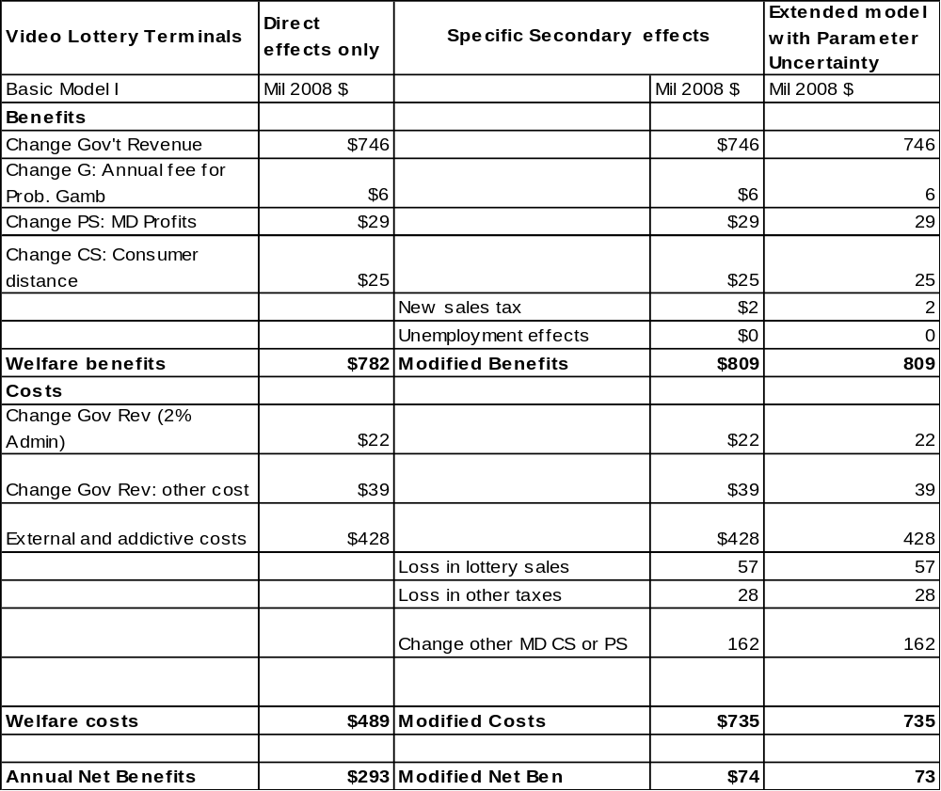

The point estimate used for long term producer surplus is 8 percent of the VLT operating revenues private operators received from the state based on the net income after taxes, depreciation, and before losses of all U.S. corporations in 2006 (US Census 2010). There is little in the secondary literature to guide uncertainty analysis about the appropriate revenue data to use or the rate in a regulated setting. Grinols uses twenty percent of gross revenue as the gross profit to include depreciation, interest, and profit in his example of the regional effect of gambling. If all firms are incorporated outside Maryland, then the producer surplus within Maryland would be zero. Consequently, the distribution used for producer surplus as a percentage of private VLT income is triangular with a lower bound of zero, a mode of 8 percent and a maximum of 20 percent.

Consumer benefit: Grinols distinguishes a consumer benefit based on reduced distance to gambling for an average consumer from a consumer benefit due to a price change in the more traditional consumer surplus. The distance benefit is estimated by Grinols using a functional form for utility that incorporates an intensity of gambling into a utility function to model both the number of visits and expenditures and distance to the gambling site. Shinogle, et al. (p. 11-12) report a distance consumer benefit of $25 million based on Grinols and the estimated average change in distance from 75 to 20 miles for gamblers in Maryland who may have previously gambles in the neighboring states of Pennsylvania, Delaware and West Virginia.

These distance benefits are approximations in several ways. The preferred interpolation is not clear for the assumed change in distance, the average distance may be different, and a recalculation of the 2008 data indicates the number may be less per person but larger than the $25 million for the entire population. For uncertainty purposes in later estimation, the distribution of distance consumer benefit has a most likely value of $40 million, a minimum of $25 million and a maximum of $100 million as the average distance was decreased to 10 miles and the value was applied to all adults as was typically although not universally identified in Grinols instead of to an expected number of gamblers.

Government expenses: Maryland legislation estimated that state costs would be 4.8 percent of total gross revenues (prior to payout to operators). The funding for these costs was to be split with two percent from VLT revenue and 2.8 percent from general funds. These costs are included as part of the direct “net” cost to government. On costs drawn from the general funds, a marginal excess burden of taxation of twenty-five percent is applied (Boardman, et al.; Grinols). The distribution of these costs is here driven by uncertainty in the gross revenues with the percentages remaining constant.

Problem and pathological gamblers (external and addictive impacts): Some gamblers develop an addiction to gambling that may lead to a number of self and relationship damaging actions. The literature, as summarized by Shinogle et al. (p. 12-14), identified pathological gamblers as the most at risk for addiction and problem gamblers as the next at risk. Numerous problems, both to themselves and to society have been estimated including lost productivity, crime, illness, fraud and so on. In effect, estimates in this area are a “bottom up” approach to enumerate impacts that are both external to the problem and pathological gamblers and some of which are likely internal. Although a later model will briefly discuss a different approach based on addictive preferences, this category of impact is thought to include both external effects and at least some of the components of what a problem and pathological gambler might be willing to pay to avoid their condition. While not well addressed in the gambling literature, future research could investigate what elements of this category are truly external costs, what are transfers, and what are internal to the gambler’s decision.

Estimates of the prevalence and value of these effects exist although the value is quite uncertain as the categories of impact and the marginal effect of gambling availability is poorly known. Shinogle (p. 14) reports a range of estimates for the incremental cost of problem and pathological gamblers in Maryland as being between $228.3 and $627.5 million and so the expected value, $428 million, is used as the point estimate while uncertainty is modeled as a uniform distribution for the range.

Discussion of results: Direct Effects

The result of the direct effect model is estimated net benefits of about $300 million in 2008 dollars. The key driver of the benefits is the government revenue although the estimated “external” costs due to problem and pathological gamblers are a substantial offset. Other elements, such as administrative costs, consumer benefits, producer surplus, and government fee revenue are relatively small being on the order of tens of millions of dollars instead of hundreds of millions as is the case for government revenues and external costs due to problem and pathological gamblers. The conclusion is that the direct effects, based on expected value point estimates, indicate a positive net benefit for Maryland due to VLTs.

Direct and indirect (secondary) effects, point estimates

This model adds what are generally considered the secondary, indirect, or general equilibrium effects to the core elements of the direct effect model. Some of these possible effects, such as any employment effects, are an important part of the policy debate but are generally, although not always, excluded from a benefit-cost analysis for reasons explained below. Each component that differs from the direct effects model is summarized below followed by a discussion of the results.

Employment of the unemployed: The initial estimates reported by Shinogle, et al. (p. 12) suggest that full employment existed in Maryland at the time and so there would no direct (or indirect) benefits related to employing the unemployed. Consequently the point estimate for a secondary benefit for the unemployed is zero which is also consistent with federal and textbook guidelines (OMB 2003; Boardman, et al.). However, in times of significant unemployment, a social benefit may exist over and above the reservation wage of hiring an unemployed person (Boardman, et al.; Haveman and Krutilla 1967). In the later uncertainty analysis, some potential for hiring the unemployed exists. The Maryland unemployment rate in late 2009 through 2010 was about 7 percent. In the uncertainty analysis here, the probability of an unemployment benefit was modeled as being driven by an ad-hoc probability model of hiring an unemployed person, times a social value for employing unemployed labor, times the size of the payroll. The assumed probability of hiring an unemployed person has its most likely value at 0 and increases continuously to 1; this distribution has a mean value of one-third. The probability of the unemployment benefit generated from that distribution is then multiplied times one-half of the estimated payroll, a proportion of payroll that results when the reservation wage for the unemployed is thought to range randomly between zero and the observed wage (Boardman, et al. p. 101). The VLT operator’s payroll was estimated as one third of the casino VLT expenditures (Grinols). There is no explicit multiplier effect although the proportion of unemployed hired could contain elements of such an effect.

Changes in other taxes: As an important policy issue in regional analysis is the net effect on taxes. The state legislative services (DLS) and Shingole, et al. included estimates of changes in other state revenue. The largest of these are estimated reductions in existing lottery income and the substitution effect of consumer and other expenditures in Maryland shifting from an existing taxable activity into a differently taxed activity, VLTs. Modest increases were estimated for some types of sales taxes. The point estimates are as reported in Shinogle, et al., in the case of lottery sales as an absolute dollar amounts and in the case of sales taxes, as 2.5 percent of gross VLT revenue. In the latter case, the uncertainty analysis links the loss in tax income to the uncertain change in total revenues.

Changes in other consumer and producer surplus: Including changes in related markets is a difficult conceptual and empirical issue for benefit-cost analysis. Existing guidance, as with unemployment, is to exclude such impacts. For instance, a leading textbook states “We can, and indeed, should ignore impacts in undistorted secondary markets as long as changes in social surplus in the primary market resulting from government projects are measured and prices in the secondary markets do not change” (Boardman, et al. p. 113). Distinguishing partial and general equilibrium effects can be a significant effort as illustrated by recent research on the “partial” and “full” excess burden of taxation (Goulder and Willisams 2003). However, two elements of the VLT context suggest that some macroeconomic impact is likely appropriate. First, the state and Shinogle et al. expend effort to consider the change in taxes and other state revenue. In a partial equilibrium setting, it is difficult to consider that tax revenues would change without some corresponding change in surplus measures. In addition, the regional impact and gambling literature is concerned about the source of the change in government revenues. Common terms include “recaptured” and “cannibalized” dollars where recaptured dollars are those that were previously spent, in this case by Marylanders, on gambling out of state that will be brought back into the state in some proportion. Cannibalized dollars are those expenditures that were already occurring in Maryland and now shifted into gambling which for Marylanders may have a subtle effect based on differential tax and consumer surplus across expenditure categories. For out-of-state gamblers coming into Maryland, some fraction of their expenditures might have been spent in Maryland in any event. For instance, Grinols adjusts revenue for such cannibalized dollars. In the Shinogle et al. report, this adjustment was part of the justification for lower VLT revenue forecasts based on lower rates of recapture dollars.

Consequently, for logical consistency with the estimated reduction in taxes and with regard to the literature, an indirect cost is associated with changes in consumer and producer surplus. In the absence of information about aggregate supply and demand responsiveness, which was not discussed in any of the existing reports, it is not possible with available data to directly link the change in tax revenues to changes in surplus measures. Instead, the expected adjustment for changes (losses) in indirect surplus is calibrated to be equal to an estimate of the proportion, 33 percent, of the change in government revenue generated by expanded gambling of Marylanders (DLS). This may be viewed as a conservative assumption, on very little analytical basis, as this entirely offsets the shift in spending to gambling among Marylanders, in effect creating a surplus neutral effect in Maryland. This estimate of shifted surplus, at $210 million, is over twice the estimated loss in tax and lottery revenue. The statistical distribution for this value is determined by the uncertainty of total revenue, a uniform random shift factor between 0 and 100 (the point estimate is 100 percent shifting), and a Maryland proportion of slots revenue that is triangularly distributed with a low of 25 percent, mode of 33 percent and high of 50 percent (the mean is then 36 percent).

Discussion of results: Secondary effects model

Including point estimates of the secondary effects has a substantial effect on the estimated net benefits, reducing them by almost $250 million to $74 million. Almost all of this adjustment is the result of the assumed shifts within Maryland in the surplus measures for other markets and the loss of government revenue in other markets. As the point estimate of unemployment benefits is zero, unemployment benefits have no effect on the point estimate of this model. Although net benefits are reduced they remain positive so that the conclusion of this extended model is that Maryland would benefit due to introducing VLTs.

Uncertainty analysis through Monte Carlo simulation

These results include the statistical distributions discussed in the benefit and cost categories to the model with secondary impacts. The distributions are used as the basis for 10,000 trials in a Monte Carlo simulation which produces an extended sensitivity analysis compared to considering just a few alternatives. For instance, the possible benefits from hiring the unemployed now appear in some results as do the Shinogle, et al. estimates of lower forecasted income.

Two sets of simulation results are reported. The first represents standard practice by including distributions for all the impact parameters of the model. The second includes an additional random error term associated with model fit (Farrow 2009). The distinction between the two models is that the first captures the effect of variability in the impacts, the second captures more fundamental uncertainty about how well the model fits the data.

The second model that includes uncertainty is worthy of additional discussion. The error augmented model is based on adding a distribution for a random error term to the basic Monte Carlo model. The estimation procedure described in Farrow (2009) is used here which is based on a subjective estimate of the accuracy of the overall model using a fit index ranging from 0 to 1 where 1 is a perfect fit. A value of .4 is used here to indicate that the model contains substantial uncertainty such that about the 40 percent of the true variability, analogous to R², is captured in the model. This uncertainty can come through the impact of omitted factors, such as the general state of the economy, in the use of information transferred from other settings so that the variables are proxies for the true values, in correlations between outcomes, in the treatment of secondary and external impacts, and so forth. That estimate of fit is used through a transformation to adjust the model sum of squares from the Monte Carlo simulation to estimate the mean square error. The estimated mean square error can be used as an estimate of the variance of the random error. This enlarges the overall degree of uncertainty without changing the mean value when a standard zero mean, normal error is assumed.

Discussion of results: Secondary model with uncertainty

The simulation result for the annual net benefits taking into account the variability in parameters and omitting pure uncertainty is presented in Figure 1. The mean of the simulated distribution is $104 million, about $30 million higher than the mean of the point estimate. The mean in the simulation differs from that in the models with point estimates because not all impact distributions were symmetric around their mean. For instance, the revenue estimate has most of its statistical weight for values less than the most likely value used in the point estimates, and the unemployment benefits has substantial weight for a positive impact compared to the zero value used as the most likely estimate. The 95 percent confidence interval is from minus $74 million to $280 million with other statistics as reported in the figure. Not reported in the figure is that there is a 17 percent chance of negative net benefits.

Figure 1: Simulation Results for Model with Secondary Impacts
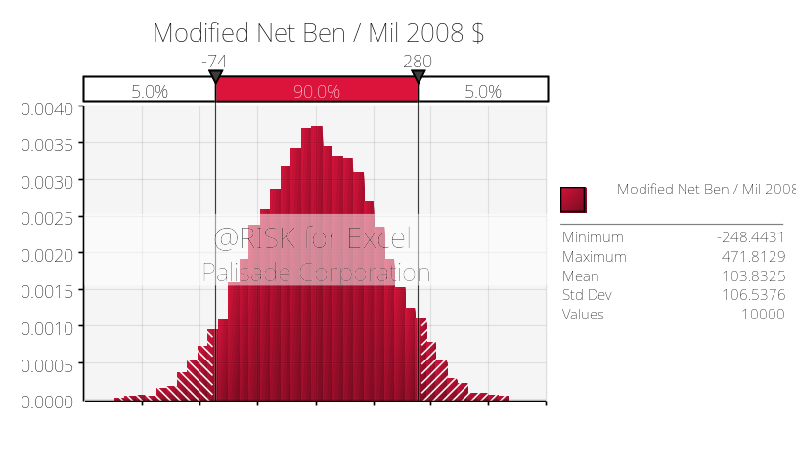
There are several ways to capture the influence of uncertainty within the benefit and cost impacts on the outcome. Figure 2 reports a method based on regression coefficients between the values drawn from the distributions and the annual net benefits. The impacts appear to fall into two categories. The largest effects are due to the forecasts for external costs and for revenues. The revenue forecast also drives several related impacts such as secondary tax and indirect consumer and producer surplus. A smaller category of impacts includes the consumer distance benefit, the effect of unemployment, and the proportion of profit.

These simulation results may suggest to decision-makers the wide range of possible outcomes, the possible shift in the mean due to varying models, and convey the sense of uncertainty compared to the potentially misleading precision that may be conveyed by the point estimates such as those in Table 1.

Figure 2: Correlation of Net Benefit to Key Input Values
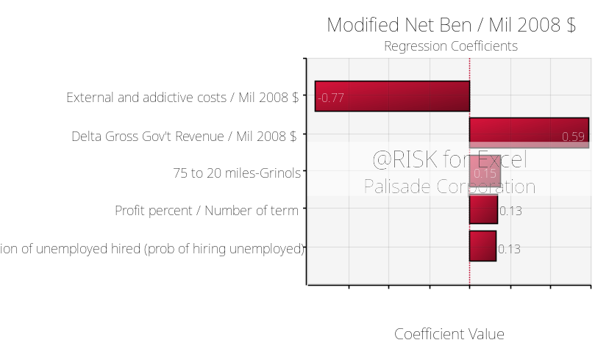

The degree of uncertainty is expanded when a subjective measure of model fit is used to estimate a pure random error. In comparison to results in Figure 1 with a 95 percent confidence interval from -74 to 280, the same confidence interval for the net benefit in the simulation model with added uncertainty is significantly expanded from -$172 million to $381 million although the means, as designed, are essentially equal. When the expanded error is included (not shown in any figure) there is a 27 percent chance that net benefits will be negative. Including the random error component may be one way to offset the apparent tendency to underestimate uncertainty in decision-making and in effect, creating “fatter” tails compared to the original distribution of the outcome.

Addictive preferences

A new area of research in benefit-cost analysis suggests that when a product is viewed as addictive, such as cigarettes, drugs, alcohol, or gambling; then there may be reason to adjust the observed behavior of those who are addicted to reflect the preferences of a non-addicted person. The Australian Gambling Commission (1999, 2009) and Weimer, Vining, and Thomas (2006) use a similar linear model. The latter authors empirically estimate the willingness to pay of those addicted to achieve an unaddicted state and estimate a downward adjustment for the modeled overconsumption of those who are addicted. The estimated adjustment factor for cigarettes was that those who are addicted receive about two-thirds the consumer surplus of those who are not. Grinols (2004) adjusts downward the average distance benefits by the estimated share of expenditures by problem and pathological gamblers; effectively reducing distance benefits by 30 percent.

No additional adjustments for addictive preferences are incorporated here although the subject remains an area of possible research. The substantial external costs reported in the models are essentially based on a cost-of-illness approach such as the dollar impacts in various categories affecting both problem and pathological gamblers (the addicted or potentially addicted). These impacts are combined, often based not on willingness to pay but on the cost to various parties. A willingness to pay by problem and pathological gamblers to avoid their state is presumably based on but not necessarily equivalent to these impacts. Consequently it is believed that substantial double-counting would occur if the costs associated with problem and pathological gamblers are included as well as an adjustment for addictive preferences.

Alternatively, there are several observations should one desire to make a downward adjustment to the results, If the distance consumer benefit is reduced by about the one-third, the amount suggested by Grinols or Weimer, Vining and Thomas, the adjustment is modest, about 8 million dollars. Alternatively, if low prevalence of problem and pathological gamblers is applied to the average distance benefit without weighting for the larger expenditures of problem and pathological gamblers, then the change is less than one million dollars. However, as a direction for further research it appears that distinguishing theoretically and empirically the benefits received by those who do not gamble, those who gamble normally, and problem and pathological gamblers may be a useful direction. At the same time, consideration should be given to the extent to which such estimates are already partially captured in the costs estimated for external and addictive effects reported here.

Distributional Impacts

Federal guidance includes consideration of the distributional impacts of an activity if they are substantial stating “Your regulatory analysis should provide a separate description of distributional effects (i.e., how both benefits and costs are distributed among sub-populations of particular concern) so that decision makers can properly consider them along with the effects on economic efficiency.” (OMB 2003). There is substantial current interest in providing sensitivity analysis to the baseline guidance, in which dollar impacts to all those affected are weighted equally, in order to explore the impact of alternative distributional assumptions (Zerbe 2001 ;Adler 2008; Farrow 2010; HM Treasury 2009). Although such adjustments have intuitive appeal, they are also inherently subjective as there is no known method to objectively determine such weights nor is there is a professional consensus on such weights.

Gambling provides a likely area of application for distributional sensitivity analysis because low income and minority people are heavy participants in existing state sanctioned gambling in Maryland. Carpenter, Perlman and Norris (2009) report zip-code data in which the codes in the lower quartile of income outspend on a per-capita basis those in the upper quartile by more than two to one although there is wide variation among various lottery type games. In Maryland, 55 percent of households are in the lower quartile of income (Maryland Department of Planning, undated) so that population weighted impacts may be substantial.

The approach to distributional benefits used here is that suggested by Farrow (2010). The U.S. Census Bureau (2008a, 2008b) uses weights for inequality aversion (Atkinson weights) that imply relative weights of 2:1; ~4:1; or 14:1 between the upper and lower segments of the income distribution. The actual weights in the ~4:1 case are 2.1 and .5 respectively which are used to weight costs or benefits for either the lower or upper quartile (Maryland (Maryland Planning Commission undated). Those in the mid-two quartiles of income are given an absolute weight of one. Implicitly, all other impacts except for the gambler’s benefits and costs are given an absolute weight of one. Distributional weights are applied only to the estimated Maryland source of revenues.

Discussion of results: Distributional Impacts

The result of such weighting can drive the annual net benefits substantially negative as indicated in Table 2. A distributional relative weight of 4:1 drives the point estimate of net benefits significantly negative, to - $171 million while relative weight of 2:1 for the highest and lowest quartiles is enough to almost exactly drive the net benefits to zero. Although equal weighting of impacts is the base case in benefit-cost analysis, the use of distributional weights changes the sign of the annual net benefits. This indicates the substantial importance for economic analysis and presumably for decision-makers of the distributional impact to the evaluation of gambling in Maryland.

Table 2: Distributional Impacts and Alternative Revenue Raising Policy
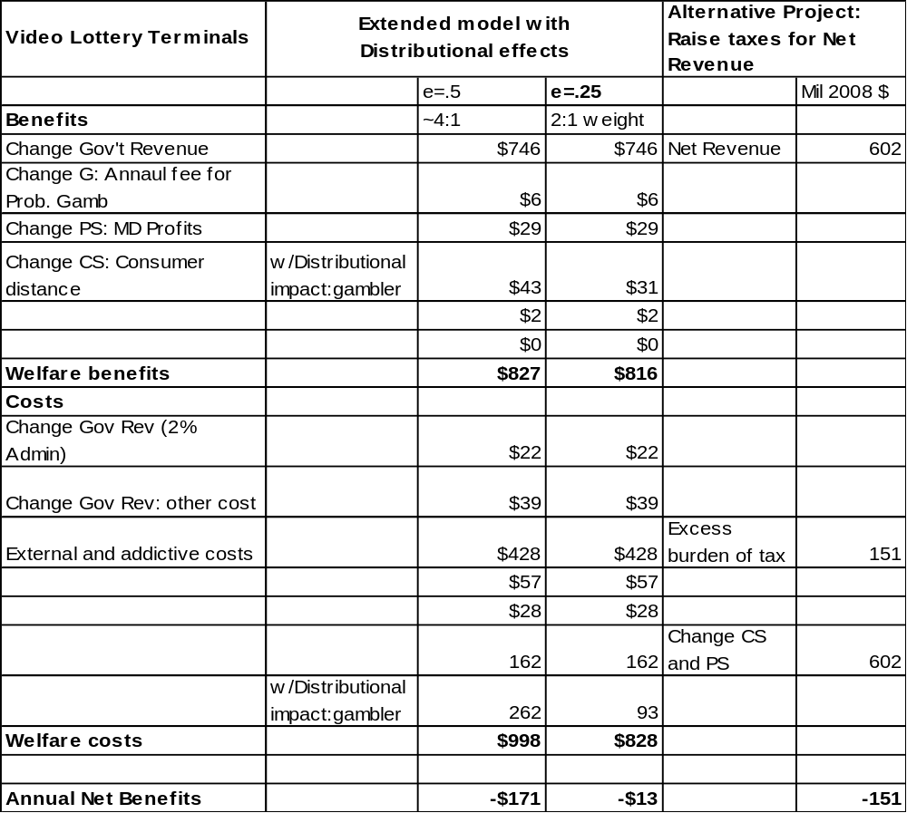

Alternative Policy: Raising revenue via the income tax

The political debate focused on legalization of VLTs as a means to raise money for higher education and other purposes in a time of particularly tight state budgets hence the previous analyses focused on a with or without legal slots analysis. However, some insight is gained by comparing the net benefits of VLTs compared to an alternative that would yield an equivalent change in net government revenue compared to the slots policy. A possible alternative policy is to raise existing sales or income taxes in Maryland. The incidence of such a tax is assumed to fall entirely on Marylanders and no new good or service is being provided in direct exchange for the taxes as there is in the case of VLTs. Raising existing taxes is unlikely to impose substantially larger administrative costs given the existing tax collection system. This alternative is thus the standard case of a transfer from taxpayers to the government with its associated excess burden of taxation, valued at 25 percent of the funds raised as in previous models (Boardman, et al.). Point estimates for such an alternative policy are presented in the final column in Table 2. The alternative of raising taxes, without consideration of the specific uses to which the funds would be used, results in an estimated loss or (negative) net benefits of - $151 million.

Discussion of results: Alternative tax based model

Standard taxation is thought to generate a welfare loss in raising funds, although the uses to which the funds are put may ultimately justify such loses. Since the alternatives in this case, VLT gambling or raising taxes, are designed to generate the same net change in government revenue; the preferred alternative would be the lowest cost source of funding. Prior to distributional weighting, it appears that VLTs would be the lesser cost method of raising funds. With distributional weighting the result is less clear, although sales taxes themselves are understood to be regressive and the Maryland tax system exhibits only a modest progressivity in income taxes.

New information

Time has passed since the policy debates on which this benefit-cost forecast is based. Consequently it is possible to have initial “in medias res” feedback on the accuracy of the forecast and any generic issues in its production in order to inform future forecasts either of VLTs in Maryland or more generally, the production of benefit-cost analyses. The issues raised to date include the general state of the economy, revenue forecasts, and the estimation of distance consumer surplus. Each is discussed in turn.

State of the economy: The impact report was developed as the economy was softening and prior to the substantial changes in unemployment that evolved over the following year. Consequently the Shinogle et al. report focused on the standard case of full employment even though supporters of government activity often cite employment as part of the benefits of an action. In the Fall of 2010, with state unemployment about 7 percent, analysts would be more likely to consider some partial and perhaps short term adjustment in benefits due employing previously unemployed labor. The uncertainty analysis in this study did incorporate some probability of workers being drawn from the unemployed. This case study demonstrates that uncertainty analysis for many projects may do well to consider the probability, even if small, for economic benefits from unemployed labor.

Revenue forecast: The state of Maryland has accepted applications for slots at various sits. The demand for site licenses and VLT terminals has been less than expected with applications received for four sites not all of which were the anticipated sites, and for about half of the expected number of terminals as of Fall, 2010. Although still early to know the full implementation results, these early applications suggest less demand than forecast by the state of Maryland (DLS 2008). The observed demand in 2010 is more consistent with the medium or low predictions provided in Shinogle et al. although the cause may be different and is not yet known. Shinogle et al. considered the source of lower revenue to be due to less play per machine and less recapture of Maryland gambling revenue that is currently spent out of state. The current situation suggests, but does not prove, that the macro economic conditions and perhaps the less favorable terms demanded by Maryland may reduce revenue forecasts separately from the amount gambled per day or their source.

Distance benefits: Measuring the consumer benefits of increased access to gambling remains a difficult empirical exercise. However, it appears that the distance benefits as calculated by Grinols (2004) may have been incorrectly applied to the specifics of the Maryland case in Shinogle et al. including the change in distance traveled and the number of people to which the benefit applied. Recalculation may increase the forecast of distance benefits from $25 to about $40 million. This change would not have significantly affected the result but is an example that calculation error is often possible, and the risks of such error increase with the speed and perhaps decrease with the resources available to the analytical team.
Conclusions and Directions for Research

This benefit-cost analysis can be viewed as an extension of a “real time” impact report for policy purposes. The level of effort required was relatively modest and yields a comparable level of accuracy. However, the benefit-cost framework informs several new issues including the net benefits to Maryland of VLTs, the importance of secondary impacts, the role of uncertainty, the comparison among alternatives, and the importance of distributional impact. With a forecast in hand “as if” it had been produced in the Fall of 2008, there are lessons to be learned about considering the sensitivity to major uncertainties, in this case the macro state of the economy and the behavioral response of casino operators to the contractual terms. As always, opportunities to consider major uncertainties and to develop evolved models depend on the time and resources available.

This case study suggests improvements for monitoring and research. As the revenue forecast and the external and addictive costs were the largest determinants of uncertainty their monitoring and more careful definition for benefit-cost purposes would be useful. The revenue estimates are expected to be relatively transparent but the external costs are much less transparent in their magnitude and causal link to changes in access to VLTs. Maryland does plan baseline and follow-up studies of the prevalence of problem and pathological gamblers but the analysis here suggests that much more than prevalence is desired. For instance, the magnitude of incremental external and addictive costs could be investigated as well as the emerging method of assessing the willingness to pay of those with addictive characteristics. Other areas for research and monitoring include: 1) the geographic source of gamblers, 2) the extent of secondary effects including hiring the unemployed, 3) what profits are retained in Maryland, 4) improving the gambler model to include those who don’t gamble, standard, and problem and pathological gamblers, and 5) improvements in model uncertainty. The monitoring and research associated with these issues can improve Maryland’s evaluation of the new program and inform continuing development of benefit and cost methods.

What analytical conclusion is reached? First, the benefit-cost analysis informs issues that are only implicit in an impact analysis. It appears, based on a modest sized forecasting effort, that VLTs would have been forecast in 2008 to generate net benefits to the state of Maryland compared to the alternative of doing nothing and in comparison to raising funds through existing taxes. There is substantial uncertainty about various point estimates so that there was some significant chance of negative net benefits based on information at the time of the elections. Finally, the analysis makes clear that differing subjective weights on the distributional impacts of gambling can lead to an estimate with negative net benefits for VLTs. For economists however, this is doubly uncertain territory both because of the subjective nature of distributional adjustments and because those in the lower portion of the income distribution are voluntary choosing to gamble.

References

Arrow, Kenneth, Maureen Cropper, George Eads, Robert Hahn, Lester Lave, Roger Knoll, Paul Portney, Milton Russell, Richard Schmalensee, V. Kerry Smith, and Robert Stavins, 1996. Is There a Role for Benefit–Cost Analysis in Environmental, Health, and Safety Regulation? Science 272(April): 221–222.

Adler, Matthew, 2008. Risk Equity: A New Proposal, Harvard Environmental Law Review, 32(1):1-47.

Australian Productivity Commission, Australia’s Gambling Industries, Report 10, November, 1999; a 2009 draft report is available at http://pc.gov.au/projects/inquiry/?a=91545 .

Boardman, Anthony, David Greenberg, Aiden Vining, and David Weimer. 2006. Cost-Benefit Analysis: Concepts and Practice. Pearson-Prentice Hall. Upper Saddle River.

Carpenter, Robert, Evan Perlman, and Don Norris, 2010. Cashing In: Who Pays for the Maryland Lottery? J. of Gambling Business and Economics, 4(1):31-52.

Department of Legislative Services (DLS), Office of Policy Analysis, State of Maryland, 2008. Update of the Legislator’s Guide to Video Lottery Terminal Gambling; accessible at http://mlis.state.md.us .

Farrow, Scott, 2009. The Missing Error Term in Simulation Models: With an Application to the Clean Air Act, Department of Economics Working Paper available at http://www.umbc.edu/economics/working_papers.html .

Farrow, Scott. 2010. Incorporating Distributional Analysis into Benefit-Cost Analysis Using Risk Based Preferences, Risk Analysis, available online at http://onlinelibrary.wiley.com/journal/10.1111/(ISSN)1539-6924/earlyview .

Freeman, Myrick III, 1989. Ex-Ante and Ex-Post Values for Changes in Risk, Risk Analysis, 9(3):309-317.

Goulder, Lawrence and Roberton Williams, III, 2003. The Substantial Bias from Ignoring General Equilibrium Effects in Estimating Excess Burden, and a Practical Solution. Journal of Political Economy, 111(4):898-927).

Grinols, Earl L., 2004. Gambling in America: Costs and Benefits, Cambridge University Press, Cambridge.

Haveman, R. and J. Krutilla, Unemployment, Excess Capacity, and Benefit-Cost Criteria, The Review of Economics and Statistics, 49(3): 382-392, 1967.

HM Treasury, 2009. The Green Book: Appraisal and Evaluation in Central Government. Accessed June 8, 2009 at http://www.hm-treasury.gov.uk/data_greenbook_index.htm
Krupnick, Alan, Richard Morgenstern, Michael Batz, Peter Nelson, Dallas Burtraw, Jhih-Shyang Shih, and Michael McWilliams, 2006. Not a Sure Thing: Making Regulatory Choices Under Uncertainty. Resources for the Future, Washington, D.C.

Maryland Department of Planning, “Income Inequality Continues to Grow,” available at http://planning.maryland.gov/msdc/income_inequality/incomeinequality_1980_2000.pdf

OMB (U.S. Office of Management and Budget). 2003. “Regulatory Analysis” OMB Circular A-4, Washington, D.C.

Pearce, David, Giles Atkinson, and Susanna Mourato 2006. Cost-Benefit Analysis and the Environment: Recent Developments. OECD, Paris.

Shinogle, Judith, Robert Carpenter, Scott Farrow, and Donald F. Norris, 2008. An Analysis of the Impact of Introducing Video Lottery Terminals in Maryland. Maryland Institute for Policy Analysis and Research (MIPAR), October 14. available at http://www.umbc.edu/mipar/Documents/Impact%20of%20Introducing%20Video%20Lottery%20Terminals%20FINAL.pdf

U.S. Census Bureau (Alemavehu Bishaw and Jessica Semega) 2008a. Income, Earnings, and Poverty Data from the 2007 American Community Survey. Available at www.census.gov/prod/2008pubs/acs-09.pdf

U.S. Census Bureau (Carmen DeNavis-Wait, Bernadette Proctor, and Jessica Smith) 2008b. Income, Poverty, and Health Insurance Coverage in the United States. Available at www.census.gov/prod/2008pubs/p60-235.pdf .

U.S. Census Bureau, 2010. Statistical Abstract. Table 737 (Corporations-Selected Financial Items), accessed February 11, 2010 at http://www.census.gov/compendia/statab/2010/tables/10s0737.xls .

Weimer, David, Aidan Vining, and Randall Thomas. Cost-Benefit Analysis Involving Addictive Goods: Contingent Valuation for Willingness-to-Pay for Smoking Cessation, Health Economics 18.2 (2009): 181-202.

Zerbe, Richard and Dwight Dively. 1994. Benefit-Cost Analysis in Theory and Practice. Harper Collins, New York.

Zerbe, Richard Jr. 2001. Economic Efficiency in Law and Economics. Edward Elgar, Cheltenham.

These net benefit would be about $200 million higher if the state estimate for projected revenues was used in place of the expected value of the state and the MIPAR generated estimates.
The @Risk software (Palisade 2008) was used to produce the simulation.

